**Freshwater Elementary School**



2024 – 2025

Comprehensive School Safety Plan

**Freshwater School District**

**Keenan & Associates | CA License No. 0451271**

Contents

Section 1 – Introduction 7

School Stakeholders 3

Law Enforcement, Fire Department, Emergency Response 3

Vision Statement 4

Mission Statement 4

Meeting Minutes 5

Frequently Asked Questions About PBIS 101

Discipline Referrals 108

Discipline Process Flowchart 109

Restorative Practices 110

Assessment and Response Procedures 112

Student Overdose or Possible Overdose Protocol 113

Student Overdose or Possible Overdose Procedures (The 4 Rs) 114

Narcan/Naloxone on School Sites: 115

Our School’s Individualized Plans 116

Drills, Training, and Exercises 117

Student Safety – Drills, Training,and Exercises 117

Emergency Operations Plan – Excerpted 118

Functional Annex 119

Attendance Records 120

Crisis or Incident Accounting 120

Assembly Areas 120

Student Release 120

Purpose 122

Scope 122

Activation 122

Key Tasks/Responsibilities 122

Internal Communications 123

Activation 123

Concept of Operations 123

General 125

Scope 125

Responsibilities 125

General 127

Concept of Operations 127

Evacuation Procedures 127

On-Site Evacuation 128

Off-Site Evacuation 128

Evacuating Students with Disabilities 128

Preparation and Planning 129

General 131

Instructions 131

General 132

Public Health 132

Medical Health 132

Mental Health 133

Purpose 134

Scope 134

Key Tasks/Responsibilities 134

Concept of Operations 135

General 136

Before – Action Items 136

During – Action Items 136

After – Action Items 138

Resources 138

General 139

Reunification Procedures 139

Traffic Control 139

Maintaining the Procedures 140

General 141

Description of Action 141

Overview 142

Prepare 142

Field Protocol 143

Disaster Service Worker 143

Planning Needs and Assumptions 144

Hazard/Threat Annex 145

HTAS Report 147

Situation and Assumptions 148

Continuity of Operations (Annex Specific) 148

Organization and Assignment of Responsibilities 148

Plan Development 148

Authorities and References 148

Incident Command Actions 150

Purpose 155

Situation and Assumptions 155

Organization and Assignment of Responsibilities 157

Glossary of Terms 157

Incident Command Actions 158

Authorities and References 160

Duck, Cover, and Hold 161

Description of Action 161

Procedures 161

During Non-Operating Hours 162

Procedure 163

General 164

Fire in Surrounding Area 164

Incident Command Actions 164

Purpose 167

Disease Sources 167

Rate of Spread 168

Situation and Assumptions 168

Concept of Operations 169

Continuity of Operations (Annex Specific) Important Notice 170

Organization and Assignment of Responsibilities 171

Plan Development 171

Authorities and References 171

Incident Command Actions 171

COVID-19 Specific Guidance 173

Historical Information 177

Before a Landslide 180

Recognize Warning Signs 181

During a Landslide 182

After a Landslide 182

Protect Students And Staff During A Power Outage 183

Electrical Systems 183

Backup Supplies and Other Resources 183

Survive During 184

Power Restoration 184

Purpose 185

Situation and Assumptions 185

Continuity of Operations (Annex Specific) 186

Organization and Assignment of Responsibilities 186

Plan Development 186

Authorities and References 186

Incident Command Actions 186

Tsunami 188

Purpose 188

Situation and Assumptions 188

Continuity of Operations (Annex Specific) 188

Organization and Assignment of Responsibilities 189

Plan Development 189

Authorities and References 189

Incident Command Actions 189

Tsunami Warnings 191

Section 3 – Data Analysis 193

Earthquake Drills (Duck, Cover, Hold) 202

Lockdown Drills 202

Evacuation 202

Section 4 – Action Plan 203

Areas of Pride/Accomplishments 204

Findings & Desired Improvements 204

Priorities/Goals 204

Overall Strategies for the 2024 – 2025 School Year 205

# Section 1 – Introduction

SB 187 & AB 1747 Compliant Document

Preface

This comprehensive school safety plan is evaluated, and amended as needed, no less than once per year per Education Code section 35294.2(e)). This plan is available for public inspection during normal business hours at the Freshwater School District office located at 75 Greenwood Heights Drive, Eureka CA 95503. For questions regarding this plan please call (707) 442-2969.

NOTE: Tactical responses to criminal incidents are excluded from this public inspection document. This document is not available for public inspection on the internet.

An “Inspection Log” is utilized to record the name, address, phone number and identification method

of all individuals that perform a public inspection of this plan.

Freshwater Elementary School CSSP

### School Stakeholders

* **Administrators:** Si Talty, Suzanne Nickols
* **Teachers:** Stacy Mintey, Danta Stoker, Kylah Rush, David Haller
* **Parents:** Korin Slaght
* **Classified**: John Andrae
* **Parent Advisory Committee Representative** Melissa Vasquez
* **Support Staff:** Meagan Bet
* **Counselors**:

### Law Enforcement, Fire Department, Emergency Response

* **Sheriff, Police:** Humboldt County Sheriff’s Office
* **Fire Department:** Humboldt Bay Fire

***District Representatives***

###### Title IV advisory council representative: Si Talty

***Health and Human Services***

**After-school coordinator:** Audrey Hildebrand

### Vision Statement

Freshwater School District prides itself in being one of the top school districts in Humboldt County. Our staff strives to nurture the abilities, talents, and interests of every child that attends our school, and parent involvement is strongly encouraged. We teach our students to be kind, productive, and considerate citizens in our community. Our District provides a safe, caring environment for all students and our rural campus setting promotes a love of nature and is a natural environment for study. We provide a comprehensive curriculum, enabling all students to excel as they meet the challenges and opportunities of our changing world. We are very proud of the many successes that our students demonstrate while attending Freshwater School and after they move forward with their education.

### Mission Statement

Freshwater School District, in partnership with district families will:

* Provide a positive, safe, caring environment which nurtures the intellectual, physical, emotional, and moral capacities of each child, so that each child can lead a fulfilling life as a productive worker, citizen, and individual.
* Develop, implement, and continue to update a student-centered, integrated curriculum which addresses the modalities, strengths, and social development of each student.
* Provide a successful educational program for each student which considers his/her unique needs, abilities, and/or cultural background.
* Provide and encourage families with opportunities to participate and share in the educational growth of their child.

### Meeting Minutes

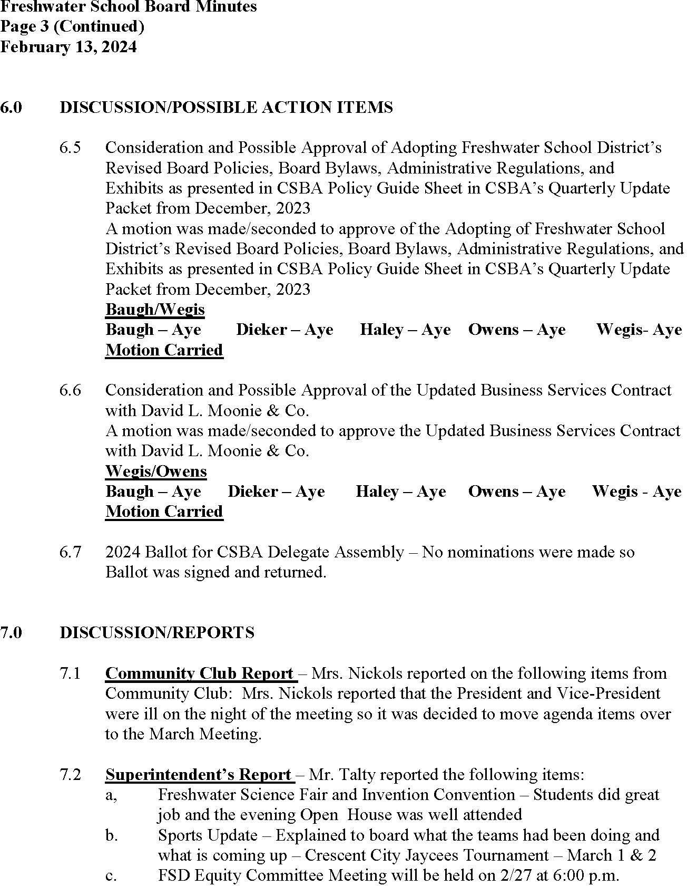

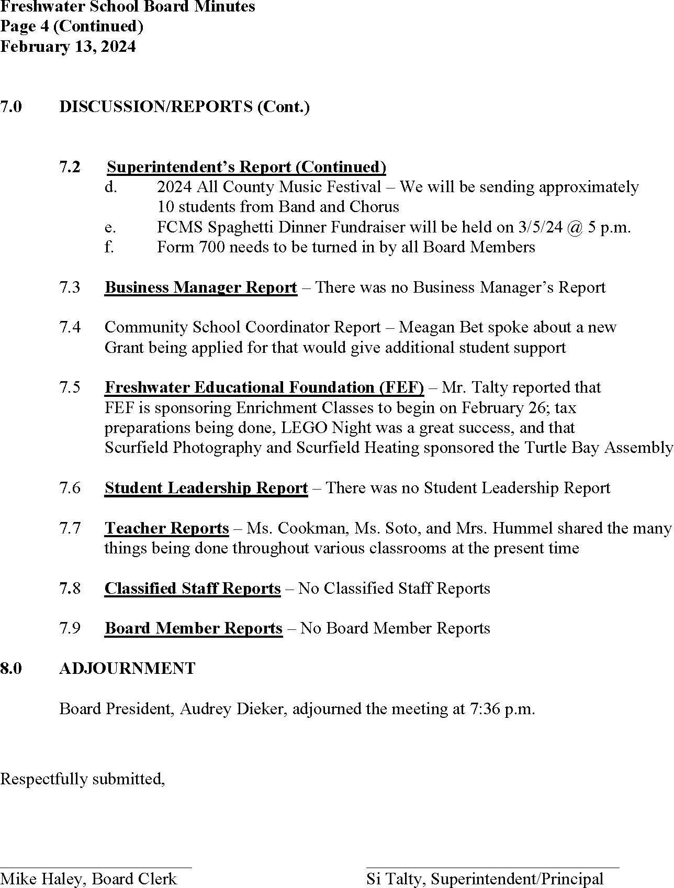

Section 2 – Policies and Procedures

(Policies and Procedures have been excerpted and reformatted for this document. Code and Legal References have been removed. For access to documents in their original and approved form please contact the (707) 442-2969.

Child Abuse Prevention and Reporting – BP 5141.4

The Board of Trustees is committed to supporting the safety and well-being of district students and desires to facilitate the prevention of and response to child abuse and neglect. The Superintendent/Principal or designee shall develop and implement strategies for preventing, recognizing, and promptly reporting known or suspected child abuse and neglect.

The Superintendent/Principal or designee may provide a student who is a victim of abuse with school-based mental health services or other support services and/or may refer the student to resources available within the community as needed.

**Child Abuse Prevention**

The district's instructional program may provide age-appropriate and culturally sensitive child abuse prevention curriculum which explains students' right to live free of abuse, includes instruction in the skills and techniques needed to identify unsafe situations and react appropriately and promptly, informs students of available support resources, and teaches students how to obtain help and disclose incidents of abuse.

The district's program also may include age-appropriate curriculum in sexual abuse and sexual assault awareness and prevention. Upon written request of a student's parent/guardian, the student shall be excused from taking such instruction. (Education Code 51900.6)

The Superintendent/Principal or designee may display posters, in areas on campus where students frequently congregate, notifying students of the appropriate telephone number to call to report child abuse or neglect. (Education Code 33133.5)

In addition, student identification cards for students in grades 7-12 shall include the National Domestic Violence Hotline telephone number. (Education Code 215.5)

The Superintendent/Principal or designee shall, to the extent feasible, seek to incorporate community resources into the district's child abuse prevention programs and may use these resources to provide parents/guardians with instruction in parenting skills and child abuse prevention.

**Child Abuse Reporting**

The Superintendent/Principal or designee shall establish procedures for the identification and reporting of known and suspected child abuse and neglect in accordance with law.

Procedures for reporting child abuse shall be included in the district and/or school

comprehensive safety plan. (Education Code 32282)

District employees who are mandated reporters, as defined by law and administrative regulation, are obligated to report all known or suspected incidents of child abuse and neglect.

The Superintendent/Principal or designee shall provide training regarding the duties of mandated reporters as required by law and as specified in the accompanying administrative regulation. (Education Code 44691; Penal Code 11165.7)

**Original Adopted Date:** 11/14/2023

**Last Reviewed Date:** 11/14/2023

Child Abuse Prevention and Reporting – AR 5141.4

###### Definitions

Child abuse or neglect includes the following: (Penal Code 11165.5, 11165.6)

A physical injury or death inflicted by other than accidental means on a child by another person

Sexual abuse of a child, including sexual assault or sexual exploitation, as defined in Penal Code 11165.1

Neglect of a child as defined in Penal Code 11165.2

Willful harming or injuring of a child or the endangering of the person or health of a child as defined in Penal Code 11165.3

Unlawful corporal punishment or injury as defined in Penal Code 11165.4 Child abuse or neglect does not include:

A mutual affray between minors (Penal Code 11165.6)

An injury caused by reasonable and necessary force used by a peace officer acting within the course and scope of employment (Penal Code 11165.5, 11165.6)

An injury resulting from the exercise by a teacher, vice principal, principal, or other certificated employee of the same degree of physical control over a student that a parent/guardian would be legally privileged to exercise, not exceeding the amount of physical control reasonably necessary to maintain order, protect property, protect the health and safety of students, or maintain proper and appropriate conditions conducive to learning (Education Code 44807)

An injury caused by a school employee's use of force that is reasonable and necessary to quell a disturbance threatening physical injury to persons or damage to property, for purposes of self- defense, or to obtain weapons or other dangerous objects within the control of a

student (Education Code 49001)

Physical pain or discomfort caused by athletic competition or other such recreational activity voluntarily engaged in by a student (Education Code 49001)

Homelessness or classification as an unaccompanied minor (Penal Code 11165.15)

Mandated reporters include, but are not limited to, teachers; instructional aides; teacher's aides or assistants; classified employees; certificated pupil personnel employees; administrative officers or supervisors of child attendance; athletic coaches, administrators, and directors; licensees, administrators, and employees of a licensed child day care facility; Head Start program teachers; district police or security officers; licensed nurses or health care providers; and administrators, presenters, and counselors of a child abuse prevention program. (Penal Code 11165.7)

Reasonable suspicion means that it is objectively reasonable for a person to entertain a suspicion, based upon facts that could cause a reasonable person in a like position, drawing when appropriate on the person's training and experience, to suspect child abuse or

neglect. However, reasonable suspicion does not require certainty that child abuse or neglect has occurred nor does it require a specific medical indication of child abuse or neglect. (Penal Code 11166)

###### Reportable Offenses

A mandated reporter shall make a report using the procedures provided below whenever, acting in a professional capacity or within the scope of employment, the mandated reporter has knowledge of or observes a child whom the mandated reporter knows or reasonably suspects has been the victim of child abuse or neglect. (Penal Code 11166)

Any mandated reporter who has knowledge of or who reasonably suspects that a child is suffering serious emotional damage or is at a substantial risk of suffering serious emotional damage, based on evidence of severe anxiety, depression, withdrawal, or untoward aggressive behavior toward self or others, may make a report to the appropriate agency. (Penal Code 11165.9, 11166.05, 11167)

Any district employee who reasonably believes to have observed the commission of a murder, rape, or lewd or lascivious act by use of force, violence, duress, menace, or fear of immediate and unlawful bodily injury against a victim who is a child under age 14 shall notify a peace officer. (Penal Code 152.3, 288)

###### Responsibility for Reporting

The reporting duties of mandated reporters are individual and cannot be delegated to another person. (Penal Code 11166)

When two or more mandated reporters jointly have knowledge of a known or suspected instance of child abuse or neglect, the report may be made by a member of the team selected by mutual agreement and a single report may be made and signed by the selected member of

the reporting team. Any member who has knowledge that the member designated to report has failed to do so shall thereafter make the report. (Penal Code 11166)

No supervisor or administrator shall impede or inhibit a mandated reporter from making a report. (Penal Code 11166)

Any person not identified as a mandated reporter who has knowledge of or observes a child whom the person knows or reasonably suspects has been a victim of child abuse or neglect may report the known or suspected instance of child abuse or neglect to the appropriate

agency. (Penal Code 11166)

###### Reporting Procedures

Initial Telephone Report

Immediately or as soon as practicable after knowing or observing suspected child abuse or neglect, a mandated reporter shall make an initial report by telephone to any police department (excluding a school district police/security department), sheriff's department, county probation department if designated by the county to receive such reports, or county welfare department. (Penal Code 11165.9, 11166)

Such reports shall be made to the following agency(ies):

Child Welfare Services 2440 6th St.

Eureka, CA 95503

1-707-445-6180

When the initial telephone report is made, the mandated reporter shall note the name of the official contacted, the date and time contacted, and any instructions or advice received.

Written Report

Within 36 hours of knowing or observing the information concerning the incident, the mandated reporter shall prepare and either send, fax, or electronically transmit to the appropriate agency a written follow-up report, which includes a completed California Department of Justice (DOJ) form (BCIA 8572). (Penal Code 11166, 11168)

The DOJ form may be obtained from the district office or other appropriate agencies, such as the police department, sheriff's department, or county probation or welfare department.

Reports of suspected child abuse or neglect shall include, if known: (Penal Code 11167)

The name, business address, and telephone number of the person making the report and the capacity that makes the person a mandated reporter

The child's name and address, present location, and, where applicable, school, grade, and class The names, addresses, and telephone numbers of the child's parents/guardians

The name, address, telephone number, and other relevant personal information about the person(s) who might have abused or neglected the child

The information that gave rise to the reasonable suspicion of child abuse or neglect and the source(s) of that information

The mandated reporter shall make a report even if some of this information is not known or is uncertain to the mandated reporter. (Penal Code 11167)

The mandated reporter may give to an investigator from an agency investigating the case, including a licensing agency, any information relevant to an incident of child abuse or neglect or to a report made for serious emotional damage pursuant to Penal Code 11166.05. (Penal Code 11167)

Internal Reporting

The mandated reporter shall not be required to disclose the mandated reporter's identity to a supervisor, the principal, or the Superintendent/Principal or designee. (Penal Code 11166)

However, employees reporting child abuse or neglect to an appropriate agency are encouraged, but not required, to notify the principal as soon as possible after the initial telephone report to the appropriate agency. When so notified, the principal shall inform the Superintendent/Principal or designee.

The principal so notified shall provide the mandated reporter with any assistance necessary to ensure that reporting procedures are carried out in accordance with law, Board policy, and administrative regulation. At the mandated reporter's request, the principal may assist in completing and filing the necessary forms.

Reporting the information to an employer, supervisor, principal, school counselor, co-worker, or other person shall not be a substitute for making a mandated report to the appropriate agency. (Penal Code 11166)

###### Training

Within the first six weeks of each school year, or within the first six weeks of employment if hired during the school year, the Superintendent/Principal or designee shall provide training on mandated reporting requirements to district employees and persons working on their behalf who are mandated reporters. (Education Code 44691; Penal Code 11165.7)

The Superintendent/Principal or designee shall use the online training module provided by the California Department of Social Services (CDSS). (Education Code 44691)

The training shall include, but not necessarily be limited to, training in identification and reporting of child abuse and neglect. In addition, the training shall include information that failure to report an incident of known or reasonably suspected child abuse or neglect as required by law is a misdemeanor punishable by imprisonment and/or a fine as

specified. (Education Code 44691; Penal Code 11165.7)

The Superintendent/Principal or designee shall obtain and retain proof of each mandated reporter's completion of the training. (Education Code 44691)

In addition, at least once every three years, school personnel may receive training in the prevention of child abuse, including sexual abuse, on school grounds, by school personnel, or in school-sponsored programs. (Education Code 44691)

###### Victim Interviews by Social Services

Whenever CDSS or another government agency is investigating suspected child abuse or neglect that occurred within the child's home or out-of-home care facility, the student may be interviewed by an agency representative during school hours, on school premises. The Superintendent/Principal or designee shall give the student the choice of being interviewed in private or in the presence of any adult school employee or volunteer aide selected by the student. (Penal Code 11174.3)

A staff member or volunteer aide selected by a child may decline to be present at the interview. If the selected person accepts, the principal or designee shall inform the person of the following requirements prior to the interview: (Penal Code 11174.3)

The purpose of the selected person's presence at the interview is to lend support to the child and enable the child to be as comfortable as possible.

The selected person shall not participate in the interview.

The selected person shall not discuss the facts or circumstances of the case with the child.

The selected person is subject to the confidentiality requirements of the Child Abuse and Neglect Reporting Act, a violation of which is punishable as specified in Penal Code 11167.5.

If a staff member agrees to be present, the interview shall be held at a time during school hours when it does not involve an expense to the school. (Penal Code 11174.3)

###### Release of Child to Peace Officer

When a child is released to a peace officer and taken into custody as a victim of suspected child abuse or neglect, the Superintendent/Principal or designee and/or principal shall not notify the parent/guardian, but rather shall provide the peace officer with the address and telephone number of the child's parent/guardian. (Education Code 48906)

###### Parent/Guardian Complaints

Upon request, the Superintendent/Principal or designee shall provide parents/guardians with procedures for reporting suspected child abuse occurring at a school site to appropriate agencies. For parents/guardians whose primary language is not English, such procedures shall be in their primary language and, when communicating orally regarding those guidelines and/or procedures, an interpreter shall be provided.

To file a complaint against a district employee or other person suspected of child abuse or neglect at a school site, parents/guardians may file a report by telephone, in person, or in writing with any appropriate agency identified above under "Reporting Procedures." If a parent/guardian makes a complaint about an employee to any other employee, the employee receiving the information shall notify the parent/guardian of procedures for filing a complaint with the appropriate agency. The employee shall also file a report when obligated to do so pursuant to Penal Code 11166 using the procedures described above for mandated reporters.

In addition, if the child is enrolled in special education, a separate complaint may be filed with the California Department of Education pursuant to 5 CCR 3200-3205.

###### Notifications

The Superintendent/Principal or designee shall provide to all new employees who are mandated reporters a statement that informs them of their status as mandated reporters, their reporting obligations under Penal Code 11166, and their confidentiality rights under Penal Code 11167. The district also shall provide these new employees with a copy of Penal Code 11165.7, 11166, and 11167. (Penal Code 11165.7, 11166.5)

Before beginning employment, any person who will be a mandated reporter by virtue of the person's position shall sign a statement indicating knowledge of the reporting obligations under Penal Code 11166 and compliance with such provisions. The signed statement shall be retained by the Superintendent/Principal or designee. (Penal Code 11166.5)

Employees who work with dependent adults shall be notified of legal responsibilities and reporting procedures pursuant to Welfare and Institutions Code 15630-15637.

The Superintendent/Principal or designee also shall notify all employees that:

A mandated reporter who reports a known or suspected instance of child abuse or neglect shall not be held civilly or criminally liable for making a report and this immunity shall apply even if the mandated reporter acquired the knowledge or reasonable suspicion of child abuse or neglect outside of the mandated reporter's professional capacity or outside the scope of employment. Any other person making a report shall not incur civil or criminal liability unless it can be proven that the person knowingly made a false report or made a report with reckless disregard of the truth or falsity of the report. (Penal Code 11172)

If a mandated reporter fails to timely report an incident of known or reasonably suspected child abuse or neglect, the mandated reporter may be guilty of a crime punishable by a fine and/or imprisonment. (Penal Code 11166)

No employee shall be subject to any sanction by the district for making a report unless it can be shown that the employee knowingly made a false report or made a report with reckless disregard of the truth or falsity of the report. (Penal Code 11166, 11172)

**Original Adopted Date:** 11/14/2023 Last Reviewed Date: 11/14/2023

Suspected Child Abuse Report Form – BCIA 8572

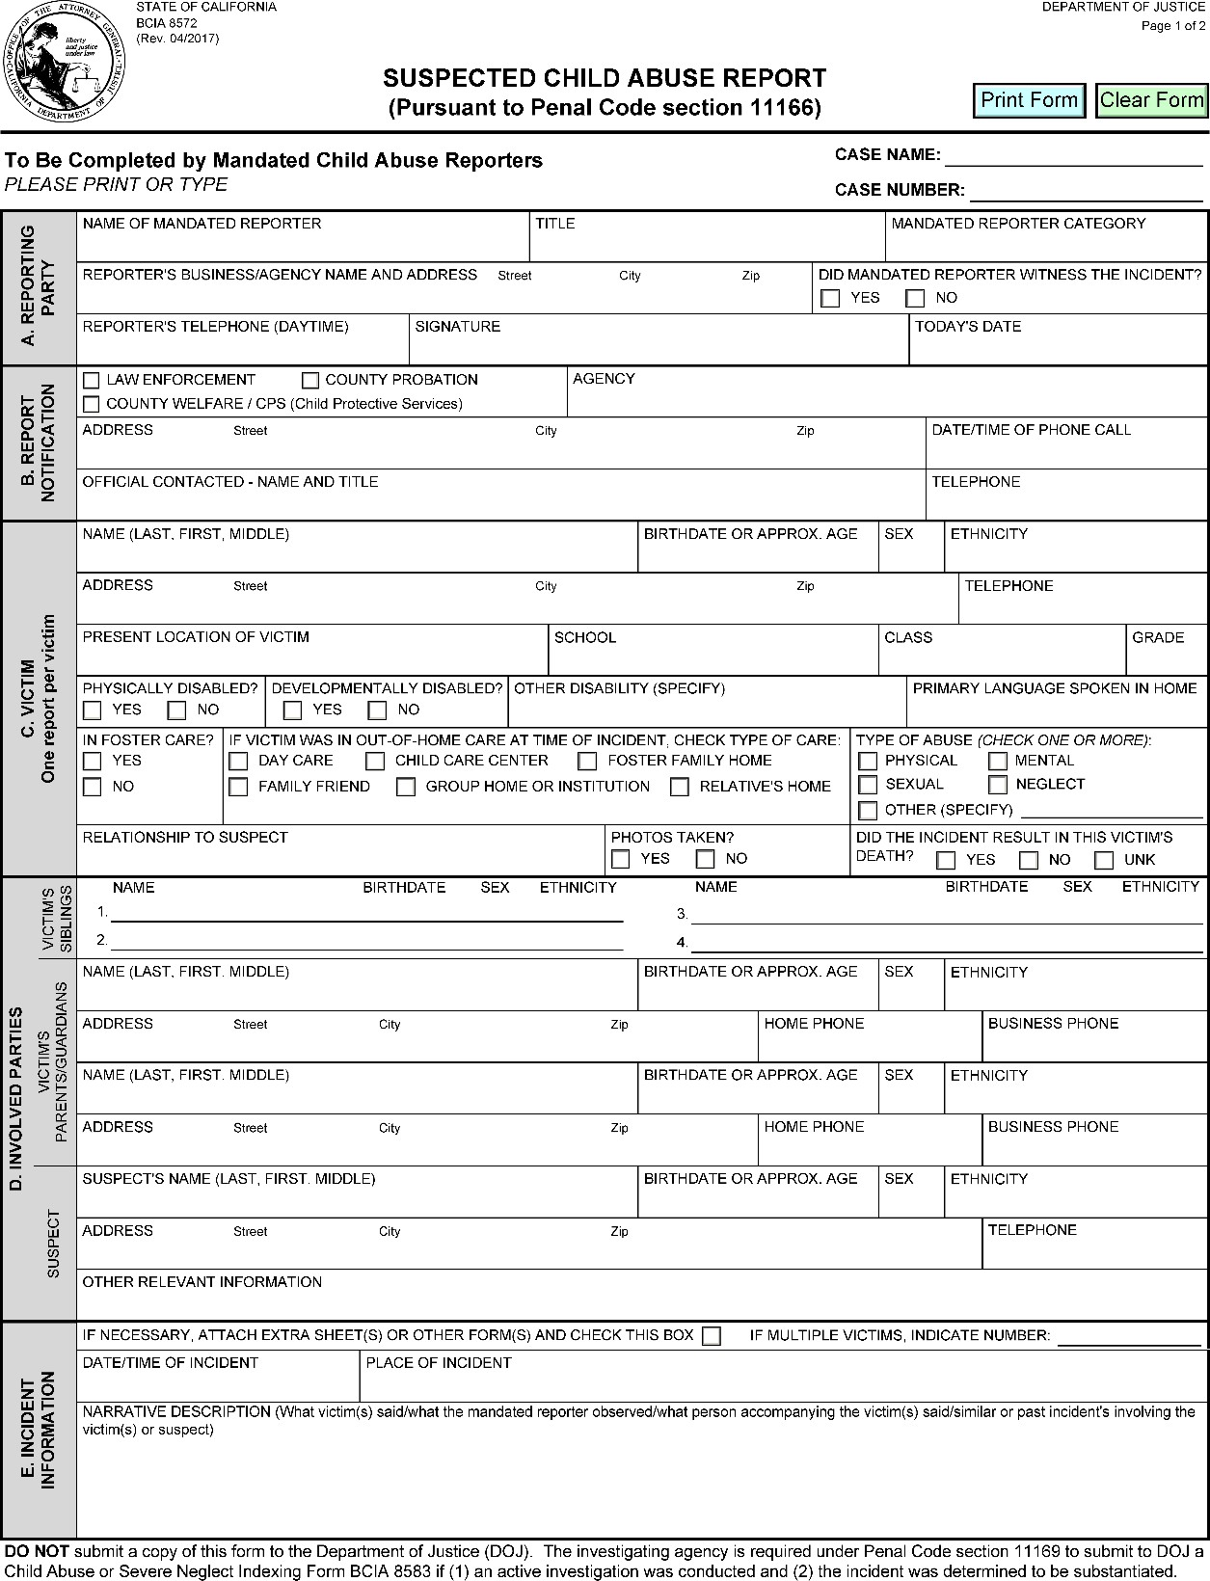

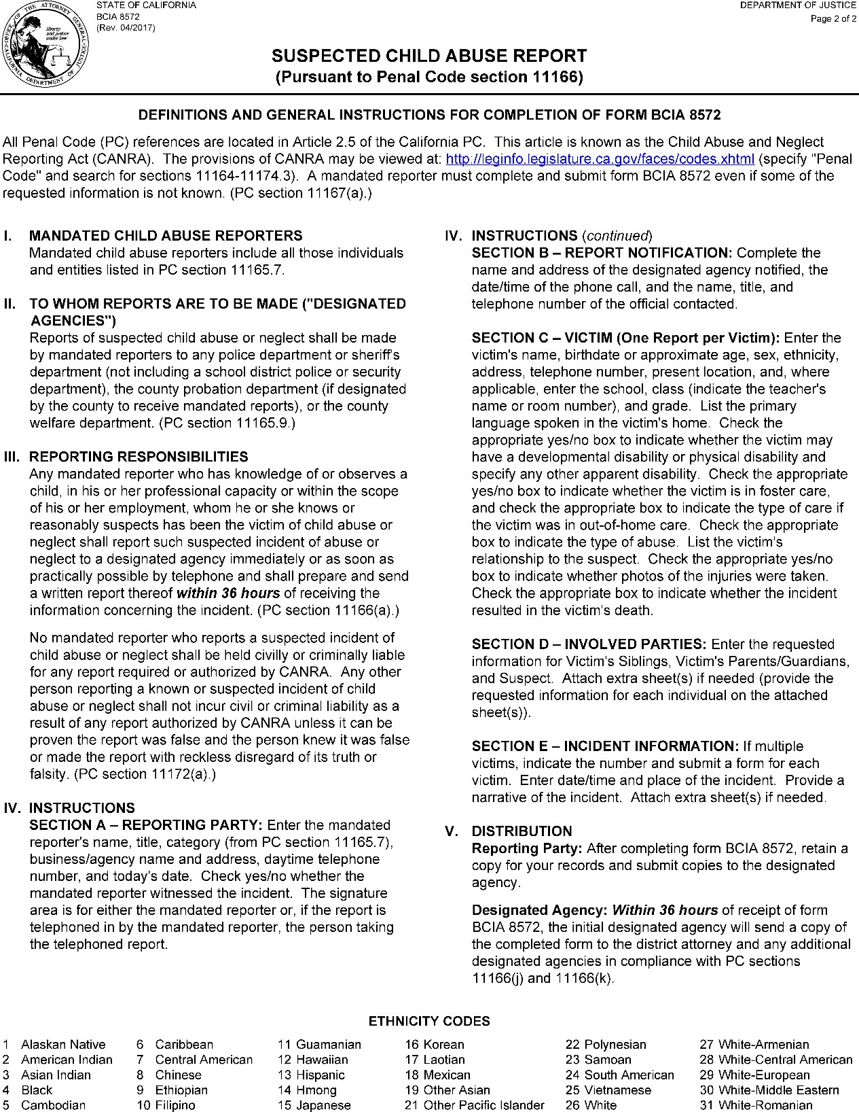

Suspension and Expulsion/Due Process – BP 5144.1

The Board of Trustees desires to provide district students access to educational opportunities in an orderly school environment that protects their safety and security, ensures their welfare and well-being, and promotes their learning and development. The Board shall develop rules and regulations setting the standards of behavior expected of district students and the disciplinary processes and procedures for addressing violations of those standards, including suspension and/or expulsion.

The grounds for suspension and expulsion and the procedures for considering, recommending, and/or implementing suspension and expulsion shall be only those specified in law, in this policy, and in the accompanying administrative regulation.

Except when otherwise permitted by law, a student may be suspended or expelled only when the behavior is related to a school activity or school attendance occurring within any district school or another school district, regardless of when it occurs, including, but not limited to, the following: (Education Code 48900(s))

1. While on school grounds
2. While going to or coming from school
3. During the lunch period, whether on or off the school campus
4. During, going to, or coming from a school-sponsored activity

District staff shall enforce the rules concerning suspension and expulsion of students fairly, consistently, equally, and in accordance with the district's nondiscrimination policies.

###### Appropriate Use of Suspension Authority

Except when a student's act violates Education Code 48900(a)-(e), as listed in Items #1-5 under "Grounds for Suspension and Expulsion: Grades K-12" of the accompanying administrative regulation, or when the student's presence causes a danger to others, suspension shall be used only when other means of correction have failed to bring about proper conduct. (Education Code 48900.5, 48900.6)

A student's parents/guardians shall be notified as soon as possible when there is an escalating pattern of misbehavior that could lead to on-campus or off-campus suspension.

No student may be suspended for disruption or willful defiance, except by a teacher pursuant to Education Code 48910. (Education Code 48900)

Students shall not be suspended or expelled for truancy, tardiness, or absenteeism from assigned school activities.

###### On-Campus Suspension

To ensure the proper supervision and ongoing learning of students who are suspended for any of the reasons enumerated in Education Code 48900 and 48900.2, but who pose no imminent danger or threat to anyone at school and for whom expulsion proceedings have not been initiated, the Superintendent/Principal or designee shall establish a supervised suspension classroom program which meets the requirements of law.

Except where a supervised suspension is permitted by law for a student's first offense, supervised suspension shall be imposed only when other means of correction have failed to bring about proper conduct. (Education Code 48900.5)

###### Authority to Expel

A student may be expelled only by the Board. (Education Code 48918(j))

As required by law, the Superintendent/Principal or principal shall recommend expulsion and the Board shall expel any student found to have committed any of the following "mandatory recommendation and mandatory expulsion" acts at school or at a school activity off school grounds: (Education Code 48915)

1. Possessing a firearm which is not an imitation firearm, as verified by a certificated employee, unless the student had obtained prior written permission to possess the item from a certificated school employee, with the principal or designee's concurrence
2. Selling or otherwise furnishing a firearm
3. Brandishing a knife at another person
4. Unlawfully selling a controlled substance listed in Health and Safety Code 11053-11058
5. Committing or attempting to commit a sexual assault as defined in Penal Code 261, 266c, 286, 287, 288, or 289, or former 288a, or committing a sexual battery as defined in Penal Code 243.4
6. Possessing an explosive as defined in 18 USC 921

For all other violations listed in the accompanying administrative regulation, the Superintendent/Principal or principal shall have the discretion to recommend expulsion of a student. If expulsion is recommended, the Board shall order the student expelled only if it makes a finding of either or both of the following: (Education Code 48915(b) and (e))

1. That other means of correction are not feasible or have repeatedly failed to bring about proper conduct
2. That due to the nature of the violation, the presence of the student causes a continuing danger to the physical safety of the student or others

A vote to expel a student shall be taken in an open session of a Board meeting.

The Board may vote to suspend the enforcement of the expulsion order pursuant to the requirements of law and the accompanying administrative regulation. (Education Code 48917)

No student shall be expelled for disruption or willful defiance. (Education Code 48900)

No child enrolled in a preschool program shall be expelled except under limited circumstances as specified in AR 5148.3 - Preschool/Early Childhood Education.

###### Due Process

The Board shall provide for the fair and equitable treatment of students facing suspension and/or expulsion by affording them their due process rights under the law. The Superintendent/Principal or designee shall comply with procedures for notices, hearings, and appeals as specified in law and administrative regulation. (Education Code 48911, 48915, 48915.5, 48918)

###### Maintenance and Monitoring of Outcome Data

The Superintendent/Principal or designee shall maintain outcome data related to student suspensions and expulsions in accordance with Education Code 48900.8 and 48916.1, including, but not limited to, the number of students recommended for expulsion, the grounds for each recommended expulsion, the actions taken by the Board, the types of referral made after each expulsion, and the disposition of the students after the expulsion period. For any expulsion that involves the possession of a firearm, such data shall include the name of the school and the type of firearm involved, as required pursuant to 20 USC 7961. Suspension and expulsion data shall be reported to the Board annually and to the California Department of Education when so required.

In presenting the report to the Board, the Superintendent/Principal or designee shall

disaggregate data on suspensions and expulsions by school and by numerically significant student subgroups, including, but not limited to, ethnic subgroups, socioeconomically disadvantaged students, English learners, students with disabilities, foster youth, and homeless students. Based on the data, the Board shall address any identified disparities in the imposition of student discipline and shall determine whether and how the district is meeting its goals for improving school climate as specified in its local control and accountability plan.

**Original Adopted Date:** 11/14/2023

**Last Reviewed Date:** 11/14/2023

.

Suspension and Expulsion/Due Process – AR 5144.1

###### Definitions

Suspension means removal of a student from ongoing instruction for adjustment purposes. However, suspension does not mean any of the following: (Education Code 48925)

Reassignment to another education program or class at the same school where the student will receive continuing instruction for the length of day prescribed by the Board of Trustees for students of the same grade level

Referral to a certificated employee designated by the principal to advise students

Removal from the class, but without reassignment to another class or program, for the remainder of the class period without sending the student to the principal or designee as provided in Education Code 48910, so long as removal from a particular class does not occur more than once every five school days.

*Expulsion* means removal of a student from the immediate supervision and control or the general supervision of school personnel. (Education Code 48925)

###### Notice of Regulations

At the beginning of each school year, the principal of each school shall ensure that all students and parents/guardians are notified in writing of all school rules related to discipline, including suspension and expulsion. (Education Code 35291, 48900.1, 48980)

###### Grounds for Suspension and Expulsion: Grades K-12

Acts for which a student, including a student with disabilities, may be suspended or expelled shall be only those specified as follows and in the sections "Additional Grounds for Suspension and Expulsion: Grades 4-12" and "Additional Grounds for Suspension and Expulsion: Grades 9- 12" below:

Caused, attempted to cause, or threatened to cause physical injury to another person; willfully used force or violence upon another person, except in self-defense; or committed as an aider or abettor, as adjudged by a juvenile court, a crime of physical violence in which the victim suffered great or serious bodily injury (Education Code 48900(a) and (t))

Possessed, sold, or otherwise furnished any firearm, knife, explosive, or other dangerous object, unless, in the case of possession of any object of this type, the student had obtained

written permission to possess the item from a certificated school employee, with the principal or designee's concurrence (Education Code 48900(b))

Unlawfully possessed, used, sold, otherwise furnished, or was under the influence of any controlled substance as defined in Health and Safety Code 11053-11059, alcoholic beverage, or intoxicant of any kind (Education Code 48900(c))

Unlawfully offered, arranged, or negotiated to sell any controlled substance as defined in Health and Safety Code 11053-11059, alcoholic beverage, or intoxicant of any kind, and then sold, delivered, or otherwise furnished to any person another liquid, substance, or material and represented the same as a controlled substance, alcoholic beverage, or intoxicant (Education Code 48900(d))

Committed or attempted to commit robbery or extortion (Education Code 48900(e))

Caused or attempted to cause damage to school property or private property (Education Code 48900(f))

Stole or attempted to steal school property or private property (Education Code 48900(g))

Possessed or used tobacco or products containing tobacco or nicotine products, including, but not limited to, cigars, cigarettes, miniature cigars, clove cigarettes, smokeless tobacco, snuff, chew packets, and betel, except that this restriction shall not prohibit a student from using or possessing prescription products (Education Code 48900(h))

Committed an obscene act or engaged in habitual profanity or vulgarity (Education Code 48900(i))

Unlawfully possessed, offered, arranged, or negotiated to sell any drug paraphernalia, as defined in Health and Safety Code 11014.5 (Education Code 48900(j))

Knowingly received stolen school property or private property (Education Code 48900(l)) Possessed an imitation firearm (Education Code 48900(m))

*Imitation firearm* means a replica of a firearm that is so substantially similar in physical properties to an existing firearm as to lead a reasonable person to conclude that the replica is a

firearm. (Education Code 48900(m))

Committed or attempted to commit a sexual assault as defined in Penal Code 261, 266c, 286, 287, 288, 289, or former 288a, or committed a sexual battery as defined in Penal Code

243.4 (Education Code 48900(n))

Harassed, threatened, or intimidated a student who is a complaining witness or witness in a school disciplinary proceeding for the purpose of preventing that student from being a witness and/or retaliating against that student for being a witness (Education Code 48900(o))

Unlawfully offered, arranged to sell, negotiated to sell, or sold the prescription drug Soma (Education Code 48900(p))

Engaged in, or attempted to engage in, hazing (Education Code 48900(q))

*Hazing* means a method of initiation or pre-initiation into a student organization or body, whether or not the organization or body is officially recognized by an educational institution, which is likely to cause serious bodily injury or personal degradation or disgrace resulting in physical or mental harm to a former, current, or prospective student. Hazing does not include athletic events or school-sanctioned events. (Education Code 48900(q))

Engaged in an act of bullying (Education Code 48900(r))

*Bullying* means any severe or pervasive physical or verbal act or conduct, including communications made in writing or by means of an electronic act, directed toward one or more students that has or can reasonably be predicted to have the effect of placing a reasonable student(s) in fear of harm to self or property; cause the student to experience a substantially detrimental effect on physical or mental health; or cause the student to experience substantial interferences with academic performance or ability to participate in or benefit from the services, activities, or privileges provided by a school. (Education Code 48900(r))

*Bullying* includes any act of sexual harassment, hate violence, or harassment, threat, or intimidation, as defined in Education Code 48900.2, 48900.3, or 48900.4 and below in the section "Additional Grounds for Suspension and Expulsion: Grades 4-12," that has any of the effects described above on a reasonable student.

*Bullying* also includes an act of cyber sexual bullying by a student through the dissemination of, or the solicitation or incitement to disseminate, a photograph or other visual recording that depicts a nude, semi-nude, or sexually explicit photograph or other visual recording of an identifiable minor, when such dissemination is to another student or to school personnel by

means of an electronic act and has or can be reasonably predicted to have one or more of the effects of bullying described above. Cyber sexual bullying does not include a depiction, portrayal, or image that has any serious literary, artistic, educational, political, or scientific value or that involves athletic events or school-sanctioned activities.

*Electronic act* means the creation or transmission originated on or off the school site by means of an electronic device, including, but not limited to, a telephone, wireless telephone, or other wireless communication device, computer, or pager, of a communication including, but not limited to: (Education Code 48900(r))

A message, text, sound, video, or image

A post on a social network Internet web site, including, but not limited to, posting to or creating a burn page or creating a credible impersonation or false profile for the purpose of causing a reasonable student any of the effects of bullying described above.

*Reasonable student* means a student, including, but not limited to, a student who has been identified as a student with a disability, who exercises average care, skill, and judgment in conduct for a person of the student's age, or for a person of the student's age and disability. (Education Code 48900(r))

*Burn page* means an internet web site created for the purpose of causing a reasonable student any of the effects of bullying described above. (Education Code 48900(r))

*Credible impersonation* means to knowingly and without consent impersonate a student for the purpose of bullying the student and such that the student would reasonably believe, or has reasonably believed, that the student was or is the student who was impersonated. (Education Code 48900(r))

*False profile* means a profile of a fictitious student or profile using the likeness or attributes of an actual student other than the student who created the false profile. (Education Code 48900(r))

An electronic act is not considered pervasive conduct solely on the basis that it has been transmitted to the internet or is currently posted on the internet. (Education Code 48900(r))

Aided or abetted the infliction or attempted infliction of physical injury on another person, as defined in Penal Code 31 (Education Code 48900(t))

Made terrorist threats against school officials and/or school property (Education Code 48900.7)

*A terrorist threat* includes any written or oral statement by a person who willfully threatens to commit a crime which will result in death or great bodily injury to another person or property damage in excess of $1,000, with the specific intent that the statement is to be taken as a threat, even if there is no intent of actually carrying out the crime. (Education Code 48900.7)

###### Additional Grounds for Suspension and Expulsion: Grades 4-12

A student in grades 4-12 shall be subject to suspension or recommendation for expulsion when it is determined that the student:

Committed sexual harassment as defined in Education Code 212.5 (Education Code 48900.2)

*Sexual harassment* means conduct which, when considered from the perspective of a reasonable person of the same gender as the victim, is sufficiently severe or pervasive as to have a negative impact upon the victim's academic performance or to create an intimidating, hostile, or offensive educational environment. (Education Code 212.5, 48900.2)

Caused, attempted to cause, threatened to cause, or participated in an act of hate violence as defined in Education Code 233 (Education Code 48900.3)

*Hate violence* means any act punishable under Penal Code 422.6, 422.7, or 422.75. Such acts include injuring or intimidating a victim, interfering with the exercise of a victim's civil rights, or damaging a victim's property because of the victim's race, ethnicity, religion, nationality, disability, gender, gender identity, gender expression, or sexual orientation; a perception of the presence of any of those characteristics in the victim; or the victim's association with a person or group with one or more of those actual or perceived characteristics. (Education Code 233; Penal Code 422.55)

Intentionally engaged in harassment, threats, or intimidation against district personnel or students that is sufficiently severe or pervasive to have the actual and reasonably expected effect of materially disrupting classwork, creating substantial disorder, and invading the rights of school personnel or students by creating an intimidating or hostile educational environment. (Education Code 48900.4)

###### Additional Grounds for Suspension and Expulsion: Grades 9-12

Any student in grades 9-12 may be suspended, but not expelled, for disrupting school activities or otherwise willfully defying the valid authority of supervisors, teachers, administrators, other school officials, or other school personnel engaged in the performance of their

duties. (Education Code 48900(k))

###### Suspension from Class by a Teacher

A teacher may suspend a student from class for the remainder of the day and the following day for any of the acts specified in Education Code 48900 and listed as Items #1-19 under "Grounds for Suspension and Expulsion: Grades K-12" above or for disruption or willful defiance at any grade level, including grades K-8. (Education Code 48910)

When suspending a student from class, the teacher shall immediately report this action to the principal or designee and send the student to the principal or designee for appropriate action. If that action requires the continuing presence of the student at school, the student shall be appropriately supervised during the class periods from which the student has been

suspended. (Education Code 48910)

As soon as possible after the teacher decides to suspend the student, the teacher shall ask the student's parent/guardian to attend a parent-teacher conference regarding the suspension. A counselor or psychologist may attend the conference if it is practicable, and a school administrator shall attend if either the parent/guardian or teacher so requests. (Education Code 48910)

A student suspended from class shall not be returned to class during the period of the suspension without the approval of the teacher of the class and the principal or designee. (Education Code 48910)

A student suspended from class shall not be placed in another regular class during the period of suspension. However, a student assigned to more than one class per day may continue to attend other regular classes except those held at the same time as the class from which the student was suspended. (Education Code 48910)

A teacher may also refer a student, for any of the acts specified above in Education Code 48900, to the principal or designee for consideration of a suspension from school. (Education Code 48910)

The teacher of any class from which a student is suspended may require the student to complete any assignments and tests missed during the removal. (Education Code 48913)

###### Suspension by Superintendent/Principal, Principal or Principal's Designee

To implement disciplinary procedures at a school site, the principal may, in writing, designate as the principal's designee another administrator or, if the principal is the only administrator at the school site, a certificated employee. As necessary, the principal may, in writing, also designate another administrator or certificated employee as the secondary designee to assist with disciplinary procedures when the principal and the principal's primary designee are absent from the school site.

The Superintendent/Principal, principal, or designee shall immediately suspend any student found at school or at a school activity away from school to have committed any of the acts listed in the Board policy under "Authority to Expel" for which a recommendation of expulsion is required. (Education Code 48915(c))

The Superintendent/Principal, principal, or designee may impose a suspension for a first offense if it is determined that the student violated any of Items #1-5 listed under "Grounds for Suspension and Expulsion: Grades K-12" above or if the student's presence causes a danger to persons. (Education Code 48900.5)

For all other offenses, a student may be suspended only when the Superintendent/Principal or principal has determined that other means of correction have failed to bring about proper conduct. (Education Code 48900.5)

When other means of correction are implemented prior to imposing suspension upon a student, including supervised suspension, the Superintendent/Principal, principal, or designee shall document the other means of correction used and retain the documentation in the student's record. (Education Code 48900.5)

###### Length of Suspension

The Superintendent/Principal, principal, or designee may suspend a student from school for not more than five consecutive school days. (Education Code 48911)

A student may be suspended from school for not more than 20 school days in any school year. However, if a student enrolls in or is transferred to another regular school, an opportunity school or class, or continuation school or class for the purpose of adjustment, the student may be suspended for not more than 30 school days in a school year. The district may count suspensions that occur while a student is enrolled in another school district toward the maximum number of days for which the student may be suspended in any school

year. (Education Code 48903, 48911, 48912)

These restrictions on the number of days of suspension shall not apply when the suspension is extended pending an expulsion. (Education Code 48911)

###### Due Process Procedures for Suspension

Suspensions shall be imposed in accordance with the following procedures:

Informal Conference: Suspension shall be preceded by an informal conference conducted by the Superintendent/Principal, principal, or designee with the student and, whenever practicable, the teacher, supervisor, or school employee who referred the student to the

principal. At the conference, the student shall be informed of the reason for the disciplinary action, including the other means of correction that were attempted before the suspension as required pursuant to Education Code 48900.5, and the evidence against the student, and shall be given the opportunity to present the student's version and evidence in the student's defense. (Education Code 48911)

This conference may be omitted if the Superintendent/Principal, principal, or designee determines that an emergency situation exists involving a clear and present danger to the lives, safety, or health of students or school personnel. If a student is suspended without this conference, the student, the student's parent/guardian, or if the student is a foster youth, the foster youth's educational rights holder, attorney, and county social worker, or if the student is an Indian child, the Indian child's tribal social worker and, if applicable, county social worker, shall be notified of the student's right to a conference and the right to return to school for the purpose of the conference. The conference shall be held within two school days, unless the student waives the right to it or is physically unable to attend for any reason. In such a case, the conference shall be held as soon as the student is physically able to return to school for the conference. (Education Code 48911)

Administrative Actions: All requests for student suspension are to be processed by the principal or designee. A school employee shall report the suspension, including the name of the student and the cause for the suspension, to the Superintendent/Principal or designee. (Education Code 48911)

Notice to Parents/Guardians: At the time of the suspension, a school employee shall make a reasonable effort to contact the parent/guardian, or if the student is a foster youth, the foster youth's educational rights holder, attorney, and county social worker, or if the student is an Indian child, the Indian child's tribal social worker, and, if applicable, the county social worker, in person, by email, or by telephone. Whenever a student is suspended, the parent/guardian, or, if applicable, the foster youth's educational rights holder, attorney, and county social worker, or the Indian child's tribal social worker and, if applicable, the county social worker, shall also be notified in writing of the suspension. (Education Code 48911)

This notice shall state the specific offense committed by the student. (Education Code 48900.8) In addition, the notice may state the date and time when the student may return to school.

Parent/Guardian Conference: Whenever a student is suspended, school officials may conduct a meeting with the parent/guardian to discuss the cause(s) and duration of the suspension, the school policy involved, and any other pertinent matter. (Education Code 48914)

If school officials request to meet with the parent/guardian, a foster youth's educational rights

holder, attorney, and county social worker, or an Indian child's tribal social worker, and, if applicable, the county social worker, the notice may state that the law requires such individuals to respond to the request without delay. However, the student shall not be penalized for the failure of the parent/guardian, a foster youth's educational rights holder, attorney, and county social worker, or an Indian child's tribal social worker, and, if applicable, the county social worker, to attend such a conference. The student may not be denied reinstatement solely because such individuals failed to attend the conference. (Education Code 48911)

Extension of Suspension: If the Board is considering the expulsion of a suspended student from any school or the suspension of a student for the balance of the semester from continuation school, the Superintendent/Principal or designee may, in writing, extend the suspension until such time as the Board has made a decision, provided the following requirements are followed: (Education Code 48911)

The extension of the original period of suspension is preceded by notice of such extension with an offer to hold a conference concerning the extension, giving the student an opportunity to be heard. This conference may be held in conjunction with a meeting requested by the student or parent/guardian to challenge the original suspension.

The Superintendent/Principal or designee determines, following a meeting in which the student and the student's parent/guardian were invited to participate, that the student's presence at the school or at an alternative school would endanger persons or property or threaten to disrupt the instructional process.

If the student involved is a foster youth or Indian child, the Superintendent/Principal or designee shall notify the district's educational liaison of the need to invite the foster youth's educational rights holder, attorney and county social worker, or the Indian child's tribal social worker or, if applicable, the county social worker, to attend the meeting. (Education Code 48853.5, 48911, 48918.1)

If the student involved is a homeless child or youth, the Superintendent/Principal or designee shall notify the district liaison for homeless students. (Education Code 48918.1)

In lieu of or in addition to suspending a student, the Superintendent/Principal, principal, or designee may provide services or require the student to participate in an alternative disciplinary program designed to correct the behavior and keep the student in school.

###### Suspension by the Board

The Board may suspend a student for any of the acts listed under "Grounds for Suspension and

Expulsion: Grades K-12," "Additional Grounds for Suspension and Expulsion: Grades 4-12," and "Additional Grounds for Suspension and Expulsion: Grades 9-12" above and within the limits specified under "Suspension by Superintendent/Principal, Principal, or Designee"

above. (Education Code 48912)

The Board may suspend a student enrolled in a continuation school or class for a period not longer than the remainder of the semester. The suspension shall meet the requirements of Education Code 48915. (Education Code 48912.5)

When the Board is considering a suspension, disciplinary action, or any other action (except expulsion) against any student, it shall hold a closed session if a public hearing would lead to disclosure of information that would violate a student's right to privacy under Education Code 49073-49079. (Education Code 35146, 48912)

The Board shall provide the student and parent/guardian with written notice of the closed session by registered or certified mail or personal service. Upon receiving this notice, the student or parent/guardian may request a public meeting, and this request shall be granted if made in writing within 48 hours after receipt of the Board's notice. However, any discussion that conflicts with any other student's right to privacy still shall be held in closed

session. (Education Code 35146, 48912)

###### On-Campus Suspension

A student for whom an expulsion action has not been initiated and who poses no imminent danger or threat to the school, students, or staff may be assigned to on-campus suspension in a separate classroom, building, or site for the entire period of suspension. The following conditions shall apply: (Education Code 48911.1)

The on-campus suspension classroom shall be staffed in accordance with law. The student shall have access to appropriate counseling services.

The on-campus suspension classroom shall promote completion of schoolwork and tests missed by the student during the suspension.

The student shall be responsible for contacting the student's teacher(s) to receive assignments to be completed in the supervised suspension classroom. The teacher(s) shall provide all assignments and tests that the student will miss while suspended. If no such work is assigned, the person supervising the suspension classroom shall assign schoolwork.

At the time a student is assigned to an on-campus suspension classroom, the principal or designee shall notify the student's parent/guardian, or if the student is a foster youth, the

foster youth's educational rights holder, attorney, and county social worker, or, if the student if an Indian child, the Indian child's tribal social worker and, if applicable, county social worker, in person, by email, or by telephone. When the assignment is for longer than one class period, this notification shall be made in writing. (Education Code 48911.1)

###### Superintendent/Principal or Principal's Authority to Recommend Expulsion

Unless the Superintendent/Principal or principal determines that expulsion should not be recommended under the circumstances or that an alternative means of correction would address the conduct, the Superintendent/Principal or principal shall recommend a student's expulsion for any of the following acts: (Education Code 48915)

Causing serious physical injury to another person, except in self-defense

Possession of any knife or other dangerous object of no reasonable use to the student

Unlawful possession of any controlled substance as listed in Health and Safety Code 11053- 11059, except for:

The first offense for the possession of not more than one ounce of marijuana, other than concentrated cannabis

The student's possession of over-the-counter medication for use by the student for medical purposes

Medication prescribed for the student by a physician Robbery or extortion

Assault or battery, as defined in Penal Code 240 and 242, upon any school employee

In determining whether to recommend the expulsion of a student, the Superintendent/Principal, principal, or designee shall act as quickly as possible to ensure that the student does not lose instructional time. (Education Code 48915)

###### Student's Right to Expulsion Hearing

Any student recommended for expulsion shall be entitled to a hearing to determine whether the student should be expelled. The hearing shall be held within 30 school days after the Superintendent/Principal, principal, or designee determines that the student has committed the act(s) that form the basis for the expulsion recommendation. (Education Code 48918(a))

The student is entitled to at least one postponement of an expulsion hearing for a period of not more than 30 calendar days. The request for postponement shall be in writing. Any subsequent postponement may be granted at the Board's discretion. (Education Code 48918(a))

If the Board finds it impractical during the regular school year to comply with these time requirements for conducting an expulsion hearing, the Superintendent/Principal or designee may, for good cause, extend the time period by an additional five school days. Reasons for the extension shall be included as a part of the record when the expulsion hearing is

held. (Education Code 48918(a))

If the Board finds it impractical to comply with the time requirements of the expulsion hearing due to a summer recess of Board meetings of more than two weeks, the days during the recess shall not be counted as school days. The days not counted during the recess may not exceed 20 school days, as defined in Education Code 48925. Unless the student requests in writing that the expulsion hearing be postponed, the hearing shall be held not later than 20 calendar days prior to the first day of the next school year. (Education Code 48918(a))

Once the hearing starts, all matters shall be pursued with reasonable diligence and concluded without unnecessary delay. (Education Code 48918(a))

###### Stipulated Expulsion

After a determination that a student has committed an offense for which the student may be expelled, the Superintendent/Principal, principal, or designee shall offer the student, the student's parent/guardian, or, when applicable, other person holding the right to make educational decisions for the student, the option to waive a hearing and stipulate to the expulsion or to a suspension of the expulsion under certain conditions. The offer shall be made only after written notice of the expulsion hearing pursuant to Education Code 48918 has been given.

The stipulation agreement shall be in writing and shall be signed by the student, the student's parent/guardian, or, when applicable, the person holding the right to make educational decisions for the student. The stipulation agreement shall include notice of all the rights that the student is waiving, including the waiving of the right to have a full hearing, to appeal the expulsion to the County Board of Education, and to consult legal counsel.

A stipulated expulsion agreed to by the student, the student's parent/guardian, or, when applicable, the person holding the right to make educational decisions for the student, shall be effective upon approval by the Board.

###### Rights of Complaining Witness

An expulsion hearing involving allegations of sexual assault or sexual battery may be postponed for one school day in order to accommodate the special physical, mental, or emotional needs of a student who is the complaining witness. (Education Code 48918.5)

Whenever the Superintendent/Principal or designee recommends an expulsion hearing that addresses allegations of sexual assault or sexual battery, the Superintendent/Principal or designee shall give the complaining witness a copy of the district's suspension and expulsion policy and regulation and shall advise the witness of the right to: (Education Code 48918.5)

Receive five days' notice of the scheduled testimony at the hearing

Have up to two adult support persons present at the hearing at the time the witness testifies

Have a closed hearing during the time the witness testifies

Whenever any allegation of sexual assault or sexual battery is made, the Superintendent/Principal or designee shall immediately advise complaining witnesses and accused students to refrain from personal or telephone contact with each other during the time when an expulsion process is pending. (Education Code 48918.5)

###### Written Notice of the Expulsion Hearing

Written notice of the expulsion hearing shall be forwarded to the student and the student's parent/guardian at least 10 calendar days before the date of the hearing. The notice shall include: (Education Code 48900.8, 48918(b))

The date and place of the hearing

A statement of the specific facts, charges, and offense upon which the proposed expulsion is based

A copy of district disciplinary rules which relate to the alleged violation

Notification of the student's or parent/guardian's obligation, pursuant to Education Code 48915.1, to provide information about the student's status in the district to any other district in which the student seeks enrollment

This obligation applies when a student is expelled for acts other than those described in Education Code 48915(a) or (c).

The opportunity for the student or the student's parent/guardian to appear in person or be represented by legal counsel or by a nonattorney adviser

Legal counsel means an attorney or lawyer who is admitted to the practice of law in California and is an active member of the State Bar of California.

Nonattorney adviser means an individual who is not an attorney or lawyer, but who is familiar with the facts of the case and has been selected by the student or student's parent/guardian to provide assistance at the hearing.

The right to inspect and obtain copies of all documents to be used at the hearing The opportunity to confront and question all witnesses who testify at the hearing

The opportunity to question all evidence presented and to present oral and documentary evidence on the student's behalf, including witnesses

###### Additional Notice of Expulsion Hearing for Foster Youth, Homeless Students, and Indian Children

If the student facing expulsion is a foster student or Indian child, the Superintendent/Principal or designee shall also send notice of the hearing to the foster youth's' educational rights holder, attorney, and county social worker, or the Indian child's tribal social worker and, if applicable, county social worker, at least 10 calendar days prior to the hearing. (Education Code 48918.1)

If the student facing expulsion is a homeless student, the Superintendent/Principal or designee shall also send notice of the hearing to the district liaison for homeless students at least 10 calendar days prior to the hearing. (Education Code 48918.1)

Any notice for these purposes may be provided by the most cost-effective method possible, including by email or a telephone call. (Education Code 48918.1)

###### Conduct of Expulsion Hearing

Closed Session: Notwithstanding Education Code 35145, the Board shall conduct a hearing to consider the expulsion of the student in a session closed to the public unless the student requests in writing at least five days prior to the hearing that the hearing be a public meeting. If such a request is made, the meeting shall be public to the extent that privacy rights of other students are not violated. (Education Code 48918)

Whether the expulsion hearing is held in closed or public session, the Board may meet in closed session to deliberate and determine whether the student should be expelled. If the Board

admits any other person to this closed session, the parent/guardian, the student, and the counsel of the student also shall be allowed to attend the closed session. (Education Code 48918(c))

If a hearing that involves a charge of sexual assault or sexual battery is to be conducted in public, a complaining witness shall have the right to testify in closed session when testifying in public would threaten serious psychological harm to the witness and when there are no alternative procedures to avoid the threatened harm, including, but not limited to, a videotaped deposition or contemporaneous examination in another place communicated to the hearing room by closed-circuit television. (Education Code 48918(c))

Record of Hearing: A record of the hearing shall be made and may be maintained by any means, including electronic recording, as long as a reasonably accurate and complete written transcription of the proceedings can be made. (Education Code 48918(g))

Subpoenas: Before commencing a student expulsion hearing, the Board may issue subpoenas, at the request of either the student or the Superintendent/Principal or designee, for the personal appearance at the hearing of any person who actually witnessed the action that gave rise to the recommendation for expulsion. After the hearing has commenced, the Board or the hearing officer or administrative panel may issue such subpoenas at the request of the student or the County Superintendent/Principal of Schools or designee. All subpoenas shall be issued in accordance with Code of Civil Procedure 1985-1985.2 and enforced in accordance with Government Code 11455.20. (Education Code 48918(i))

Any objection raised by the student or the Superintendent/Principal or designee to the issuance of subpoenas may be considered by the Board in closed session, or in open session if so requested by the student, before the meeting. The Board's decision in response to such an objection shall be final and binding. (Education Code 48918(i))

If the Board determines, or if the hearing officer or administrative panel finds and submits to the Board, that a witness would be subject to unreasonable risk of harm by testifying at the hearing, a subpoena shall not be issued to compel the personal attendance of that witness at the hearing. However, that witness may be compelled to testify by means of a sworn declaration as described in Item #6 below. (Education Code 48918(i))

Presentation of Evidence: Technical rules of evidence shall not apply to the expulsion hearing, but relevant evidence may be admitted and used as proof only if it is the kind of evidence on which reasonable persons can rely in the conduct of serious affairs. The decision of the Board to expel shall be supported by substantial evidence that the student committed any of the acts pursuant to Education Code 48900 and listed in "Grounds for Suspension and Expulsion: Grades K-12," "Additional Grounds for Suspension and Expulsion: Grades 4-12," and "Additional

Grounds for Suspension and Expulsion: Grades 9-12" above. (Education Code 48918(h))

Findings of fact shall be based solely on the evidence at the hearing. Although no finding shall be based solely on hearsay, sworn declarations may be admitted as testimony from witnesses whose disclosure of their identity or testimony at the hearing may subject them to an unreasonable risk of physical or psychological harm. (Education Code 48918(f))

In cases where a search of a student's person or property has occurred, evidence describing the reasonableness of the search shall be included in the hearing record.

Testimony by Complaining Witnesses: The following procedures shall be observed when a hearing involves allegations of sexual assault or sexual battery by a student: (Education Code 48918, 48918.5)

Any complaining witness shall be given five days' notice before being called to testify.

Any complaining witness shall be entitled to have up to two adult support persons, including, but not limited to, a parent/guardian or legal counsel, present during the testimony.

Before a complaining witness testifies, support persons shall be admonished that the hearing is confidential.

The person presiding over the hearing may remove a support person who is disrupting the hearing.

If one or both support persons are also witnesses, the hearing shall be conducted in accordance with Penal Code 868.5.

Evidence of specific instances of prior sexual conduct of a complaining witness shall be presumed inadmissible and shall not be heard unless the person conducting the hearing determines that extraordinary circumstances require the evidence to be heard. Before such a determination is made, the complaining witness shall be given notice and an opportunity to oppose the introduction of this evidence. In the hearing on the admissibility of this evidence, the complaining witness shall be entitled to be represented by a parent/guardian, legal counsel, or other support person. Reputation or opinion evidence regarding the sexual behavior of a complaining witness shall not be admissible for any purpose.

In order to facilitate a free and accurate statement of the experiences of the complaining witness and to prevent discouragement of complaints, the district shall provide a

nonthreatening environment.

The district shall provide a room separate from the hearing room for the use of the complaining witness before and during breaks in testimony.

At the discretion of the person conducting the hearing, the complaining witness shall be allowed reasonable periods of relief from examination and cross-examination during which the complaining witness may leave the hearing room.

The person conducting the hearing may:

Arrange the seating within the hearing room so as to facilitate a less intimidating environment for the complaining witness

Limit the time for taking the testimony of a complaining witness to normal school hours, if there is no good cause to take the testimony during other hours

Permit one of the support persons to accompany the complaining witness to the witness stand

Decision: The Board's decision as to whether to expel a student shall be made within 40 school days after the student is removed from school, unless the student requests in writing that the decision be postponed. (Education Code 48918(a))

###### Alternative Expulsion Hearing: Hearing Officer or Administrative Panel

Instead of conducting an expulsion hearing itself, the Board may contract with the county hearing officer or with the Office of Administrative Hearings of the State of California for a hearing officer. The Board may also appoint an impartial administrative panel composed of three or more certificated personnel, none of whom shall be members of the Board or on the staff of the school in which the student is enrolled. (Education Code 48918)

A hearing conducted by the hearing officer or administrative panel shall conform to the same procedures applicable to a hearing conducted by the Board as specified above in "Conduct of Expulsion Hearing," including the requirement to issue a decision within 40 school days of the student's removal from school, unless the student requests that the decision be

postponed. (Education Code 48918(a) and (d))

The hearing officer or administrative panel shall, within three school days after the hearing, determine whether to recommend expulsion of the student to the Board. If expulsion is not recommended, the expulsion proceeding shall be terminated and the student shall be

immediately reinstated and permitted to return to the classroom instructional program from which the referral was made, unless another placement is requested in writing by the student's parent/guardian. Before the student's placement decision is made by the student's parent/guardian, the Superintendent/Principal or designee shall consult with the parent/guardian and district staff, including the student's teachers, regarding other placement options for the student in addition to the option to return to the classroom instructional program from which the student's expulsion referral was made. The decision to not recommend expulsion shall be final. (Education Code 48918(e))

If expulsion is recommended, findings of fact in support of the recommendation shall be prepared and submitted to the Board. All findings of fact and recommendations shall be based solely on the evidence presented at the hearing. The Board may accept the recommendation based either upon a review of the findings of fact and recommendations submitted or upon the results of any supplementary hearing the Board may order. (Education Code 48918(f))

In accordance with Board policy, the hearing officer or administrative panel may recommend that the Board suspend the enforcement of the expulsion. If the hearing officer or administrative panel recommends that the Board expel a student but suspend the enforcement of the expulsion, the student shall not be reinstated and permitted to return to the classroom instructional program from which the referral was made until the Board has ruled on the recommendation. (Education Code 48917, 48918)

###### Final Action by the Board

Whether the expulsion hearing is conducted in closed or open session by the Board, a hearing officer, or an administrative panel or is waived through the signing of a stipulated expulsion agreement, the final action to expel shall be taken by the Board in public. (Education Code 48918(j))

The Board's decision is final. If the decision is to not expel, the student shall be reinstated immediately. If the decision is to suspend the enforcement of the expulsion, the student shall be reinstated under the conditions of the suspended expulsion.

Upon ordering an expulsion, the Board shall set a date when the student shall be reviewed for readmission to a school within the district. For a student expelled for any "mandatory recommendation and mandatory expulsion" act listed in the section "Authority to Expel" in the accompanying Board policy, this date shall be one year from the date the expulsion occurred, except that the Board may set an earlier date on a case-by-case basis. For a student expelled for other acts, this date shall be no later than the last day of the semester following the semester in which the expulsion occurred. If an expulsion is ordered during summer session or the intersession period of a year-round program, the Board shall set a date when the student shall be reviewed for readmission not later than the last day of the semester following the summer

session or intersession period in which the expulsion occurred. (Education Code 48916)

At the time of the expulsion order, the Board shall recommend a plan for the student's rehabilitation, which may include: (Education Code 48916)

Periodic review, as well as assessment at the time of review, for readmission

Recommendations for improved academic performance, tutoring, special education assessments, job training, counseling, employment, community service, or other rehabilitative programs

With parent/guardian consent, students who have been expelled for reasons relating to controlled substances or alcohol may be required to enroll in a county-sponsored drug rehabilitation program before returning to school. (Education Code 48916.5)

###### Written Notice to Expel

The Superintendent/Principal or designee shall send written notice of the decision to expel to the student or parent/guardian. This notice shall include the following:

The specific offense committed by the student for any of the causes for suspension or expulsion listed above under "Grounds for Suspension and Expulsion: Grades K-12," "Additional Grounds for Suspension and Expulsion: Grades 4-12," or "Additional Grounds for Suspension and Expulsion: Grades 9-12" (Education Code 48900.8)

The fact that a description of readmission procedures will be made available to the student and parent/guardian (Education Code 48916)

Notice of the right to appeal the expulsion to the County Board (Education Code 48918)

Notice of the alternative educational placement to be provided to the student during the time of expulsion (Education Code 48918)

Notice of the student's or parent/guardian's obligation to inform any new district in which the student seeks to enroll of the student's status with the expelling district, pursuant to Education Code 48915.1 (Education Code 48918)

###### Decision to Suspend Expulsion Order

In accordance with Board policy, when deciding whether to suspend the enforcement of an expulsion order, the Board shall take into account the following criteria:

The student's pattern of behavior The seriousness of the misconduct

The student's attitude toward the misconduct and willingness to follow a rehabilitation program

The suspension of the enforcement of an expulsion shall be governed by the following:

The Board may, as a condition of the suspension of enforcement, assign the student to a school, class, or program appropriate for the student's rehabilitation. This rehabilitation program may provide for the involvement of the student's parent/guardian in the student's education. However, a parent/guardian's refusal to participate in the rehabilitation program shall not be considered in the Board's determination as to whether the student has satisfactorily completed the rehabilitation program. (Education Code 48917)

During the period when enforcement of the expulsion order is suspended, the student shall be on probationary status. (Education Code 48917)

The suspension of the enforcement of an expulsion order may be revoked by the Board if the student commits any of the acts listed under "Grounds for Suspension and Expulsion: Grades K- 12," "Additional Grounds for Suspension and Expulsion: Grades 4-12," or "Additional Grounds for Suspension and Expulsion: Grades 9-12" above or violates any of the district's rules and regulations governing student conduct. (Education Code 48917)

When the suspension of enforcement of an expulsion order is revoked, a student may be expelled under the terms of the original expulsion order. (Education Code 48917)

Upon satisfactory completion of the rehabilitation assignment, the Board shall reinstate the student in a district school. Upon reinstatement, the Board may order the expunging of any or all records of the expulsion proceedings. (Education Code 48917)

The Superintendent/Principal or designee shall send written notice of any decision to suspend the enforcement of an expulsion order during a period of probation to the student or parent/guardian. The notice shall inform the parent/guardian of the right to appeal the expulsion to the County Board, the alternative educational placement to be provided to the student during the period of expulsion, and the student's or parent/guardian's obligation to inform any new district in which the student seeks to enroll of the student's status with the expelling district, pursuant to Education Code 48915.1(b). (Education Code 48918(j))

Suspension of the enforcement of an expulsion order shall not affect the time period and requirements for the filing of an appeal of the expulsion order with the County Board. (Education Code 48917)

###### Appeal

If a student is expelled from school, the student or parent/guardian is entitled to file an appeal of the Board's decision with the County Board. The appeal must be filed within 30 days of the Board's decision to expel, even if the expulsion order is suspended and the student is placed on probation. (Education Code 48919)

If the student submits a written request for a copy of the written transcripts and supporting documents from the district simultaneously with the filing of the notice of appeal with the County Board, the district shall provide the student with these documents within 10 school days following the student's written request. (Education Code 48919)

###### Notification to Law Enforcement Authorities

Prior to the suspension or expulsion of any student, the principal or designee shall notify appropriate city or county law enforcement authorities of any student acts of assault which may have violated Penal Code 245. (Education Code 48902)

The principal or designee shall notify appropriate city or county law enforcement authorities of any student acts which may involve the possession or sale of narcotics or of a controlled substance, or of any student acts involving the possession, sale, or furnishing of firearms, explosives, or other dangerous weapons in violation of Education Code 48915(c)(1) or (5) or Penal Code 626.9 and 626.10. (Education Code 48902)

Within one school day after a student's suspension or expulsion, the principal or designee shall notify appropriate county or district law enforcement authorities, by telephone or other appropriate means, of any student acts which may violate Education Code 48900(c) or (d), relating to the possession, use, offering, or sale of controlled substances, alcohol, or intoxicants of any kind. (Education Code 48902)

###### Placement During Expulsion

The Board shall refer expelled students to a program of study that is: (Education Code 48915, 48915.01)

Appropriately prepared to accommodate students who exhibit discipline problems

Not provided at a comprehensive middle, junior, or senior high school or at any elementary school, unless the program is offered at a community day school established at any of these

Not housed at the school site attended by the student at the time of suspension When the placement described above is not available and when the County

Superintendent/Principal so certifies, students expelled for only acts described in Items #6-12 under "Grounds for Suspension and Expulsion: Grades K-12" and Items #1-3 under "Additional Grounds for Suspension and Expulsion: Grades 4-12" above may be referred to a program of study that is provided at another comprehensive middle, junior, or senior high school or at an elementary school. (Education Code 48915)

The program for a student expelled from any of grades K-6 shall not be combined or merged with programs offered to students in any of grades 7-12. (Education Code 48916.1)

###### Readmission After Expulsion

Prior to the date set by the Board for the student's readmission:

The Superintendent/Principal or designee shall hold a conference with the student's parent/guardian, or other person holding the right to make educational decisions for the student, and the student. At the conference, the student's rehabilitation plan shall be reviewed and the Superintendent/Principal or designee shall verify that the provisions of this plan have been met. School regulations shall be reviewed and the student and the student's parent/guardian or other person holding the right to make educational decisions for the student shall be asked to indicate in writing their willingness to comply with these regulations.

The Superintendent/Principal or designee shall transmit to the Board a recommendation regarding readmission. The Board shall consider this recommendation in closed session. If a written request for open session is received from the student's parent/guardian or other person holding the right to make educational decisions for the student, or adult student, it shall be honored to the extent that privacy rights of other students are not violated.

If the readmission is granted, the Superintendent/Principal or designee shall notify the student and the student's parent/guardian, or other person holding the right to make educational decisions for the student, by registered mail, of the Board's decision regarding readmission.

The Board may deny readmission only if it finds that the student has not satisfied the conditions of the rehabilitation plan or that the student continues to pose a danger to campus safety or to other district students or employees. (Education Code 48916)

If the Board denies the readmission of a student, the Board shall determine either to continue the student's placement in the alternative educational program initially selected or to place the student in another program that serves expelled students, including placement in a county community school.

The Board shall provide written notice to the expelled student and the

student's parent/guardian, or other person holding the right to make educational decisions for the student, describing the reasons for denying readmittance into the regular program. This notice shall indicate the Board's determination of the educational program which the Board has chosen. The student shall enroll in that program unless the parent/guardian chooses to enroll the student in another school district.

No student shall be denied readmission into the district based solely on the student's arrest, adjudication by a juvenile court, formal or informal supervision by a probation officer, detention in a juvenile facility, enrollment in a juvenile court school, or other such contact with the juvenile justice system. (Education Code 48645.5)

###### Maintenance of Records

The district shall maintain a record of each suspension and expulsion, including its specific cause(s). (Education Code 48900.8)

Expulsion records of any student shall be maintained in the student's mandatory interim record and sent to any school in which the student subsequently enrolls upon written request by that school. (Education Code 48918(k))

The Superintendent/Principal or designee shall, within five working days, honor any other district's request for information about an expulsion from this district. (Education Code 48915.1)

**Original Adopted Date:** 11/14/2023 Last Reviewed Date: 11/14/2023

Suspension And Expulsion/Due Process (Students With Disabilities)– AR 5144.2

A student identified as an individual with a disability pursuant to the Individuals with Disabilities Education Act (IDEA), 20 USC 1400-1482, is subject to the same grounds and procedures for suspension and expulsion which apply to students without disabilities, except as otherwise specified in this administrative regulation.

Suspension or expulsion of a student with disabilities shall be in accordance with Board Policy 5144.1 - Suspension and Expulsion/Due Process and this administrative regulation.

When a student with disabilities exhibits behavior which impedes the student's own learning or that of others, the student's individualized education program (IEP) team shall consider positive behavioral interventions and supports, and other strategies, to address the

behavior. (Education Code 56521.2; 20 USC 1414)

###### Suspension

The Superintendent/Principal or designee may suspend a student with a disability for up to 10 consecutive school days for a single incident of misconduct, and for up to 20 cumulative school days in a school year as long as the pattern of suspension(s) does not constitute a change in placement pursuant to 34 CFR 300.536. (Education Code 48903; 34 CFR 300.530)

The Superintendent/Principal or designee shall determine, on a case-by-case basis, whether a pattern of removals of a student from the student's current educational placement for disciplinary reasons constitutes a change of placement. A change of placement shall be deemed to have occurred under either of the following circumstances: (34 CFR 300.536)

1. The removal is for more than 10 consecutive school days
2. The student has been subjected to a series of removals that constitute a pattern because of all of the following:
   1. The series of removals total more than 10 school days in a school year
   2. The student's behavior is substantially similar to the student's behavior in previous incidents that resulted in the series of removals
   3. Additional factors, such as the length of each removal, the total amount of time the student has been removed, and the proximity of the removals to one another

If a student's removal is determined to be a change of placement as specified in Items #1-2 above, the student's IEP team shall determine the appropriate educational services. Such services shall be designed to enable the student to continue to participate in the general education curriculum in another setting, to progress toward meeting the goals set out in the student's IEP, and to address the student's behavior violation so that it does not recur. (20 USC 1412(a)(1)(A); 34 CFR 300.530)

If the IEP of a student with a disability requires the district to provide the student with transportation, the district shall provide the student with an alternative form of transportation at no cost to the student or the student's parent/guardian when, as a result of a suspension, the student is excluded from school bus transportation. (Education Code 48915.5)

###### Interim Alternative Educational Placement Due to Dangerous Behavior

The district may unilaterally place a student with a disability in an appropriate interim alternative educational setting for up to 45 school days, without regard to whether the behavior is a manifestation of the student's disability, when the student commits one of the following acts while at school, going to or from school, or at a school-related function: (20 USC 1415(k)(1)(G); 34 CFR 300.530)

1. Carries or possesses a weapon, as defined in 18 USC 930
2. Knowingly possesses or uses illegal drugs
3. Sells or solicits the sale of a controlled substance as identified in 21 USC 812(c), Schedules I-V
4. Inflicts serious bodily injury upon another person as defined in 18 USC 1365

The student's interim alternative educational setting shall be determined by the student's IEP team. (20 USC 1415(k)(1)(G); 34 CFR 300.531)

On the date the decision to take disciplinary action is made, the student's parent/guardian shall be notified of the decision and provided the procedural safeguards notice pursuant to 34 CFR

300.504. (20 USC 1415(k)(1)(H); 34 CFR 300.530)

A student who has been removed from the student's current placement because of dangerous behavior shall receive services, although in another setting, to the extent necessary to allow the student to participate in the general education curriculum and to progress toward meeting the

goals set out in the IEP. As appropriate, the student shall also receive a functional behavioral assessment and behavioral intervention services and modifications that are designed to address the behavior violation so that it does not recur. (20 USC 1415(k)(1)(D); 34 CFR 300.530)

###### Manifestation Determination

The following procedural safeguards shall apply when a student with a disability is suspended for more than 10 consecutive school days, when a series of removals of a student constitutes a pattern, or when a change of placement of a student is contemplated due to a violation of the district's code of conduct:

1. Notice: On the date the decision to take disciplinary action is made, the student's parent/guardian shall be notified of the decision and provided the procedural safeguards notice pursuant to 34 CFR 300.504. If the student is a foster youth, the notice shall be given to the student's educational rights holder, attorney, and county social worker, and, if the student is an Indian child, the student's tribal social worker and, if applicable, county social worker. (Education Code 48853.5; 20 USC 1415(k)(1)(H); 34 CFR 300.530)
2. Manifestation Determination Review: Immediately if possible, but in no case later than 10 school days after the date the decision to take disciplinary action is made, a manifestation determination review shall be made of the relationship between the student's disability and the behavior subject to the disciplinary action. (20 USC 1415(k)(1)(E); 34 CFR 300.530)

If the student is a foster youth or Indian child, the foster youth's educational rights holder, attorney, or county social worker, or the Indian child's tribal social worker and, if applicable, county social worker, shall be invited to participate in the manifestation determination review. (Education Code 48915.5)

At the manifestation determination review, the district, the student's parent/guardian, and relevant members of the IEP team (as determined by the district and parent/guardian) shall review all relevant information in the student's file, including the student's IEP, any teacher observations, and any relevant information provided by the parents/guardians, to determine whether the conduct in question was either of the following: (20 USC 1415(k)(1)(E); 34 CFR 300.530)

* 1. Caused by or had a direct and substantial relationship to the student's disability
  2. A direct result of the district's failure to implement the student's IEP, in which case the district shall take immediate steps to remedy those deficiencies

If the manifestation review team determines that either of the above conditions applies, the student's conduct shall then be determined to be a manifestation of the student's disability. (20 USC 1415(k)(1)(E); 34 CFR 300.530)

1. Determination that Behavior is a Manifestation of the Student's Disability: When the student's conduct has been determined to be a manifestation of the student's disability, the IEP team shall conduct a functional behavioral assessment, unless one had been conducted before the occurrence of the behavior that resulted in the change of placement, and shall implement a behavioral intervention plan for the student. If a behavioral intervention plan has already been developed, the IEP team shall review the behavioral intervention plan and modify it as necessary to address the behavior. (20 USC 1415(k)(1)(F); 34 CFR 300.530)

The student shall be returned to the placement from which the student was removed, unless the parent/guardian and Superintendent/Principal or designee agree to a change of placement as part of the modification of the behavioral intervention plan. (20 USC 1415(k)(1)(F); 34 CFR 300.530)

1. Determination that Behavior is Not a Manifestation of the Student's Disability: When it has been determined that the student's conduct was not a manifestation of the disability, the student may be disciplined in accordance with the procedures for students without disabilities. However, the student's IEP team shall determine services necessary to enable the student to participate in the general education curriculum in another setting and to allow the student to progress toward meeting the goals set out in the IEP. (20 USC 1415(k)(1)(D); 34 CFR 300.530)

As appropriate, the student also shall receive a functional behavioral assessment and behavioral intervention services and modifications that are designed to address the behavior violation so that it does not recur. (20 USC 1415(k)(1)(D); 34 CFR 300.530)

###### Due Process Appeals

If the parent/guardian disagrees with any district decision regarding placement under 34 CFR

300.530 (suspension and removal for dangerous circumstances), 34 CFR 300.531 (interim alternative placement), or the manifestation determination under 34 CFR 300.530(e), the parent/guardian may appeal the decision by requesting a hearing. The district may request a hearing if the district believes that maintaining the student's current placement is substantially likely to result in injury to the student or others. In order to request a due process hearing, the requesting party shall file a complaint pursuant to 34 CFR 300.507 and 300.508(a) and (b). (20 USC 1415(k)(3); 34 CFR 300.532)

Whenever a hearing is requested as specified above, the parent/guardian or the district shall

have an opportunity for an expedited due process hearing consistent with requirements specified in 34 CFR 300.507, 300.508 (a)-(c), and 300.510-300.514.

If the student's parent/guardian or the district has initiated a due process hearing under 34 CFR

300.532 as detailed above, the student shall remain in the interim alternative educational setting pending the decision of the hearing officer or until the expiration of the 45-day time period, whichever occurs first, unless the parent/guardian and district agree otherwise. (20 USC 1415(k)(4); 34 CFR 300.533)

###### Readmission

Readmission procedures for students with disabilities shall be the same as those adopted for students without disabilities. Upon readmission of a student with disabilities, an IEP team meeting shall be convened to review and, as necessary, modify the student's IEP.

###### Decision Not to Enforce Expulsion Order

The Board of Trustees' criteria for suspending the enforcement of an expulsion order shall be applied to students with disabilities in the same manner as they are applied to all other students. (Education Code 48917)

###### Notification to Law Enforcement Authorities

Law enforcement notification requirements involving students with disabilities shall be the same as those specified for all students in AR 5144.1 - Suspension and Expulsion/Due Process.

When giving any required notification concerning a student with disabilities to any law enforcement official, the principal or designee shall require the law enforcement official to certify in writing that the student's information or records will not be disclosed to any other person without the prior written consent of the student's parent/guardian. (Education Code 49076)

###### Report to County Superintendent/Principal of Schools

The Superintendent/Principal or designee shall report to the County Superintendent/Principal of Schools when any special education student has been expelled or suspended for more than 10 school days. The report shall include the student's name, last known address, and the reason for the action. (Education Code 48203)

###### Procedures for Students Not Yet Eligible for Special Education Services

A student who has not been determined to be eligible for special education and related services

and who has violated the district's code of student conduct may nevertheless assert any of the protections under IDEA, if the district had knowledge of the student's disability. (20 USC 1415(k)(5); 34 CFR 300.534)

*Knowledge* means that, before the occurrence of the behavior that precipitated the disciplinary action, one of the following occurred: (20 USC 1415(k)(5); 34 CFR 300.534)

1. The parent/guardian, in writing, has expressed concern to district supervisory or administrative personnel, or to a teacher of the student, that the student is in need of special education or related services
2. The parent/guardian has requested an evaluation of the student for special education pursuant to 20 USC 1414(a)(1)(B) or 34 CFR 300.300-300.311
3. The teacher of the student or other district personnel has expressed specific concerns directly to the district's director of special education or other supervisory district personnel about a pattern of behavior demonstrated by the student

However, the district shall not be deemed to have knowledge of a student's disability if the student's parent/guardian has not allowed the student to be evaluated for special education services or has refused services or, after evaluating the student pursuant to 34 CFR 300.300- 300.311, the district determined that the student was not an individual with a disability. (20 USC 1415(k)(5); 34 CFR 300.534)

When the district is deemed to not have knowledge of a student's disability, the student shall be disciplined in accordance with procedures established for students without disabilities who engage in comparable behavior. (20 USC 1415(k)(5); 34 CFR 300.534)

If a request is made for an evaluation of a student during the time period in which the student is subject to disciplinary measures pursuant to 34 CFR 300.530, the evaluation shall be conducted in an expedited manner. Until the evaluation is completed, the student shall remain in the educational placement determined by school authorities. (20 USC 1415(k)(5); 34 CFR 300.534)

**Original Adopted Date:** 11/14/2023 Last Reviewed Date**:** 11/14/2023

Employee Security – BP 4158

The Board of Trustees desires to provide a safe and orderly work environment for all employees. As part of the district's comprehensive safety plan, the Superintendent/Principal or designee shall develop strategies for protecting employees from potentially dangerous persons and situations and for providing necessary assistance and support when emergency situations occur.

Any person who threatens the safety of others at any district facility may be removed by the Superintendent/Principal or designee in accordance with AR 3515.2 - Disruptions.

Any employee against whom violence or any threat of violence has been directed in the workplace shall notify the Superintendent/Principal or designee immediately. As appropriate, the Superintendent/Principal or designee shall initiate legal and security measures to protect the employee and others in the workplace. Such measures may include seeking a temporary restraining order on behalf of the employee pursuant to Code of Civil Procedure 527.8 and/or a gun violence restraining order pursuant to Penal Code 18150 and 18170.

Upon request by an employee who is a victim of domestic violence, sexual assault, or stalking, the Superintendent/Principal or designee shall provide reasonable accommodations in accordance with Labor Code 230-230.1 and the accompanying administrative regulation to protect the employee's safety while at work.

The Superintendent/Principal or designee may pursue legal action on behalf of an employee against a student or the student's parent/guardian to recover damages for injury to the employee's person or property caused by the student's willful misconduct that occurred on district property, at a school or district activity, or in retaliation for lawful acts of the employee in the performance of the employee's duties. (Education Code 48904, 48905)

The Superintendent/Principal or designee shall provide staff development in crisis prevention and intervention techniques, which may include training in classroom management, effective communication techniques, procedures for responding to an active shooter situation, and crisis resolution.

In accordance with law, the Superintendent/Principal or designee shall inform teachers, administrators, and/or counselors of crimes and offenses committed by students who may pose a danger in the classroom. (Education Code 48201, 49079; Welfare and Institutions Code 827)

The Superintendent/Principal or designee may make available at appropriate locations, including, but not limited to, district and school offices, gyms, and classrooms, communication devices that would enable two-way communication with law enforcement and others when emergencies occur.

**Use of Pepper Spray**

Employees shall not carry or possess pepper spray on school property or at school activities except when authorized by the Superintendent/Principal or designee for self-defense purposes. When allowed, an employee may only possess pepper spray in accordance with administrative regulations and Penal Code 22810. Any employee who is negligent or careless in the possession or handling of pepper spray shall be subject to appropriate disciplinary measures.

**Reporting of Injurious Objects**

Employees shall take immediate action upon being made aware that any person is in possession of a weapon or unauthorized injurious object on school grounds or at a school- related or school-sponsored activity. Employees shall exercise their best judgment as to the potential danger involved and shall do one of the following:

1. Confiscate the object and deliver it to the principal immediately
2. Immediately notify the principal, who shall take appropriate action
3. Immediately call 911 and the principal

When informing the principal about the possession or seizure of a weapon or dangerous device, an employee shall report the name(s) of persons involved, witnesses, location, and the circumstances of any seizure.

**Original Adopted Date:** 11/14/2023 Last Reviewed Date: 11/14/2023

Employee Security – AR 4158

An employee may use reasonable and necessary force for self-defense or defense of another person, to quell a disturbance threatening physical injury to others or damage to property, or to obtain possession of weapons or other dangerous objects within the control of a

student. (Education Code 44807, 49001)

An employee shall promptly report to the principal or other immediate supervisor any attack, assault, or physical threat made against the employee by a student or by any other individual in relation to the performance of the employee's duties, and any action the employee took in response. Reports of an attack, assault, or threat shall be forwarded immediately to the Superintendent/Principal or designee.

In addition, the employee and the principal or other immediate supervisor shall promptly report to local law enforcement authorities an attack, assault, or physical threat made against the employee by a student. (Education Code 44014)

###### Notice Regarding Student Offenses

When a student commits certain offenses that may endanger staff or others, the following procedures shall be implemented to notify staff members as appropriate:

1. Acts That Are Grounds for Suspension or Expulsion
   1. The Superintendent/Principal or designee shall inform the teacher(s) of each student who, during the previous three school years, has engaged in or is reasonably suspected to have engaged in any act, except the possession or use of tobacco products, that would constitute a ground for suspension or expulsion as specified in AR 5144.1 - Suspension and Expulsion/Due Process. This information shall be based upon district records maintained in the ordinary course of business or records received from a law enforcement

agency. (Education Code 49079)

* 1. Upon receiving a transfer student's record regarding acts committed by the student that resulted in suspension or expulsion, the Superintendent/Principal or designee shall inform the student's teacher(s) that the student was suspended from school or expelled from the former district and of the act that resulted in the suspension or expulsion. (Education Code 48201)

Information received by teacher(s) shall be received in confidence for the limited purpose for which it was provided and shall not be further disseminated by the teacher. (Education Code 48201, 49079)

1. Offenses Reported to the District by a Court
   1. When informed by a court that a minor student has been found by the court to have committed any felony or any misdemeanor involving curfew, gambling, alcohol, drugs, tobacco products, carrying of weapons, a sex offense listed in Penal Code 290, assault or battery, larceny, vandalism, or graffiti, the Superintendent/Principal or designee shall expeditiously notify the school principal. (Welfare and Institutions Code 827)
   2. The principal shall expeditiously disseminate this information to any counselor who directly supervises or reports on the student's behavior or progress and to any teacher or administrator directly supervising or reporting on the student's behavior or progress whom the principal thinks may need the information in order to work with the student appropriately, avoid being needlessly vulnerable, or protect others from vulnerability. (Welfare and Institutions Code 827)
   3. Any court-initiated information that a teacher, counselor, or administrator receives shall be kept confidential and used only to rehabilitate the student and protect other students and staff. The information shall be further disseminated only when communication with the student, parent/guardian, law enforcement staff, and probation officer is necessary to rehabilitate the student or to protect students and staff. (Welfare and Institutions Code 827)
   4. When a student is removed from school as a result of an offense, the Superintendent/Principal shall hold the court's information in a separate confidential file until the student is returned to the district. If the student is returned to a different district, the Superintendent/Principal shall transmit the information provided by the student's parole or probation officer to the Superintendent/Principal of the new district of attendance. (Welfare and Institutions Code 827)
   5. Any confidential file of court-initiated information shall be kept until the student becomes 18, graduates from high school, or is released from juvenile court jurisdiction, whichever occurs first, and shall then be destroyed. (Welfare and Institutions Code 827)

In order to maintain confidentiality when providing information about student offenses to a counselor or teacher, the principal or designee shall send the staff member a written

notification that a student has committed an offense that requires review of a student's file in the school office. This notice shall not name or otherwise identify the student. The staff member shall initial the notification and shall also initial the student's file when reviewing it in the school office.

###### Accommodations for Victims of Domestic Violence, Sexual Assault, or Stalking

When requested by an employee who is a victim of domestic violence, sexual assault, or stalking, the district shall provide the employee reasonable accommodations which may include the implementation of safety measures, including: (Labor Code 230)

1. A transfer, reassignment, or modified schedule
2. A changed work telephone or work station
3. An installed lock
4. Assistance in documenting domestic violence, sexual assault, stalking, or other crime that occurs in the workplace
5. Referral to a victim assistance organization

Another safety procedure or adjustment to a job structure, workplace facility, or work requirement in response to domestic violence, sexual assault, stalking, or other crime

The Superintendent/Principal or designee shall engage in a timely, good faith, and interactive process with the employee to determine effective reasonable accommodations that do not pose an undue hardship on the district. In determining whether an accommodation is reasonable, the Superintendent/Principal or designee shall consider any exigent circumstance or danger facing the employee. (Labor Code 230)

Upon the request of the Superintendent/Principal or designee, an employee requesting a reasonable accommodation shall provide a written statement, signed by the employee or an individual acting on the employee's behalf, certifying that the accommodation is for an authorized purpose. The Superintendent/Principal or designee may also request that the employee provide certification of the employee's status as a victim of domestic violence, sexual assault, or stalking. Such certification may include: (Labor Code 230)

1. A police report indicating that the employee was a victim
2. A court order protecting or separating the employee from the perpetrator of the crime or abuse, or other evidence from the court or prosecuting attorney that the employee has appeared in court
3. Documentation from a licensed medical professional or health care provider, domestic violence or sexual assault counselor, victim advocate, or counselor that the employee was undergoing treatment or receiving services for physical or mental injuries or abuse resulting in victimization from the crime or abuse
4. Any other form of documentation that reasonably verifies that the crime or abuse occurred, including, but not limited to, a written statement signed by the employee or by an individual acting on the employee's behalf

Any verbal or written statement, police or court record, or other documentation identifying an employee as a victim shall be confidential and shall not be disclosed by the district except as required by federal or state law or as necessary to protect the employee's safety in the workplace. The employee shall be notified before any authorized disclosure. (Labor Code 230)

Every six months after the date of the certification, the Superintendent/Principal or designee may request recertification of the employee's status as a victim of domestic violence, sexual assault, or stalking or ongoing circumstances related to the crime or abuse. The employee shall notify the Superintendent/Principal or designee if, due to changing circumstances, the employee needs a new accommodation or no longer needs an accommodation. (Labor Code 230)

The district shall not retaliate against an employee because of the employee's status as a victim of crime or abuse or for requesting a reasonable accommodation, regardless of whether the request was granted. (Labor Code 230)

###### Use of Pepper Spray

The Superintendent/Principal or designee shall notify employees of the district's policy prohibiting the possession of pepper spray on school property or at school-related activities without prior approval of the Superintendent/Principal or designee. Employees wishing to carry pepper spray shall submit to the Superintendent/Principal or designee a written request setting forth the need for the pepper spray. The Superintendent/Principal or designee shall notify the employee in writing as to whether the request was approved or denied.

When approving an employee's request, the Superintendent/Principal or designee shall inform the employee of the following conditions:

1. The pepper spray shall be used only in self-defense pursuant to Penal Code 22810.
2. An employee who uses pepper spray other than in self-defense shall be subject to disciplinary action by the district and, in accordance with law, a fine and/or imprisonment.
3. The pepper spray must be stored in a secure place and not be accessible to students or other individuals. Negligent storage of the pepper spray may subject the employee to disciplinary action.

**Original Adopted Date:** 11/14/2023 Last Reviewed Date: 11/14/2023

Nondiscrimination In District Programs And Activities– BP 0410

The Board of Trustees is committed to providing equal opportunity for all individuals in district programs and activities. District programs, activities, and practices shall be free from unlawful discrimination, including discrimination against an individual or group based on race, color, ancestry, nationality, national origin, immigration status, ethnic group identification, ethnicity, age, religion, marital status, pregnancy, parental status, physical or mental disability, sex, sexual orientation, gender, gender identity, gender expression, or genetic information; a perception of one or more of such characteristics; or association with a person or group with one or more of these actual or perceived characteristics.

All individuals shall be treated equitably in the receipt of district and school services. Personally identifiable information collected in the implementation of any district program, including, but not limited to, student and family information for the free and reduced-price lunch program, transportation, or any other educational program, shall be used only for the purposes of the program, except when the Superintendent/Principal or designee authorizes its use for another purpose in accordance with law. Resources and data collected by the district shall not be used, directly or by others, to compile a list, registry, or database of individuals based on race, gender, sexual orientation, religion, ethnicity, national origin, or immigration status or any other category identified above.

District programs and activities shall be free of any racially derogatory or discriminatory school or athletic team names, mascots, or nicknames.

The Superintendent/Principal or designee shall annually review district programs and activities to ensure the removal of any derogatory or discriminatory name, image, practice, or other barrier that may unlawfully prevent an individual or group in any of the protected categories stated above from accessing district programs and activities. He/she shall take prompt, reasonable actions to remove any identified barrier. The Superintendent/Principal or designee shall report his/her findings and recommendations to the Board after each review.

All allegations of unlawful discrimination in district programs and activities shall be investigated and resolved in accordance with the procedures specified in AR 1312.3 - Uniform Complaint Procedures.

Pursuant to 34 CFR 104.8 and 34 CFR 106.9, the Superintendent/Principal or designee shall notify students, parents/guardians, employees, employee organizations, applicants for admission and employment, and sources of referral for applicants about the district's policy on nondiscrimination and related complaint procedures. Such notification shall be included in the annual parental notification distributed pursuant to Education Code 48980 and, as applicable,

in announcements, bulletins, catalogs, handbooks, application forms, or other materials distributed by the district. The notification shall also be posted on the district's web site and social media, in the district school, and in district offices, including staff lounges, student government meeting rooms, and other prominent locations as appropriate.

In addition, the annual parental notification shall inform parents/guardians of their children's right to a free public education regardless of immigration status or religious beliefs, including information on educational rights issued by the California Attorney General. Alternatively, such information may be provided through any other cost-effective means determined by the Superintendent/Principal or designee. (Education Code 234.7)

The district's nondiscrimination policy and related informational materials shall be published in a format that parents/guardians can understand. In addition, when 15 percent or more of the district's students speak a single primary language other than English, those materials shall be translated into that other language.

###### Access for Individuals with Disabilities

District programs and facilities, viewed in their entirety, shall be in compliance with the Americans with Disabilities Act (ADA) and any implementing standards and/or regulations. When structural changes to existing district facilities are needed to provide individuals with disabilities access to programs, services, activities, or facilities, the Superintendent/Principal or designee shall develop a transition plan that sets forth the steps for completing the changes.

The Superintendent/Principal or designee shall ensure that the district provides appropriate auxiliary aids and services when necessary to afford individuals with disabilities equal opportunity to participate in or enjoy the benefits of a service, program, or activity. These aids and services may include, but are not limited to, qualified interpreters or readers, assistive listening devices, assistive technologies or other modifications to increase accessibility to district and school web sites, notetakers, written materials, taped text, and Braille or large-print materials. Individuals with disabilities shall notify the Superintendent/Principal or principal if they have a disability that requires special assistance or services. Reasonable notification should be given prior to a school-sponsored function, program, or meeting.

The individual identified in AR 1312.3 - Uniform Complaint Procedures as the employee responsible for coordinating the district's response to complaints and for complying with state federal civil rights laws is hereby designated as the district's ADA coordinator. He/she shall receive and address requests for accommodation submitted by individuals with disabilities, and shall investigate and resolve complaints regarding their access to district programs, services, activities, or facilities.

Superintendent/Principal

75 Greenwood Heights Drive

Eureka, CA 95503

(707) 442-2969

**Original Adopted Date:** 11/14/2023 Last Reviewed Date: 11/14/2023

Discrimination/Harassment – BP 5145.3

This policy shall apply to all acts constituting unlawful discrimination or harassment related to school activity or to school attendance occurring within a district school, and to acts which occur off campus or outside of school-related or school-sponsored activities but which may have an impact or create a hostile environment at school.

The Board of Trustees desires to provide a safe school environment that allows all students equal access to and opportunities in the district's academic, extracurricular, and other educational support programs, services, and activities. The Board prohibits, at any district school or school activity, unlawful discrimination, including discriminatory harassment, intimidation, and bullying, targeted at any student by anyone, based on the student's actual or perceived race, color, ancestry, nationality, national origin, immigration status, ethnic group identification, ethnicity, age, religion, marital status, pregnancy, parental status, physical or mental disability, medical condition, sex, sexual orientation, gender, gender identity, gender expression, or genetic information, or association with a person or group with one or more of these actual or perceived characteristics.

Unlawful discrimination, including discriminatory harassment, intimidation, or bullying, may result from physical, verbal, nonverbal, or written conduct based on any of the categories listed above. Unlawful discrimination also occurs when prohibited conduct is so severe, persistent, or pervasive that it affects a student's ability to participate in or benefit from an educational program or activity; creates an intimidating, threatening, hostile, or offensive educational environment; has the effect of substantially or unreasonably interfering with a student's academic performance; or otherwise adversely affects a student's educational opportunities.

Unlawful discrimination also includes disparate treatment of students based on one of the categories above with respect to the provision of opportunities to participate in school programs or activities or the provision or receipt of educational benefits or services.

The Board also prohibits any form of retaliation against any individual who reports or participates in the reporting of unlawful discrimination, files or participates in the filing of a complaint, or investigates or participates in the investigation of a complaint or report alleging unlawful discrimination. Retaliation complaints shall be investigated and resolved in the same manner as a discrimination complaint.

The Superintendent/Principal or designee shall facilitate students' access to the educational program by publicizing the district's nondiscrimination policy and related complaint procedures to students, parents/guardians, and employees. In addition, the Superintendent/Principal or designee shall post the district's policies prohibiting discrimination, harassment, intimidation,

and bullying and other required information on the district's web site in a manner that is easily accessible to parents/guardians and students, in accordance with law and the accompanying administrative regulation.

The Superintendent/Principal or designee shall provide training and/or information on the scope and use of the policy and complaint procedures and take other measures designed to increase the school community's understanding of the requirements of law related to discrimination. The Superintendent/Principal or designee shall regularly review the implementation of the district's nondiscrimination policies and practices and, as necessary, shall take action to remove any identified barrier to student access to or participation in the district's educational program. The Superintendent/Principal or designee shall report the findings and recommendations to the Board after each review.

Regardless of whether a complainant complies with the writing, timeline, and/or other formal filing requirements, all complaints alleging unlawful discrimination, including discriminatory harassment, intimidation, or bullying, shall be investigated and prompt action taken to stop the discrimination, prevent recurrence, and address any continuing effect on students.

Students who engage in unlawful discrimination, including discriminatory harassment, intimidation, retaliation, or bullying, in violation of law, Board policy, or administrative regulation shall be subject to appropriate consequence or discipline, which may include suspension or expulsion when the behavior is severe or pervasive as defined in Education Code 48900.4. Any employee who permits or engages in prohibited discrimination, including discriminatory harassment, intimidation, retaliation, or bullying, shall be subject to disciplinary action, up to and including dismissal.

###### Record-Keeping

The Superintendent/Principal or designee shall maintain a record of all reported cases of unlawful discrimination, including discriminatory harassment, intimidation, or bullying, to enable the district to monitor, address, and prevent repetitive prohibited behavior in district schools.

**Original Adopted Date:** 11/14/2023 Last Reviewed Date: 11/14/2023

Discrimination/Harassment – AR 5145.3

1. The district designates the individual(s) identified below as the employee(s) responsible for coordinating the district's efforts to comply with applicable state and federal civil rights laws and to answer inquiries regarding the district's nondiscrimination policies. The individual(s) shall also serve as the compliance officer(s) specified in AR 1312.3 - Uniform Complaint Procedures as the responsible employee to handle complaints alleging unlawful discrimination targeting a student, including discriminatory harassment, intimidation, or bullying, based on the student's actual or perceived race, color, ancestry, nationality, national origin, immigration status, ethnic group identification, ethnicity, age, religion, marital status, pregnancy, parental status, physical or mental disability, medical condition, sex, sexual orientation, gender, gender identity, gender expression, genetic information, or any other legally protected status or association with a person or group with one or more of these actual or perceived characteristics. The coordinator/compliance officer(s) may be contacted at: (Education Code 234.1; 5 CCR 4621)
2. Superintendent/Principal

75 Greenwood Heights Drive Eureka, CA 95503

(707) 442-2969

[administration@freshwatersd.org](mailto:administration@freshwatersd.org)

###### Measures to Prevent Discrimination

To prevent unlawful discrimination, including discriminatory harassment, intimidation, retaliation, and bullying, of students at district schools or in school activities and to ensure equal access of all students to the educational program, the Superintendent/Principal or designee shall implement the following measures:

* 1. Publicize the district's nondiscrimination policy and related complaint procedures, including the coordinator/compliance officer's contact information, to students, parents/guardians, employees, volunteers, and the general public by posting them in prominent locations and providing easy access to them through district-supported communications
  2. Post the district's policies and procedures prohibiting discrimination, harassment, student sexual harassment, intimidation, bullying, and cyberbullying, including a section on social media bullying that includes all of the references described in Education Code

234.6 as possible forums for social media, in a prominent location on the district's web

site in a manner that is easily accessible to parents/guardians and students (Education Code 234.6)

* 1. Post the definition of sex discrimination and harassment as described in Education Code 230, including the rights set forth in Education Code 221.8, in a prominent location on the district's web site in a manner that is easily accessible to parents/guardians and students (Education Code 234.6)
  2. Post in a prominent location on the district web site in a manner that is easily accessible to parents/guardians and students information regarding Title IX prohibitions against discrimination based on a student's sex, gender, gender identity, pregnancy, and parental status, including the following: (Education Code 221.6, 221.61, 234.6)
     1. The name and contact information of the district's Title IX Coordinator, including the phone number and email address
     2. The rights of students and the public and the responsibilities of the district under Title IX, including a list of rights as specified in Education Code 221.8 and web links to information about those rights and responsibilities located on the web sites of the Office for Equal Opportunity and the U.S. Department of Education's Office for Civil Rights (OCR)
     3. A description of how to file a complaint of noncompliance under Title IX, which shall include:
        1. An explanation of the statute of limitations within which a complaint must be filed after an alleged incident of discrimination has occurred and how a complaint may be filed beyond the statute of limitations
        2. An explanation of how the complaint will be investigated and how the complainant may further pursue the complaint, including web links to this information on the OCR's web site
        3. A web link to the OCR complaints form and the contact information for the office, including the phone number and email address for the office
     4. A link to the Title IX information included on the California Department of Education's (CDE) web site
  3. Post a link to statewide CDE-compiled resources, including community-based organizations, that provide support to youth who have been subjected to school-based discrimination, harassment, intimidation, or bullying and to their families. Such resources shall be posted in a prominent location on the district's web site in a manner that is easily accessible to parents/guardians and students. (Education Code 234.5, 234.6)
  4. Provide to students a handbook that contains age-appropriate information that clearly describes the district's nondiscrimination policy, procedures for filing a complaint, and resources available to students who feel that they have been the victim of any such behavior.
  5. Annually notify all students and parents/guardians of the district's nondiscrimination policy, including its responsibility to provide a safe, nondiscriminatory school environment for all students. The notice shall inform students and parents/guardians that they may request to meet with the compliance officer to determine how best to accommodate or resolve concerns that may arise from the district's implementation of its nondiscrimination policies. The notice shall also inform all students and parents/guardians that, to the extent possible, the district will address any individual student's interests and concerns in private.
  6. Ensure that students and parents/guardians, including those with limited English proficiency, are notified of how to access the relevant information provided in the district's nondiscrimination policy and related complaint procedures, notices, and forms in a language they can understand.

If 15 percent or more of students enrolled in a particular district school speak a single primary language other than English, the district's policy, regulation, forms, and notices concerning nondiscrimination shall be translated into that language in accordance with Education Code 234.1 and 48985. In all other instances, the district shall ensure meaningful access to all relevant information for parents/guardians with limited English proficiency.

* 1. Provide to students, employees, volunteers, and parents/guardians age-appropriate training and/or information regarding the district's nondiscrimination policy; what constitutes prohibited discrimination, including discriminatory harassment, intimidation, retaliation, or bullying; how and to whom a report of an incident should be made; and how to guard against segregating or stereotyping students when providing instruction, guidance, supervision, or other services to them. Such training and information shall include details of guidelines the district may use to provide a discrimination-free environment for all district students.
  2. At the beginning of each school year, inform school employees that any employee who witnesses any act of unlawful discrimination, including discriminatory harassment, intimidation, or bullying, against a student is required to intervene if it is safe to do

so. (Education Code 234.1)

* 1. At the beginning of each school year, inform each principal or designee of the district's responsibility to provide appropriate assistance or resources to protect students from threatened or potentially discriminatory behavior and ensure their privacy rights.

###### Enforcement of District Policy

The Superintendent/Principal or designee shall take appropriate actions to reinforce BP 5145.3

* Nondiscrimination/Harassment. As needed, these actions may include any of the following:
  1. Removing vulgar or offending graffiti
  2. Providing training to students, staff, and parents/guardians about how to recognize unlawful discrimination, how to report it or file a complaint, and how to respond
  3. Disseminating and/or summarizing the district's policy and regulation regarding unlawful discrimination
  4. Consistent with laws regarding the confidentiality of student and personnel records, communicating to students, parents/guardians, and the community the school's response plan to unlawful discrimination or harassment
  5. Taking appropriate disciplinary action against students, employees, and anyone determined to have engaged in wrongdoing in violation of district policy, including any student who is found to have filed a complaint of discrimination that the student knew was not true

###### Process for Initiating and Responding to Complaints

Students who feel that they have been subjected to unlawful discrimination described above or in district policy are strongly encouraged to immediately contact the compliance officer, principal, or any other staff member. In addition, students who observe any such incident are strongly encouraged to report the incident to the compliance officer or principal, whether or not the alleged victim files a complaint.

Any school employee who observes an incident of unlawful discrimination, including discriminatory harassment, intimidation, retaliation, or bullying, or to whom such an incident is reported shall report the incident to the compliance officer or principal within a school day, whether or not the alleged victim files a complaint.

Any school employee who witnesses an incident of unlawful discrimination, including discriminatory harassment, intimidation, retaliation, or bullying, shall immediately intervene to stop the incident when it is safe to do so. (Education Code 234.1)

When a report of unlawful discrimination, including discriminatory harassment, intimidation,

retaliation, or bullying, is made to or received by the principal or compliance officer, the principal or compliance officer shall notify the student or parent/guardian of the right to file a formal complaint in accordance with AR 1312.3 - Uniform Complaint Procedures or, for complaints of sexual harassment that meet the federal Title IX definition, AR 5145.71 - Title IX Sexual Harassment Complaint Procedures. Once notified verbally or in writing, the compliance officer shall begin the investigation and shall implement immediate measures necessary to stop the discrimination and ensure that all students have access to the educational program and a safe school environment. Any interim measures adopted to address unlawful discrimination shall, to the extent possible, not disadvantage the complainant or a student who is the victim of the alleged unlawful discrimination.

Any report or complaint alleging unlawful discrimination by the principal, compliance officer, or any other person to whom a report would ordinarily be made or complaint filed shall instead be made to or filed with the Superintendent/Principal or designee who shall determine how the complaint will be investigated.

###### Issues Unique to Intersex, Nonbinary, Transgender and Gender-Nonconforming Students

*Gender identity of a student* means the student's gender-related identity, appearance, or behavior as determined from the student's internal sense, whether or not that gender-related identity, appearance, or behavior is different from that traditionally associated with the student's physiology or assigned sex at birth.

*Gender expression* means a student's gender-related appearance and behavior, whether stereotypically associated with the student's assigned sex at birth. (Education Code 210.7)

*Gender transition* refers to the process in which a student changes from living and identifying as the sex assigned to the student at birth to living and identifying as the sex that corresponds to the student's gender identity.

*Gender-nonconforming student* means a student whose gender expression differs from stereotypical expectations.

*Intersex student* means a student with natural bodily variations in anatomy, hormones, chromosomes, and other traits that differ from expectations generally associated with female and male bodies.

*Nonbinary student* means a student whose gender identity falls outside of the traditional conception of strictly either female or male, regardless of whether or not the student identifies as transgender, was born with intersex traits, uses gender-neutral pronouns, or uses agender, genderqueer, pangender, gender nonconforming, gender variant, or such other more specific term to describe their gender.

*Transgender student* means a student whose gender identity is different from the gender assigned at birth.

The district prohibits acts of verbal, nonverbal, or physical aggression, intimidation, or hostility that are based on sex, gender identity, or gender expression, or that have the purpose or effect of producing a negative impact on the student's academic performance or of creating an intimidating, hostile, or offensive educational environment, regardless of whether the acts are sexual in nature. Examples of the types of conduct which are prohibited in the district and which may constitute gender-based harassment include, but are not limited to:

1. Refusing to address a student by a name and the pronouns consistent with the student's gender identity
2. Disciplining or disparaging a student or excluding the student from participating in activities, for behavior or appearance that is consistent with the student's gender identity or that does not conform to stereotypical notions of masculinity or femininity, as applicable
3. Blocking a student's entry to the restroom that corresponds to the student's gender identity
4. Taunting a student because the student participates in an athletic activity more typically favored by a student of the other sex
5. Revealing a student's gender identity to individuals who do not have a legitimate need for the information, without the student's consent
6. Using gender-specific slurs
7. Physically assaulting a student motivated by hostility toward the student because of the student's gender, gender identity, or gender expression

The district's uniform complaint procedures (AR 1312.3) or Title IX sexual harassment procedures (AR 5145.71), as applicable, shall be used to report and resolve complaints alleging discrimination against intersex, nonbinary, transgender, and gender-nonconforming students.

Examples of bases for complaints include, but are not limited to, the above list, as well as improper rejection by the district of a student's asserted gender identity, denial of access to facilities that correspond with a student's gender identity, improper disclosure of a student's gender identity, discriminatory enforcement of a dress code, and other instances of gender- based harassment.

To ensure that intersex, nonbinary, transgender, and gender-nonconforming students are

afforded the same rights, benefits, and protections provided to all students by law and Board policy, the district shall address each situation on a case-by-case basis, in accordance with the following guidelines:

1. Right to privacy: A student's intersex, nonbinary, transgender, or gender- nonconforming status is the student's private information. The district shall develop strategies to prevent unauthorized disclosure of students’ private information. Such strategies may include, but are not limited to, collecting or maintaining information about student gender only when relevant to the educational program or activity,

protecting or revealing a student’s gender identity as necessary to protect the health or safety of the student, and keeping a student’s unofficial record separate from the official record.

The district shall only disclose the information to others with the student's prior written consent, except when the disclosure is otherwise required by law or when the district has compelling evidence that disclosure is necessary to preserve the student's physical or mental well-being. In any case, the district shall only allow disclosure of a student's personally identifiable information to employees with a legitimate educational interest as determined by the district pursuant to 34 CFR 99.31. Any district employee to whom a student's intersex, nonbinary, transgender, or gender-nonconforming status is disclosed shall keep the student's information confidential. When disclosure of a student's gender identity is made to a district employee by a student, the employee shall seek the student's permission to notify the compliance officer. If the student refuses to give permission, the employee shall keep the student's information confidential, unless the employee is required to disclose or report the student's information pursuant to this administrative regulation, and shall inform the student that honoring the student's request may limit the district's ability to meet the student's needs related to the student's status as an intersex, nonbinary, transgender, or gender- nonconforming student. If the student permits the employee to notify the compliance officer, the employee shall do so within three school days.

As appropriate given the student's need for support, the compliance officer may discuss with the student any need to disclose the student's intersex, nonbinary, transgender, or gender-nonconformity status or gender identity or gender expression to the student's parents/guardians and/or others, including other students, teacher(s), or other adults on campus. The district shall offer support services, such as counseling, to students who wish to inform their parents/guardians of their status and desire assistance in doing so.

1. Determining a Student's Gender Identity: The compliance officer shall accept the student's assertion of gender identity and begin to treat the student consistent with that gender identity unless district personnel present a credible and supportable basis for believing that the student's assertion is for an improper purpose.
2. Addressing a Student's Transition Needs: The compliance officer shall arrange a meeting with the student and, if appropriate, the student's parents/guardians to identify and develop strategies for ensuring that the student's access to educational programs and activities is maintained. The meeting shall discuss the intersex, nonbinary, transgender, or gender-nonconforming student's rights and how those rights may affect and be affected by the rights of other students and shall address specific subjects related to the student's access to facilities and to academic or educational support programs, services, or activities, including, but not limited to, sports and other competitive endeavors. In addition, the compliance officer shall identify specific school site employee(s) to whom the student may report any problem related to the student's status as an intersex, nonbinary, transgender, or gender-nonconforming individual, so that prompt action can be taken to address it. Alternatively, if appropriate and desired by the student, the school may form a support team for the student that will meet periodically to assess whether the arrangements for the student are meeting the student's educational needs and providing equal access to programs and activities, educate appropriate staff about the student's transition, and serve as a resource to the student to better protect the student from gender-based discrimination.
3. Accessibility to Sex-Segregated Facilities, Programs, and Activities: When the district maintains sex-segregated facilities, such as restrooms and locker rooms, or offers sex- segregated programs and activities, such as physical education classes, intermural sports, and interscholastic athletic programs, students shall be permitted to access facilities and participate in programs and activities consistent with their gender identity. To address any student's privacy concerns in using sex-segregated facilities, the district shall offer available options such as a gender-neutral or single-use restroom or changing area, a bathroom stall with a door, an area in the locker room separated by a curtain or screen, or use of the locker room before or after the other students. However, the district shall not require a student to utilize these options because the student is intersex, nonbinary, transgender, or gender-nonconforming. In addition, a student shall be permitted to participate in accordance with the student's gender identity in other circumstances where students are separated by gender, such as for class discussions, yearbook pictures, and field trips. A student's right to participate in a sex-segregated activity in accordance with the student's gender identity shall not render invalid or inapplicable any other eligibility rule established for participation in the activity.
4. Student Records: Upon each student’s enrollment, the district is required to maintain a mandatory permanent student record (official record) that includes the student’s gender and legal name.

A student's legal name as entered on the mandatory student record required pursuant to 5 CCR 432 shall only be changed with proper documentation. A student’s gender as entered on the student’s official record required pursuant to 5 CCR 432 shall only be

changed with written authorization of a parent/guardian having legal custody of the student. (Education Code 49061)

However, when proper documentation or authorization, as applicable, is not submitted with a request to change a student’s legal name or gender, any change to the student’s record shall be limited to the student’s unofficial records such as attendance sheets, report cards, and school identification.

1. Names and Pronouns: If a student so chooses, district personnel shall be required to address the student by a name and the pronoun(s) consistent with the student's gender identity, without the necessity of a court order or a change to the student's official district record. However, inadvertent slips or honest mistakes by district personnel in the use of the student's name and/or consistent pronouns will, in general, not constitute a violation of this administrative regulation or the accompanying district policy.
2. Uniforms/Dress Code: A student has the right to dress in a manner consistent with the student's gender identity, subject to any dress code adopted on a school site.

**Original Adopted Date:** 11/14/2023 Last Reviewed Date: 11/14/2023

Sexual Harassment – BP 5145.7

The Board of Trustees is committed to maintaining a safe school environment that is free from harassment and discrimination. The Board prohibits, at school or at school-sponsored or school-related activities, sexual harassment targeted at any student by anyone. The Board also prohibits retaliatory behavior or action against any person who reports, files a complaint or testifies about, or otherwise supports a complainant in alleging sexual harassment.

The district strongly encourages students who feel that they are being or have been sexually harassed on school grounds or at a school-sponsored or school-related activity by another student or an adult, or who have experienced off-campus sexual harassment that has a continuing effect on campus, to immediately contact their teacher, the principal, the district's Title IX Coordinator, or any other available school employee. Any employee who receives a report or observes an incident of sexual harassment shall notify the Title IX Coordinator.

Once notified, the Title IX Coordinator shall ensure the complaint or allegation is addressed through AR 5145.71 - Title IX Sexual Harassment Complaint Procedures or BP/AR 1312.3 - Uniform Complaint Procedures, as applicable. Because a complaint or allegation that is dismissed or denied under the Title IX complaint procedure may still be subject to consideration under state law, the Title IX Coordinator shall ensure that any implementation of AR 5145.71 concurrently meets the requirements of BP/AR 1312.3.

The Title IX Coordinator shall offer supportive measures to the complainant and respondent, as deemed appropriate under the circumstances.

The Superintendent/Principal or designee shall inform students and parents/guardians of the district's sexual harassment policy by disseminating it through parent/guardian

notifications, publishing it on the district's web site, and including it in student and staff handbooks. All district staff shall be trained regarding the policy.

###### Instruction/Information

The Superintendent/Principal or designee shall ensure that all district students receive age- appropriate information on sexual harassment. Such instruction and information shall include:

* 1. What acts and behavior constitute sexual harassment, including the fact that sexual harassment could occur between people of the same sex and could involve sexual violence
  2. A clear message that students do not have to endure sexual harassment under any circumstance
  3. Encouragement to report observed incidents of sexual harassment even when the alleged victim of the harassment has not complained
  4. A clear message that student safety is the district's primary concern, and that any separate rule violation involving an alleged victim or any other person reporting a sexual harassment incident will be addressed separately and will not affect the manner in which the sexual harassment complaint will be received, investigated, or resolved
  5. A clear message that, regardless of a complainant's noncompliance with the writing, timeline, or other formal filing requirements, every sexual harassment allegation that involves a student, whether as the complainant, respondent, or victim of the harassment, shall be investigated and action shall be taken to respond to harassment, prevent recurrence, and address any continuing effect on students
  6. Information about the district's procedures for investigating complaints and the person(s) to whom a report of sexual harassment should be made
  7. Information about the rights of students and parents/guardians to file a civil or criminal complaint, as applicable, including the right to file a civil or criminal complaint while the district investigation of a sexual harassment complaint continues
  8. A clear message that, when needed, the district will implement supportive measures to ensure a safe school environment for a student who is the complainant or victim of sexual harassment and/or other students during an investigation

###### Disciplinary Actions

Upon completion of an investigation of a sexual harassment complaint, any student found to have engaged in sexual harassment or sexual violence in violation of this policy shall be subject to disciplinary action. For students in grades 4-12, disciplinary action may include suspension and/or expulsion, provided that, in imposing such discipline, the entire circumstances of the incident(s) shall be taken into account.

Upon investigation of a sexual harassment complaint, any employee found to have engaged in sexual harassment or sexual violence toward any student shall be subject to disciplinary action, up to and including dismissal, in accordance with law and the applicable collective bargaining agreement.

###### Record-Keeping

In accordance with law and district policies and regulations, the Superintendent/Principal or designee shall maintain a record of all reported cases of sexual harassment to enable the district to monitor, address, and prevent repetitive harassing behavior in district schools.

**Original Adopted Date:** 11/14/2023 Last Reviewed Date: 11/14/2023

Sexual Harassment – AR 5145.7

###### Definitions

Sexual harassment includes, but is not limited to, unwelcome sexual advances, unwanted requests for sexual favors, or other unwanted verbal, visual, or physical conduct of a sexual nature made against another person of the same or opposite sex in the educational setting, under any of the following conditions: (Education Code 212.5; 5 CCR 4916)

1. Submission to the conduct is explicitly or implicitly made a term or condition of a student's academic status or progress.
2. Submission to or rejection of the conduct by a student is used as the basis for academic decisions affecting the student.
3. The conduct has the purpose or effect of having a negative impact on the student's academic performance or of creating an intimidating, hostile, or offensive educational environment.
4. Submission to or rejection of the conduct by the student is used as the basis for any decision affecting the student regarding benefits and services, honors, programs, or activities available at or through any district program or activity.

Any prohibited conduct that occurs off campus or outside of school-related or school- sponsored programs or activities will be regarded as sexual harassment in violation of district policy if it has a continuing effect on or creates a hostile school environment for the complainant or victim of the conduct.

For purposes of applying the complaint procedures specified in Title IX of the Education Amendments of 1972, sexual harassment is defined as any of the following forms of conduct that occurs in an education program or activity in which a district school exercises substantial control over the context and respondent: (34 CFR 106.30, 106.44)

1. A district employee conditioning the provision of a district aid, benefit, or service on the student's participation in unwelcome sexual conduct
2. Unwelcome conduct determined by a reasonable person to be so severe, pervasive, and objectively offensive that it effectively denies a student equal access to the district's education program or activity
3. Sexual assault, dating violence, domestic violence, or stalking as defined in 20 USC 1092 or 34 USC 12291

###### Examples of Sexual Harassment

Examples of types of conduct which are prohibited in the district and which may constitute

sexual harassment under state and/or federal law, in accordance with the definitions above, include, but are not limited to:

1. Unwelcome leering, sexual flirtations, or propositions
2. Unwelcome sexual slurs, epithets, threats, verbal abuse, derogatory comments, or sexually degrading descriptions
3. Graphic verbal comments about an individual's body or overly personal conversation
4. Sexual jokes, derogatory posters, notes, stories, cartoons, drawings, pictures, obscene gestures, or computer-generated images of a sexual nature
5. Spreading sexual rumors
6. Teasing or sexual remarks about students enrolled in a predominantly single-sex class
7. Massaging, grabbing, fondling, stroking, or brushing the body
8. Touching an individual's body or clothes in a sexual way
9. Impeding or blocking movements or any physical interference with school activities when directed at an individual on the basis of sex
10. Displaying sexually suggestive objects
11. Sexual assault, sexual battery, or sexual coercion
12. Electronic communications containing comments, words, or images described above

###### Title IX Coordinator/Compliance Officer

The district designates the following individual(s) as the responsible employee(s) to coordinate its efforts to comply with Title IX of the Education Amendments of 1972 in accordance with AR 5145.71 - Title IX Sexual Harassment Complaint Procedures, as well as to oversee investigate, and/or resolve sexual harassment complaints processed under AR 1312.3 - Uniform Complaint Procedures. The Title IX Coordinator(s) may be contacted at:

Superintendent/Principal

75 Greenwood Heights Drive Eureka, CA 95503

707-442-2969

[administration@freshwatersd.org](mailto:administration@freshwatersd.org)

###### Notifications

The Superintendent/Principal or designee shall notify students and parents/guardians that the district does not discriminate on the basis of sex as required by Title IX and that inquiries about the application of Title IX to the district may be referred to the district's Title IX Coordinator

and/or to the Assistant Secretary for Civil Rights, U.S. Department of Education. (34 CFR 106.8)

The district shall notify students and parents/guardians of the name or title, office address, email address, and telephone number of the district's Title IX Coordinator. (34 CFR 106.8)

A copy of the district's sexual harassment policy and regulation shall:

1. Be included in the notifications that are sent to parents/guardians at the beginning of each school year (Education Code 48980; 5 CCR 4917)
2. Be displayed in a prominent location in the main administrative building or other area where notices of district rules, regulations, procedures, and standards of conduct are posted (Education Code 231.5)
3. Be posted, along with the name or title and contact information of the Title IX Coordinator, in a prominent location on the district's web site in a manner that is easily accessible to parents/guardians and students. (Education Code 234.6; 34 CFR 106.8)
4. Be provided as part of any orientation program conducted for new and continuing students at the beginning of each quarter, semester, or summer session (Education Code 231.5)
5. Appear in any school or district publication that sets forth the school's or district's comprehensive rules, regulations, procedures, and standards of conduct (Education Code 231.5)
6. Be included, along with the name or title and contact information of the Title IX Coordinator, in any handbook provided to students or parents/guardians (34 CFR 106.8)

The Superintendent/Principal or designee shall also post the definition of sex discrimination and harassment as described in Education Code 230, including the rights set forth in Education Code 221.8, in a prominent location on the district's web site in a manner that is easily accessible to parents/guardians and students. (Education Code 234.6)

###### Reporting Complaints

A student or parent/guardian who believes that the student has been subjected to sexual harassment by another student, an employee, or a third party or who has witnessed sexual harassment is strongly encouraged to report the incident to a teacher, the principal, the district's Title IX Coordinator, or any other available school employee. Within one school day of receiving such a report, the principal or other school employee shall forward the report to the district's Title IX Coordinator. Any school employee who observes an incident of sexual harassment involving a student shall, within one school day, report the observation to the principal or Title IX Coordinator. The report shall be made regardless of whether the alleged victim files a formal complaint or requests confidentiality.

When a report or complaint of sexual harassment involves off-campus conduct, the Title IX Coordinator shall assess whether the conduct may create or contribute to the creation of a hostile school environment. If the Title IX Coordinator determines that a hostile environment may be created, the complaint shall be investigated and resolved in the same manner as if the prohibited conduct occurred at school.

When a verbal or informal report of sexual harassment is submitted, the Title IX Coordinator shall inform the student or parent/guardian of the right to file a formal written complaint in accordance with applicable district complaint procedures.

###### Complaint Procedures

All complaints and allegations of sexual harassment by and against students shall be investigated and resolved in accordance with law and district procedures. The Title IX Coordinator shall review the allegations to determine the applicable procedure for responding to the complaint. All complaints that meet the definition of sexual harassment under Title IX shall be investigated and resolved in accordance with AR 5145.71 - Title IX Sexual Harassment Complaint Procedures. Other sexual harassment complaints shall be investigated and resolved pursuant to BP/AR 1312.3 - Uniform Complaint Procedures.

If sexual harassment is found following an investigation, the Title IX Coordinator, or designee in consultation with the Coordinator, shall take prompt action to stop the sexual harassment, prevent recurrence, implement remedies, and address any continuing effects.

**Original Adopted Date:** 11/14/2023 Last Reviewed Date: 11/14/2023

Safety – BP 5142

The Board of Trustees recognizes the importance of providing a safe school environment that is conducive to learning and promotes student safety and well-being. Appropriate measures shall be implemented to minimize the risk of harm to students, including, but not limited to, protocols for maintaining safe conditions on school grounds, promoting safe use of school facilities and equipment, and guiding student participation in educational programs and school- sponsored activities.

Additionally, the Superintendent/Principal or designee shall regularly review current guidance regarding cybersecurity and digital media awareness and incorporate recommended practices into the district's processes and procedures related to the protection of the district's network infrastructure, and the monitoring and response to suspicious and/or threatening digital media content.

School staff shall be responsible for the proper supervision of students at all times when students are subject to district rules, including, but not limited to, during school hours, school- sponsored activities, before and after-school programs, morning drop-off and afternoon pick- up, and while students are using district provided transportation.

The Superintendent/Principal or designee shall ensure that students receive appropriate instruction on topics related to safety and emergency procedures, as well as injury and disease prevention.

###### Crossing Guards/Student Safety Patrol

To assist students in safely crossing streets adjacent to or near school sites, the Board may employ crossing guards and/or establish a student safety patrol at any district school. The Superintendent/Principal or designee shall periodically examine traffic patterns within school attendance areas in order to identify locations where crossing assistance may be needed.

###### Student Identification Cards and Safety Information

Student identification cards of students in grades 7-12 shall have printed on them safety information, including the following: (Education Code 215.5)

1. The National Suicide Prevention Lifeline telephone number and, at the district's discretion, the Crisis Text Line and/or a local suicide prevention hotline telephone number
2. The National Domestic Violence Hotline

###### Original Adopted Date: 11/14/2023 | Last Reviewed Date: 11/14/2023

Safety – AR 5142

At each school, the principal or designee shall establish emergency procedures, rules for student conduct, and rules for the safe and appropriate use of school facilities, equipment, and materials, consistent with law, Board policy, and administrative regulation. The rules shall be communicated to students, distributed to parents/guardians, and readily available at the school at all times.

###### Release of Students

Students shall be released during the school day only to the custody of an adult who is one of the following:

1. The student's custodial parent/guardian
2. An adult authorized on the student's emergency card as an individual to whom the student may be released when the custodial parent/guardian cannot be reached, provided the principal or designee verifies the adult's identity
3. An authorized law enforcement officer acting in accordance with law
4. An adult taking the student to emergency medical care at the request of the principal or designee

###### Supervision of Students

Teachers shall be present at their respective rooms and shall open them to admit students not less than 30 minutes before the time that school starts. (5 CCR 5570)

Every teacher shall hold students to a strict account for their conduct on the way to and from school, on the playgrounds, and during recess. (Education Code 44807)

The principal or designee shall require all individuals supervising students to remain alert for unauthorized persons and dangerous conditions, and promptly report any unusual incidents to the principal or designee and file a written report as appropriate.

Any certificated or classified employee, or other school official, whose duties bring the employee or other school official in contact on a regular basis with students in any of grades 6- 12, as part of a middle of high school, who are alerted to or observe any threat or perceived threat of a homicidal act, as defined, shall immediately report the threat or perceived threat to law enforcement in accordance with Education Code 49393. (Education Code 49390, 49393)

*Threat or perceived threat* means any writing or action of a student that creates a reasonable suspicion that the student is preparing to commit a homicidal act related to school or a school activity. This may include possession, use, or depictions of firearms, ammunition, shootings, or

targets in association with infliction of physical harm, destruction, or death in a social media post, journal, class note, or other media associated with the student. It may also include a warning by a parent, student, or other individual.

Additionally, anyone who receives or learns of a health or safety threat related to school or a school activity is encouraged to report the threat to a school or district administrator.

In arranging for appropriate supervision on playgrounds, the principal or designee shall:

1. Clearly identify supervision zones and require all playground supervisors to remain at a location from which they can observe their entire zone of supervision and be observed by students in the supervision zone
2. Consider the size of the playground area, the number of areas that are obstructed from open view, and the age of the students to determine the ratio of playground supervisors to students

At any school where playground supervision is not otherwise provided, the principal or designee shall provide for certificated employees to supervise the conduct and safety, and direct the play, of students who are on school grounds before and after school and during recess and other intermissions. (5 CCR 5552)

The Superintendent/Principal or designee shall ensure that teachers, teacher aides, playground supervisors, yard aides, and volunteers who supervise students receive training in safety practices and in supervisory techniques that will help prevent problems and resolve conflicts among students. Additionally, all staff and other school officials shall be made aware of their responsibilities regarding the reporting of potential homicidal acts to law enforcement, and receive training in the assessment and reporting of such threats. The training shall be documented and kept on file.

###### Student Safety Patrols

A school safety patrol shall be composed of students of the school selected by the principal or designee and shall be allowed to serve only with written consent of the students and their parents/guardians. Patrol members shall be at least 10 years old and in the fifth

grade. (Education Code 49302; 5 CCR 571)

School safety patrols shall be used only at those locations where the nature of traffic will permit their safe operation. The locations where school safety patrols are used should be determined jointly with the local law enforcement agency. (5 CCR 572)

Patrol members shall be under the supervision and control of the principal or designee and shall receive training in proper procedures, including, but not limited to, the operations specified in 5 CCR 573-574. Whenever on duty, patrol members shall wear the standard uniform required by 5 CCR 576.

###### Playground Safety

Any new playground or any replacement of equipment or modification of components inside an existing playground shall conform to standards set forth by the American Society for Testing and Materials and the guidelines set forth by the U.S. Consumer Product Safety Commission.

The Superintendent/Principal or designee shall have a playground safety inspector certified by the National Playground Safety Institute conduct an initial inspection to aid compliance with applicable safety standards. (Health and Safety Code 115725)

###### Activities with Safety Risks

Due to concerns about the risk to student safety, the principal or designee shall not permit the following activities on campus or during school-sponsored events unless the activity is properly supervised, students wear protective gear as appropriate, and each participant has insurance coverage:

1. Trampolining
2. Scuba diving
3. Skateboarding or use of scooters
4. In-line or roller skating or use of skate shoes
5. Sailing, boating, or water skiing
6. Cross-country or downhill skiing
7. Motorcycling
8. Target shooting
9. Horseback riding
10. Rodeo
11. Archery
12. Mountain bicycling
13. Rock climbing
14. Rocketeering
15. Surfing
16. Body Contact Sports
17. Other activities determined by the principal to have a high risk to student safety

As needed, the Superintendent/Principal or designee may periodically provide training or instruction to students on the safe use of electric, motorized or nonmotorized bicycles, scooters, skateboards, and roller skates. Any student who rides any such bicycle, scooter, skateboard, or roller skates at school shall wear a properly fitted and fastened bicycle helmet.

###### Events In or Around a Swimming Pool

When any on-campus event that is not part of an interscholastic athletic program is sponsored or hosted by the district and is to be held in or around a swimming pool, at least one adult with a valid certification of cardiopulmonary resuscitation training shall be present throughout the duration of the event. (Education Code 35179.6)

###### Laboratory Safety

The principal of each school offering laboratory work shall develop procedures for laboratory safety and designate a trained certificated employee to regularly review, update, and implement these procedures.

Students in a laboratory shall be under the supervision of a certificated employee. Students shall be taught laboratory safety, and safety guidelines and procedures shall be posted in science classrooms. Students shall receive continual reminders about general and specific hazards.

Hazardous materials shall be properly used, stored, and disposed of in accordance with law and the district's chemical hygiene plan.

Bloodborne pathogens shall be handled in accordance with the district's exposure control plan.

The district's emergency plan, emergency contact numbers, and first aid supplies shall be readily accessible.

Parents/guardians shall be made aware of the kinds of laboratory activities that will be conducted during the school year.

###### Hearing Protection

The Superintendent/Principal or designee shall monitor students' exposure to excessive noise in classrooms and provide protection as necessary. The Superintendent/Principal or designee may also provide hearing conservation education to teach students ways to protect their hearing.

###### Eye Safety Devices

The Superintendent/Principal or designee shall provide schools with eye safety devices for use whenever students, teachers, or visitors are engaged in or observing an activity or using hazardous substances likely to cause injury to the eyes. Eye safety devices may be sold to students for an amount not to exceed the actual cost to the district. (Education Code 32030, 32031, 32033)

###### Protection Against Insect Bites

To help protect students against insect bites or stings that may spread disease or cause allergic

reactions, students shall be allowed to apply insect repellent provided by their parents/guardians, when engaging in outdoor activities. Any application of insect repellent shall occur under the supervision of school personnel, and in accordance with the manufacturer's directions.

###### Original Adopted Date: 11/14/2023 | Last Reviewed Date: 11/14/2023

Conduct – BP 5131

The Board of Trustees believes that all students have the right to be educated in a safe and positive learning environment free from disruptions. Students shall be expected to exhibit appropriate conduct that does not infringe upon the rights of others or interfere with the school program while on school grounds, going to or coming from school, at school activities, or using district transportation.

The Superintendent/Principal or designee shall ensure that each school develops standards of conduct and discipline consistent with Board policies and administrative regulations. Students and parents/guardians shall be notified of district and school rules related to conduct.

Prohibited student conduct includes, but is not limited to:

1. Conduct that endangers students, staff, or others, including, but not limited to, physical violence, possession of a firearm or other weapon, and terrorist threats
2. Discrimination, harassment, intimidation, or bullying of students or staff, including sexual harassment, hate-motivated behavior, cyberbullying, hazing or initiation activity, extortion, or any other verbal, written, or physical conduct that causes or threatens to cause violence, bodily harm, or substantial disruption to the school program
3. Conduct that disrupts the orderly classroom or school environment
4. Willful defiance of staff's authority
5. Damage to or theft of property belonging to students, staff, or the district
6. Obscene acts or use of profane, vulgar, or abusive language
7. Possession, use, or being under the influence of tobacco, alcohol, or other prohibited substances
8. Possession or use of a laser pointer, unless for a valid instructional or other school- related purpose with prior permission of the principal or designee (Penal Code 417.27)
9. Use of a cell phone, smart watch, pager, or other mobile communication device during instructional time or in an unauthorized manner in violation of district policy
10. Plagiarism or dishonesty on school work or tests
11. Wearing of any attire that violates district or school dress codes, including gang-related apparel
12. Tardiness or unexcused absence from school
13. Failure to remain on school premises in accordance with school rules

Employees are expected to enforce standards of conduct and, when they observe or receive a report of a violation of these standards, to appropriately intervene or seek assistance. As necessary, the employee shall refer the matter to a supervisor or the principal or designee.

When a school employee suspects that a search of a student or a student's belongings will turn up evidence of the student's violation of the law or school rules, such a search shall be conducted in accordance with BP/AR 5145.12 - Search and Seizure.

When a student uses any prohibited device, or uses a permitted device in an unauthorized manner, a district employee may confiscate the device. The employee shall store the device securely until it is returned to the student or turned over to the principal or designee, as appropriate.

Students who violate district or school rules and regulations may be subject to discipline including, but not limited to, suspension, expulsion, transfer to alternative programs, referral to a student success team or counseling services, or denial of participation in extracurricular or cocurricular activities or other privileges in accordance with Board policy and administrative regulation. The Superintendent/Principal or designee shall notify local law enforcement as appropriate.

Students also may be subject to discipline, in accordance with law, Board policy, or administrative regulation, for any off-campus conduct during nonschool hours which poses a threat or danger to the safety of students, staff, or district property, or substantially disrupts school activities.

**Original Adopted Date:** 11/14/2023 Last Reviewed Date: 11/14/2023

Discipline – BP 5144

The Board of Trustees is committed to providing a safe, supportive, and positive school environment which is conducive to student learning and achievement and desires to prepare students for responsible citizenship by fostering self-discipline and personal responsibility. The Board believes that high expectations for student behavior, use of effective school and classroom management strategies, provision of appropriate intervention and support, and parent/guardian involvement can minimize the need for disciplinary measures that exclude students from instruction as a means for correcting student misbehavior.

The Superintendent/Principal or designee shall develop effective, age-appropriate strategies for maintaining a positive school climate and correcting student misbehavior at district schools.

The strategies shall focus on providing students with needed supports; communicating clear, appropriate, and consistent expectations and consequences for student conduct; and ensuring equity and continuous improvement in the implementation of district discipline policies and practices.

In addition, the Superintendent/Principal or designee's strategies for correcting student misconduct shall reflect the Board's preference for the use of positive interventions and alternative disciplinary measures over exclusionary discipline measures.

Disciplinary measures that may result in loss of instructional time or cause students to be disengaged from school, such as detention, suspension, and expulsion, shall be imposed only when required or permitted by law or when other means of correction have been documented to have failed. (Education Code 48900.5)

School personnel and volunteers shall not allow any disciplinary action taken against a student to result in the denial or delay of a school meal. (Education Code 49557.5)

Seclusion and behavioral restraint are prohibited as a means of discipline and shall not be used to correct student behavior except as permitted pursuant to Education Code 49005.4 and in accordance with district regulations. (Education Code 49005.2)

The Superintendent/Principal or designee shall create a model discipline matrix that lists violations and the consequences for each as allowed by law.

The administrative staff at the school may develop disciplinary rules to meet the school's particular needs consistent with law, Board policy, and district regulations. The Board, at an open meeting, shall review the approved school discipline rules for consistency with Board policy and state law. Site-level disciplinary rules shall be included in the district's comprehensive safety plan. (Education Code 32282, 35291.5)

At all times, the safety of students and staff and the maintenance of an orderly school environment shall be priorities in determining appropriate discipline. When misconduct occurs, staff shall attempt to identify the causes of the student's behavior and implement appropriate

discipline. When choosing between different disciplinary strategies, staff shall consider the effect of each option on the student's health, well-being, and opportunity to learn.

Staff shall enforce disciplinary rules fairly, consistently, and in accordance with the district's nondiscrimination policies.

The Superintendent/Principal or designee shall provide professional development as necessary to assist staff in developing the skills needed to effectively and equitably implement the disciplinary strategies adopted for district schools, including, but not limited to, knowledge of school and classroom management skills and their consistent application, effective accountability and positive intervention techniques, and the tools to form strong, cooperative relationships with parents/guardians.

District goals for improving school climate, based on suspension and expulsion rates, surveys of students, staff, and parents/guardians regarding their sense of school safety and connectedness to the school community, and other local measures, shall be included in the district's local control and accountability plan, as required by law.

At the beginning of each school year, the Superintendent/Principal or designee shall report to the Board regarding disciplinary strategies used in district schools in the immediately preceding school year and their effect on student learning.

**Original Adopted Date:** 11/14/2023 Last Reviewed Date: 11/14/2023

Discipline – AR 5144

###### Site-Level Rules

Site-level rules shall be consistent with state law and Board policies and administrative regulations. In developing site-level disciplinary rules, the Superintendent/Principal or designee shall solicit the participation, views, and advice of one representative selected by each of the following groups: (Education Code 35291.5)

1. Parents/guardians
2. Teachers
3. School administrators
4. School security personnel, if any
5. For junior high and high schools, students enrolled in the school

Annually, site-level discipline rules shall be reviewed and, if necessary, updated to align with any changes in state law, district discipline policies and regulations, and/or goals for school safety and climate as specified in the district's local control and accountability plan. A copy of the rules shall be filed with the Superintendent/Principal or designee for inclusion in the comprehensive safety plan.

School rules shall be communicated to students clearly and in an age-appropriate manner.

It shall be the duty of each employee of the school to enforce the school rules on student discipline. (Education Code 35291.5)

###### Disciplinary Strategies

To the extent possible, staff shall use disciplinary strategies that keep students in school and participating in the instructional program. Except when students' presence causes a danger to themselves or others or they commit a single act of a grave nature or an offense for which suspension or expulsion is required by law, suspension or expulsion shall be used only when other means of correction have failed to bring about proper conduct. Disciplinary strategies may include, but are not limited to:

1. Discussion or conference between school staff and the student and parents/guardians
2. Referral of the student to the school counselor or other school support service personnel for case management and counseling
3. Convening of a study team, guidance team, resource panel, or other intervention- related team to assess the behavior and develop and implement an individual plan to address the behavior in partnership with the student and parents/guardians
4. When applicable, referral for a comprehensive psychosocial or psychoeducational assessment, including for purposes of creating an individualized education program or a Section 504 plan
5. Enrollment in a program for teaching prosocial behavior or anger management
6. Participation in a restorative justice program
7. A positive behavior support approach with tiered interventions that occur during the school day on campus
8. Participation in a social and emotional learning program that teaches students the ability to understand and manage emotions, develop caring and concern for others, make responsible decisions, establish positive relationships, and handle challenging situations capably
9. Participation in a program that is sensitive to the traumas experienced by students, focuses on students' behavioral health needs, and addresses those needs in a proactive manner
10. After-school programs that address specific behavioral issues or expose students to positive activities and behaviors, including, but not limited to, those operated in collaboration with local parent and community groups
11. Recess restriction as provided in the section below entitled "Recess Restriction"
12. Detention after school hours as provided in the section below entitled "Detention After School"
13. Community service as provided in the section below entitled "Community Service"
14. In accordance with Board policy and administrative regulation, restriction, or disqualification from participation in extracurricular activities
15. Reassignment to an alternative educational environment
16. Suspension and expulsion in accordance with law, Board policy, and administrative regulation

When, by law or district policy, other means of correction are required to be implemented before a student could be suspended or expelled, any other means of correction implemented shall be documented and retained in the student's records. (Education Code 48900.5)

Teachers may restrict a student's recess time only when they believe that this action is the most effective way to bring about improved behavior. When recess restriction involves the withholding of physical activity from a student, teachers shall try other disciplinary measures before imposing the restriction.

Recess restriction shall be subject to the following conditions:

1. The student shall be given adequate time to use the restroom and get a drink or eat lunch, as appropriate.
2. The student shall remain under a certificated employee's supervision during the period of restriction.
3. The student's teacher shall inform the principal of any recess restrictions imposed.

###### Detention After School

Students may be detained for disciplinary reasons for up to one hour after the close of the maximum school day, or until the departure of the school bus to which they have been assigned if applicable. (5 CCR 307, 353)

The student shall not be detained unless the Superintendent/Principal or designee notifies the parent/guardian.

Students shall remain under the supervision of a certificated employee during the period of detention.

###### Community Service

As part of or instead of disciplinary action, the Board, Superintendent, principal, or principal's designee may require a student to perform community service during non-school hours on school grounds or, with written permission of the student's parent/guardian, off school grounds. Such service may include, but is not limited to, community or school outdoor beautification, community or campus betterment, and teacher, peer, or youth assistance programs. (Education Code 48900.6)

This community service option is not available for a student who has been suspended, pending expulsion, pursuant to Education Code 48915. However, if the recommended expulsion is not implemented or the expulsion itself is suspended, then the student may be required to perform community service for the resulting suspension. (Education Code 48900.6)

###### Notice to Parents/Guardians and Students

At the beginning of the school year, the Superintendent/Principal or designee shall notify parents/guardians, in writing, about the availability of district rules related to discipline. (Education Code 35291, 48980)

The Superintendent/Principal or designee shall also provide written notice of disciplinary rules to transfer students at the time of their enrollment in the district.

Regulation Freshwater School District Approved: May 14, 2019

Bullying – BP 5131.2

The Board of Trustees recognizes the harmful effects of bullying on student well-being, student learning, and school attendance and desires to provide a safe school environment that protects students from physical and emotional harm. No individual or group shall, through physical, written, verbal, visual, or other means, harass, sexually harass, threaten, intimidate, cyberbully, cause bodily injury to, or commit hate violence against any student or school personnel, or retaliate against them for filing a complaint or participating in the complaint resolution process.

The Superintendent/Principal or designee shall develop strategies for addressing bullying in district schools with the involvement of students, parents/guardians, and staff. As appropriate, the Superintendent/Principal or designee may also collaborate with social services, mental health services, law enforcement, courts, and other agencies and community organizations in the development and implementation of effective strategies to promote safety in schools and the community.

Such strategies shall be incorporated into the comprehensive safety plan and, to the extent possible, into the local control and accountability plan and other applicable district and school plans.

Any complaint of bullying shall be investigated and, if determined to be discriminatory, resolved in accordance with law and the district's uniform complaint procedures specified in AR 1312.3. If, during the investigation, it is determined that a complaint is about nondiscriminatory bullying, the principal or designee shall inform the complainant and shall take all necessary actions to resolve the complaint.

If the Superintendent/Principal or designee believes it is in the best interest of a student who has been the victim of an act of bullying, as defined in Education Code 48900, the Superintendent/Principal or designee shall advise the student's parents/guardians that the student may transfer to another school. If the parents/guardians of a student who has been the victim of an act of bullying requests a transfer for the student pursuant to Education Code 46600, the Superintendent/Principal or designee shall allow the transfer in accordance with law and district policy on intradistrict or interdistrict transfer, as applicable.

Any employee who permits or engages in bullying or retaliation related to bullying shall be subject to disciplinary action, up to and including dismissal.

**Original Adopted Date:** 11/14/2023 Last Reviewed Date: 11/14/2023

Bullying – AR 5131.2

###### Examples of Prohibited Conduct

*Bullying* is an aggressive behavior that involves a real or perceived imbalance of power between individuals with the intent to cause emotional or physical harm. Bullying can be physical, verbal, or social/relational and may involve a single severe act or repetition or potential repetition of a deliberate act. Bullying includes, but is not limited to, any act described in Education Code 48900(r).

*Cyberbullying* includes the electronic creation or transmission of harassing communications, direct threats, or other harmful texts, sounds, or images. Cyberbullying also includes breaking into another person's electronic account or assuming that person's online identity in order to damage that person's reputation.

Examples of the types of conduct that may constitute bullying and are prohibited by the district include, but are not limited to:

1. Physical bullying: An act that inflicts harm upon a person's body or possessions, such as hitting, kicking, pinching, spitting, tripping, pushing, taking or breaking someone's possessions, or making cruel or rude hand gestures
2. Verbal bullying: An act that includes saying or writing hurtful things, such as teasing, name-calling, inappropriate sexual comments, taunting, or threats to cause harm
3. Social/relational bullying: An act that harms a person's reputation or relationships, such as leaving a person out of an activity on purpose, influencing others not to be friends with someone, spreading rumors, or embarrassing someone in public
4. Cyberbullying: An act such as sending demeaning or hateful text messages or emails, spreading rumors by email or by posting on social networking sites, or posting or sharing embarrassing photos, videos, web site, or fake profiles

###### Measures to Prevent Bullying

The Superintendent/Principal or designee shall implement measures to prevent bullying in district schools, including, but not limited to, the following:

1. Ensuring that each school establishes clear rules for student conduct and implements strategies to promote a positive, collaborative school climate
2. Providing information to students, through student handbooks, district and school web sites and social media, and other age-appropriate means, about district and school rules

related to bullying, mechanisms available for reporting incidents or threats, and the consequences for engaging in bullying

1. Encouraging students to notify school staff when they are being bullied or when they suspect that another student is being bullied, and providing means by which students may report threats or incidents confidentially and anonymously
2. Conducting an assessment of bullying incidents at each school and, if necessary, increasing supervision and security in areas where bullying most often occurs, such as playgrounds, hallways, restrooms, and cafeterias
3. Annually notifying district employees that, pursuant to Education Code 234.1, any school staff who witnesses an act of bullying against a student has a responsibility to immediately intervene to stop the incident when it is safe to do so

###### Staff Development

The Superintendent/Principal or designee shall annually make available to all certificated staff and to other employees who have regular interaction with students the California Department of Education (CDE) online training module on the dynamics of bullying and cyberbullying, including the identification of bullying and cyberbullying and the implementation of strategies to address bullying. (Education Code 32283.5)

The Superintendent/Principal or designee shall provide training to teachers and other school staff to raise their awareness about the legal obligation of the district and its employees to prevent discrimination, harassment, intimidation, and bullying of district students. Such training shall be designed to provide staff with the skills to:

1. Discuss the diversity of the student body and school community, including their varying immigration experiences
2. Discuss bullying prevention strategies with students, and teach students to recognize the behavior and characteristics of bullying perpetrators and victims
3. Identify the signs of bullying or harassing behavior
4. Take immediate corrective action when bullying is observed
5. Report incidents to the appropriate authorities, including law enforcement in instances of criminal behavior

###### Information and Resources

The Superintendent/Principal or designee shall post on the district's web site, in a prominent

location and in a manner that is easily accessible to students and parents/guardians, information on bullying and harassment prevention which includes the following: (Education Code 234.6)

1. The district's policy on student suicide prevention, including a reference to the policy's age appropriateness for students in grades K-6
2. The definition of sex discrimination and harassment as described in Education Code 230, including the rights set forth in Education Code 221.8
3. Title IX information included on the district's web site pursuant to Education Code 221.61, and a link to the Title IX information included on CDE's web site pursuant to Education Code 221.6
4. District policies on student sexual harassment, prevention and response to hate violence, discrimination, harassment, intimidation, bullying, and cyberbullying
5. A section on social media bullying that includes all of the references described in Education Code 234.6 as possible forums for social media
6. A link to statewide resources, including community-based organizations, compiled by CDE pursuant to Education Code 234.5.
7. Any additional information the Superintendent/Principal or designee deems important for preventing bullying and harassment

###### Student Instruction

As appropriate, the district shall provide students with instruction, in the classroom or other educational settings, that promotes social-emotional learning, effective communication and conflict resolution skills, character development, respect for cultural and individual differences, self-esteem development, assertiveness skills, and appropriate online behavior.

The district shall also educate students about the negative impact of bullying, discrimination, intimidation, and harassment based on actual or perceived immigration status, religious beliefs and customs, or any other individual bias or prejudice.

Students should be taught the difference between appropriate and inappropriate behaviors, how to advocate for themselves, how to help another student who is being bullied, and when to seek assistance from a trusted adult. As role models for students, staff shall be expected to demonstrate effective problem-solving and anger management skills.

To discourage cyberbullying, teachers may advise students to be cautious about sharing passwords, personal data, or private photos online and to consider the consequences of making negative comments about others online.

###### Reporting and Filing of Complaints

Any student, parent/guardian, or other individual who believes that a student has been subjected to bullying or who has witnessed bullying may report the incident to a teacher, the principal, a compliance officer, or any other available school employee.

When a report of bullying is submitted, the principal or a district compliance officer shall inform the student or parent/guardian of the right to file a formal written complaint in accordance with AR 1312.3 - Uniform Complaint Procedures. The student who is the alleged victim of the bullying shall be given an opportunity to describe the incident, identify witnesses who may have relevant information, and provide other evidence of bullying.

Within one business day of receiving such a report, a staff member shall notify the principal of the report, whether or not a uniform complaint is filed. In addition, any school employee who observes an incident of bullying involving a student shall, within one business day, report such observation to the principal or a district compliance officer, whether or not the alleged victim files a complaint.

Within two business days of receiving a report of bullying, the principal shall notify the district compliance officer identified in AR 1312.3.

When the circumstances involve cyberbullying, individuals with information about the activity shall be encouraged to save and print any electronic or digital messages that they feel constitute cyberbullying and to notify a teacher, the principal, or other employee so that the matter may be investigated. When a student uses a social networking site or service to bully or harass another student, the Superintendent/Principal or designee may file a request with the networking site or service to suspend the privileges of the student and to have the material removed.

###### Discipline/Corrective Actions

Corrective actions for a student who commits an act of bullying of any type may include counseling, behavioral intervention and education, and, if the behavior is severe or pervasive as defined in Education Code 48900, may include suspension or expulsion in accordance with district policies and regulations.

When appropriate based on the severity or pervasiveness of the bullying, the Superintendent/Principal or designee shall notify the parents/guardians of victims and

perpetrators and may contact law enforcement.

###### Support Services

The Superintendent/Principal, principal, or principal's designee may refer a victim, witness, perpetrator, or other student affected by an act of bullying to a school counselor, school psychologist, social worker, child welfare attendance personnel, school nurse, or other school support service personnel for case management, counseling, and/or participation in a restorative justice program as appropriate. (Education Code 48900.9)

If any student involved in bullying exhibits warning signs of suicidal thought or intention or of intent to harm another person, the Superintendent/Principal or designee shall, as appropriate, implement district intervention protocols which may include, but are not limited to, referral to district or community mental health services, other health professionals, and/or law enforcement.

**Original Adopted Date:** 11/14/2023 Last Reviewed Date: 11/14/2023

Positive Behavioral Interventions and Supports (PBIS)

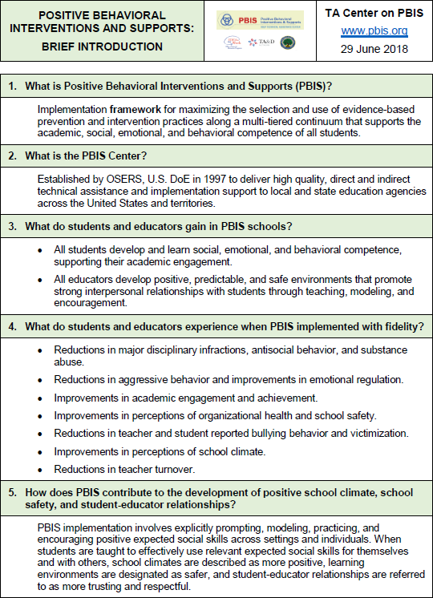

### Frequently Asked Questions About PBIS

OSEP National Technical Assistance Center on PBIS 29 June 2018

###### What is Positive Behavioral Interventions and Supports (PBIS)?

* 1. PBIS is an implementation framework for maximizing the selection and use of evidence-based prevention and interventions practices along a multi-tiered continuum that supports the academic, social, emotional, and behavioral supports of all students
  2. The interplay of 4 implementation elements is considered in all decisions
     1. **Data** – What information is needed to improve decision making
     2. **Outcomes** – What students need to do for academic and behavior success
     3. **Practices** – What students experience to support the learning and improvement of their academic and behavior success, e.g., teaching, prompting, and recognizing expected social behaviors
     4. **Systems** – What do educators experience to support their use of evidence- based academic and behavior practices, e.g., school leadership teams, data- based decision making, continuous professional development and coaching
  3. The multi-tiered “**continuum**” is comprised of carefully selected, evidence-based practices at three different levels of support intensity. Specific practices are matched both to the level of support need, and the local cultural context
     1. **Tier 1:** Universal practices are experienced by all students and educators across all settings to establish a predictable, consistent, positive and safe climate
     2. **Tier 2:** Targeted practices are designed for groups of students who need more structure, feedback, instruction and support than Tier 1 alone
     3. **Tier 3:** Indicated practices are more intense and individualized to meet the challenges of students who need more than Tiers 1 and 2 alone

###### What is the PBIS Center?

* 1. Brief History
     1. Initiated in 1997 and supported for the past 20 years by the Office of Special Education Programs, US. Department of Education.
     2. Co-directed by Universities of OR, CT, and MO and comprised of a working group of 25 technical assistance providers
     3. Began providing in 2013 TA support to 70 LEA and 20 SEA School Climate Transformation Grantees (OESE funding)
     4. Currently (August 2017), the PBIS Center and it’s national network support

###### 26,316 schools, representing 13,896,697 students

* + - 1. Of 14,324 reporting Tier 1 fidelity in 2016-17, 9564 (65%) report high fidelity implementation
      2. Of 9407 reporting T2/3 fidelity, 3114 (33%) and 1837 (19%) report high fidelity, respectfully

###### Technical assistance (TA)

* 1. Direct on-site TA to district and state leadership teams to enhance their capacity to establish and maintain a full continuum of implementation capacity for schools
  2. Indirect TA to school, district, and state leadership teams through websites, on-line webinars, regional and national conferences and forums, research and practitioner briefs, national database, and collaborations with other TA Centers and national organizations
  3. Facilitation of a national TA network of implementers comprised of (a) designated state contact person for each state, (b) assignment of PBIS Center partner to each state, and (c) regional coordination networks
  4. Collection and development of published evaluation and research articles that support implementation practices and systems

###### What do students and staff members gain in PBIS schools?

* 1. All students enhance their social, emotional, and behavioral competence by
     1. Regularly reviewing their school’s agreed upon school-wide social values.
     2. Frequently experiencing specific recognition when they engage in expected behavior
     3. Extending expected behaviors to all parts of the school, especially in classrooms to enhance their academic engagement and success
     4. Experiencing predictable instructional consequences (reteaching) for problem behavior without inadvertent rewarding of problem behavior
     5. Using a common language for communication, collaboration, play, problem solving, conflict resolution, and securing assistance
  2. All educators develop positive, predictable, and safe environments that promote strong interpersonal relationships with their students by
     1. Prompting, modeling, teaching, and acknowledging expected student behavior
     2. Actively supervising all their students across all settings
     3. Maximizing academic instruction to enhance student achievement and support social, emotional, and behavioral development
     4. Providing clear and predictable consequences for problem behavior and following up with constructive support to reduce probability of future problem behavior
     5. Intensifying their PBIS supports (T2/3) if students are unresponsive to universal practices (T1)

###### What do students and educators experience when PBIS is implemented with fidelity over time?

* 1. Reductions in major disciplinary infractions, antisocial behavior, and substance abuse.
  2. Reductions in aggressive behavior and improvements in emotional regulation.
  3. Improvements in academic engagement and achievement.
  4. Improvements in perceptions of organizational health and school safety.
  5. Reductions in teacher and student reported bullying behavior and victimization.
  6. Improvements in perceptions of school climate.
  7. Reductions in teacher turnover.

###### How does PBIS contribute to the development of positive school climate, school safety, and student-educator relationships?

* 1. In the context of school and community violence, a majority of kids consider school a safe place.
  2. Perceptions of safety are greater when students have an adult they can talk with, go to, receive support from, etc.
  3. Adult-student trusting relationships are the result of positive school and classroom climate, experiences of academic and social success, predictable school routines and supports, positive adult modeling.
  4. PBIS/MTSS framework provides a continuum of supports that enables educators to address the full range of student needs and experiences.

###### What is needed to put PBIS in place?

* 1. At **district** level
     1. Superintendent and school board endorsement
     2. Data-based decision making and problem solving
     3. Implementation leadership team
     4. Integrated initiative priority
     5. Implementation capacity
     6. Multi-tiered systems approach and expertise
     7. Policy supporting efficient and long term behavior support priority
     8. Continuous and embedded professional development opportunities
  2. At s**chool** level
     1. School Principal participation and modeling
     2. School leadership team
     3. Data-driven decision making
     4. 3-5 year implementation investment
     5. Integrated initiative priority
     6. Data-based decision making and problem solving
     7. Implementation practice and systems capacity
     8. Multi-tiered systems approach and expertise
     9. Continuous and embedded professional development opportunities
     10. Participation by all staff members across all settings
  3. At **classroom** at classroom
     1. Integration with school-wide expectations and classroom practices
     2. Teacher participation in non-classroom settings
     3. Effective instructional practices
     4. Daily use of effective classroom management practices
     5. Peer collaborations and support

###### What is NOT PBIS?

* 1. PBIS is NOT an intervention or practice.
     1. PBIS IS an implementation framework for selection and use of proven practices
  2. PBIS is NOT just for special education students.
     1. PBIS support the academic, social, emotional, and behavioral success of ALL students.
  3. PBIS is NOT a fad.
     1. PBIS Center has been in place for 20 years and the PBIS framework is visible in all 50 states.
     2. The practices within PBIS have been used successfully in schools and documented in research literature since the 1980s.
  4. PBIS is NOT implementable in one professional development day.
     1. PBIS develops local organizational structures (e.g., leadership teams) and implementation capacity (e.g., coaching and databased decision making) that enables continuous and local

professional development and technical assistance.

* 1. PBIS is NOT focused only on promoting positive behaviors.
     1. PBIS develops preventive supports to enhance and align with the procedures outline in discipline handbooks and codes of conduct.
  2. PBIS is NOT implemented independently of academic instruction.
     1. PBIS practices and systems are aligned with and integrated into academic instruction, professional development, school improvement goals, etc.
  3. PBIS is NOT a replacement for other effective social, emotional, and behavioral curricula and practices.
     1. PBIS establishes a continuum framework that guides alignment and integration of practices aligned with prioritized student outcomes.
     2. PBIS provides the systems and organizational structure that align with social emotional learning, restorative practices, the Good Behavior Game, and other proven practices.

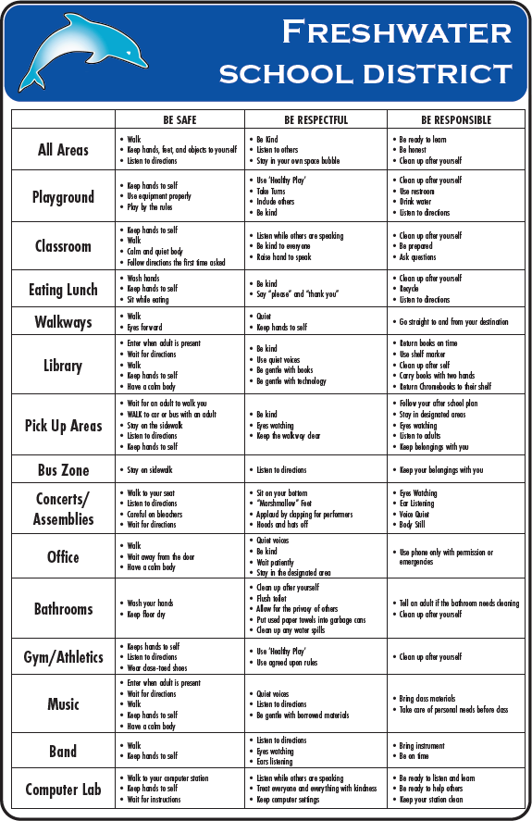

### Discipline Referrals

|  |  |  |  |
| --- | --- | --- | --- |
| **Level 1 – Incidental Behaviors** (Non-referred/Non-  recorded)   * Restorative Practices * Warning * Verbal correction/redir ection * Reteach/practic e   *Opportunity to* ***reteach***  *expectations* | **Level 2 –**  **Minor Behaviors**  (Recorded)   * Fill out BT Form * Restorative Practices * Classroom consequence * Think Sheet/Reflectio n * Staff Handled * Contact parent | **Level 3 – Major Behaviors** (Referred/Recorded)   * Fill out BT Form * Restorative Practices * Think Sheet Reflection * Consequence decided by Administrator * Contact Parent | **Level 4 – Illegal Violations** (Referred/Recorded)   * Fill out BT Form * Restorative Practices * Suspension from school * Consequence decided by Administrator |
| * Running * Loud voices/yelling * Off-task behavior * Name calling * Noise making * Insubordination * Out of Seat * Missing homework * Disruptive * Littering * Chewing gum or eating   candy except by teacher permission   * Disrespect * Non-Compliance | * Physical Contact * Inappropriate Display of   Affection   * Inappropriate Language * Property Misuse * Dress Code Violation * Technology Violation * Habitual Defiance * Lying * Cheating * **Chronic Level 1 infractions**   **that impede the learning of**  **others** | * Abusive Language * Physical Aggression * Harassment * Fighting * Inappropriate Location/Out   of Bounds Area   * Forgery * Theft * Plagiarism * Property Damage * Vandalism * Threats of Violence * **Chronic Level 2 infractions**   **that impede the learning of**  **others** | * Drug use/possession * Weapon use/possession * Truancy * Arson * Bomb threat * False Fire Alarm * Extreme property damage * Vandalism * Combustibles * Assault/threats |
| **Handled by Teacher/Support Staff** | | **Handled in Office** | |

### Discipline Process Flowchart

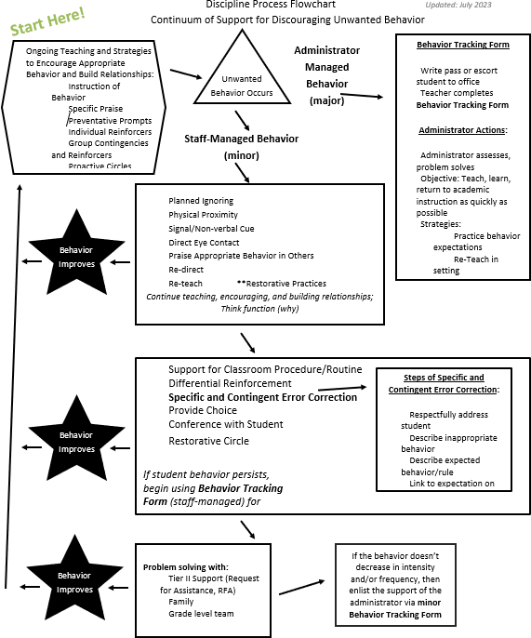

### Restorative Practices

We are excited to share that Freshwater School is now utilizing Restorative Practices to strengthen relationships to improve school climate and culture. Restorative Practices are processes that proactively build healthy relationships and a sense of community to prevent and address conflict and wrongdoing.

Restorative practices allow individuals who may have committed harm to take full responsibility for their behavior by addressing the individual(s) affected by the behavior. Taking responsibility requires understanding how the behavior affected others, acknowledging that the behavior was harmful to others, taking action to repair the harm, and making changes necessary to avoid such behavior in the future.

Restorative Practices can help our students repair harm that’s been done to a relationship. It is a zero shame philosophy. Instead of students taking a “time out” and being away from their community, they take a “time in” and practice communication skills, problem solving, and goal setting. When holding Restorative Circles, the following questions are asked:

To respond to challenging behavior:

1. What happened? NOT “Why did you…?” (Shame based)
2. Who has been harmed/affected by what you have done? In what way?
3. What do you think you need to do to make things right? To help those harmed by others actions:
   1. What did you think when you realized what had happened?
   2. What affect has this incident had on you/others?
   3. What do you think needs to happen to make things right?

Restorative practices work when they are implemented school wide and integrated into the fabric of the school community. When the whole school is infused with restorative strategies, it becomes easier to address issues faster and respond in a thoughtful way because the caring and supportive culture is already present. We even encourage our families to incorporate Restorative Practices at home to further support Freshwater’s core values.

Thanks for your support!

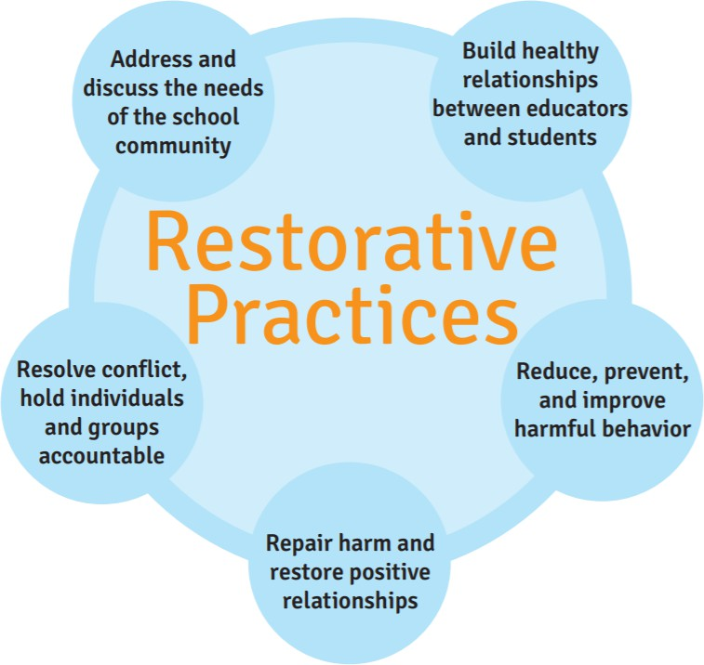

Dangerous, Violent, Or Unlawful Activities

### Assessment and Response Procedures

SB 671 requires a comprehensive school safety plan, and the school safety plan of a charter school, to include procedures to assess and respond to reports of any dangerous, violent, or unlawful activity that is being conducted or threatened to be conducted at the school, at an activity sponsored by the school, or on a school bus serving the school.

#### Emergency Incident Reporting Procedures

###### FOR ON SITE EMERGENCY, CRISIS, OR DISASTER INDIDENT REPORTING

The principal, designee, or responsible staff member determines the severity of the incident. If the incident is potentially life threatening, or if there is potential for serious injury, IMMEDIATELY CALL 911.

###### FOR SCHOOL BUS EMERGENCY, CRISIS, OR DISASTER INCIDENT REPORTING

Transportation, principal, designee, or responsible staff member determines the severity of the incident. If the incident is potentially life threatening, or if there is potential for serious injury, IMMEDIATELY CALL 911.

###### OFF SITE EMERGENCY, CRISIS, OR DISASTER REPORTNG

1st Law Enforcement personnel will notify the Superintendent,

2nd Superintendent/Incident Commander (IC) will notify the cabinet staff and the Board of Education

3rd Superintendent/Incident Commander (IC) will notify the Freshwater Chain of Command outlined in the Emergency Operations Plan (EOP).

4th Superintendent/Incident Commander (IC) will notify the community as needed. Note: When appropriate, Local Law Enforcement will notify the site(s) of a critical incident.

Opioid Overdose Protocol – Melanie’s Law

### Student Overdose or Possible Overdose Protocol

Current law (Education Code section 49414.3) allows schools to provide emergency opioid antagonist administration for individuals who may be experiencing symptoms of opioid drug poisoning. Opioid drug poisoning is a life‐threatening condition that can be reversed with the administration of an opioid antagonist medication such as naloxone. Without immediate administration of an opioid antagonist and summoning Emergency Medical Services (911), death could occur.

This law allows for a school nurse or a trained volunteer to administer an opioid antagonist medication to an individual who is exhibiting potentially life‐threatening symptoms of opioid drug poisoning. Training is provided to the volunteer on topics including but not limited to:

* Signs and symptoms of opioid drug poisoning
* How to administer the naloxone nasal spray (or other opioid antagonist)
* Calling EMS (911) and any follow up documentation or actions required.

*CPR training is recommended but not required of persons trained to administer an opioid antagonist.

Staff members who volunteer to be trained are protected under the law and will be provided defense and indemnification by the Freshwater School District for any and all civil liability.

This notification is provided annually to all staff. If staff are willing to be identified as a volunteer and be trained, staff complete the volunteer form and submit it to their site administrator.

Employees who volunteer to be trained may rescind their offer to volunteer at any time. No benefit will be granted to or withheld from any individual based on his or her offer to volunteer. There will be no retaliation against any individual for rescinding his or her offer to volunteer, including after receiving training.

### Student Overdose or Possible Overdose Procedures (The 4 Rs)



**Recognize**

**Respond**

**Recover**

**Refer**

|  |  |  |
| --- | --- | --- |
| **1. Recognize** | **2. & 3. Respond and Recover** | **4. Refer** |
| * Unconscious * Unresponsive * Not breathing or erratic * Choking/gurgling * Vomiting * Limp Body * Face pale and clammy * Fingernails/lips blue * Light skin- Bluish/Dark skin- grayish | **Give Narcan and call 9-1-1**   * Report event and time Narcan was given * Report condition of victim   **Be Ready**   * 2nd dose if no improvement after 2 minutes * CPR or Rescue Breathing if no heart rate or breathing stops   **Stay**   * Stay with victim until EMS arrives * Begin CPR/Rescue Breathing if needed * Place person on rescue position (side) * Reassure victim EMS is on the way | * Complete naloxone administration form.   + School nurse can help * Complete emergency report   + Submit to administrator * Debrief with staff   + Review response to opioid overdose * Recommend follow up support services   + Mental Health   + Counseling   + Primary   Health Provider   * + Drug Use Counseling * Restock Naloxone and document   + Freshwater School District Office |

### Narcan/Naloxone on School Sites:

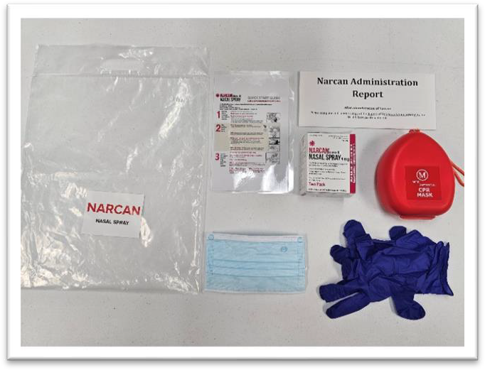Each school site is given Narcan/Naloxone packages for overdose or possible overdose events. These complete packages contain:

* Narcan Nasal Spay
* Narcan/Naloxone Quick Start Guide
* Gloves
* Face Mask
* Adult/Child CPR Rescue Mask Kit
  + Alcohol Pads
  + Rescue Mask Instructions
* Narcan/Naloxone Administration Report

(For additional supplies, please contact the District Office at 707-442-2969.)

Individualized Safety Plans

The Education Code requires school disaster procedures to also include adaptations for pupils with disabilities in accordance with the federal Individuals with Disabilities Education Act and Section 504 of the federal Rehabilitation Act of 1973, and would require the annual evaluation of the comprehensive school safety plan and the annual review of a charter school’s school safety plan to also include ensuring that the plan includes appropriate adaptations for pupils with disabilities and address any concerns to individual plans, as specified.

### Our School’s Individualized Plans

None Requested

## Drills, Training, and Exercises

The District understands the importance of drills, training, and exercises in planning for and managing an incident. To ensure that District personnel and community first responders are aware of their duties and responsibilities under the Emergency Operations Plan and incorporate best practices, the following training, drill, and exercise actions will occur.

See District Emergency Drill Schedule for current academic year. Records are maintained at each site.

### Student Safety – Drills, Training,and Exercises

|  |  |
| --- | --- |
| **Active Assailant Drill (Run, Hide, Fight)** | Provide this training for adult employees only, at least once per year, and it should be all-inclusive, addressing the Run, Hide, Fight protocols outlined by the FBI. |
| **Earthquake Drill** | Elementary Schools – one time per quarter Secondary Schools – one time per semester  Education Code Requirements (excerpted) (II) A drop procedure whereby each pupil and staff member take cover under a table or desk, dropping to his or her knees, with the head protected by the arms, and the back to the windows. A drop procedure practice shall be held at least once each school quarter in elementary schools and at least once a semester in secondary schools. |
| **Evacuation Drill** | This drill should be done one time per semester and can be combined with the Lock Down Drill (Fire Code 403.5.2 indicates the first emergency evacuation drill of each school year shall be conducted within 10 days of the beginning of class) |
| **Fire Drill(s)** | Elementary and Intermediate Schools – not less than once every calendar month Secondary Schools – not less than twice yearly  Legal Requirement:  19 CCR § 3.13  § 3.13. Fire Drills.  (a) Group E Occupancies.  (1) General. Every person and public officer managing, controlling, or in charge of any public, private, or parochial school shall cause the fire alarm signal to be sounded upon the discovery of fire. Every person and public officer managing, controlling, or in charge of any public, private, or parochial school, other than a two-year community college, shall cause the fire alarm signal to be sounded not less than once every calendar month at the elementary and intermediate levels, and not less than twice yearly at the secondary level, in the manner prescribed in California Code of Regulations, Title 24, Part 2, Section 907. |
| **Lock Down Drill (2)** | This drill should be done one time per semester and can be combined with the Evacuation Drill |

## Emergency Operations Plan – Excerpted

# Functional Annex

Accounting for all Persons

### Icon Description automatically generatedAttendance Records

It is our daily practice to maintain manual attendance records in the Administrative Office of each site. This includes Daily Attendance Records, Site Employee Logs, Visitor Logs, and Itinerant Employee Logs (such as food services, maintenance and operations, etc.). If there are contractors or contracted service workers on-site in a controlled location (such as fenced areas under construction)

the employer of record should be advised to consider keeping their own records of employee locations.

### Crisis or Incident Accounting

In the event of a crisis or incident, each site administrator will ensure there are 2 – 3 key employees (only one needs to have control of records at a time – additional staff are only for backup) who will have responsibility as scribes to collect all site attendance records from the administrative office.

These records are to be provided to the on-site incident commander upon request. It is the

scribe’s responsibility to maintain and protect these records.

In cases where students, staff, or visitors cannot be located, the name and description of the person(s) will be provided to Search and Rescue teams for more specific search. All records of searches and tracking of people on-site will be recorded in appropriate ICS log. The incident commander will be kept informed of attendance status and updated with changes.

### Assembly Areas

All staff will report as soon as is possible to their predesignated assembly areas. Premade signs may be used and maintained in assembly kits to assist in identifying specific assembly areas and will be held so as to be easily identified. Assembly area facilitators will distribute/record the attendance of all individuals in their assembly area.

For shelter-in-place or any evacuation, either on-site or off-site, attendance will be taken at any assembly areas and a comparison made to the attendance logs as follows:

Student Daily Attendance Site Employee Log

Visitor Log

Itinerant Employee Log

### Student Release

Student release will be conducted in an orderly fashion as outlined in the Reunification Annex of this plan. Attendance records will be checked and recorded as students leave the site.

Communications

### Icon Description automatically generatedPurpose

The Communications Annex ensures the availability and coordinated use of our communications systems for the dissemination of disaster information, for the exchange of information between decision-makers, and for the coordination of communications with local response agencies.

### Scope

When activated, the Communications annex coordinates and supports emergency response/recovery telecommunications requirements. This includes the interface between our District and other agencies and outside organizations, such as local, state, and federal government, private nonprofit organizations, and business/industry. Immediately report communications degradation, interruption, or failure by alternate means (e.g. cell phone) to the Communications Officer and/or the District’s Emergency Operations Center (EOC) if activated.

### Activation

The senior executive (or designee) determines whether to activate this annex based upon information from initial staff reports and local authorities. The local emergency communications plan will include:

Channel designations

Contingency communications procedures Training in back-up communications equipment

### Key Tasks/Responsibilities

Develop a local communications plan

Establish and maintain liaison with local response agencies, state agencies, commercial communications companies, and amateur radio organizations

Support communications equipment (radio, computer, fax, etc.) as needed Provide communications capability

Maintain equipment inventory

Designate a centrally-located area (usually main office) easily identified by staff, media, and the public

Predetermine an alternate location in case the primary location is inaccessible Establish communication with staff

Maintain telephone and radio communication with emergency services

Post rumor control and information on the internet and in an area accessible to our students and the community

Record emergency related incidents

Maintain communication with staff by whatever means available (SMS text messaging, audio alarm warning system, intercom, bullhorn, canned air horn, two-way radio, e-mail, written notices)

### Internal Communications

Staff will be notified when an incident occurs and kept informed as additional information becomes available and as plans for management of the situation evolve. The following practices will be utilized to disseminate information internally when appropriate:

#### Alert Notifications (SMS Texting)

In most cases our alert notification system will be used to activate and communicate within our emergency management system (following our Emergency Operations Plan). It may also be used to activate and manage our Emergency Operations Center (EOC).

#### Telephone Tree

A telephone tree is a simple, widely used system for notifying staff of an incident when they are not at their primary work location. The tree originates with the senior site official, who contacts the members of the Incident Management Team. Team members then, in turn, will contact groups of staff identified on their call list.

#### Staff Meetings

As appropriate, updated information about an incident will be presented at regularly scheduled staff meetings. In some cases, special staff meetings may be called as incident evolution requires. Staff will also have the opportunity to address any misinformation or rumors. Any new procedures or temporary changes will also be reviewed at this time.

#### Communication With the District Administrative Office

The Incident Commander will use the designated countywide Emergency Radio Network to notify the site administrator of our District’s status/needs. The site administrator will notify the District office. The District office will notify the County Office of the status of all of the District’s sites. He/she will designate staff member(s) to monitor all communications.

### Activation

### Concept of Operations

The senior executive (or designee) determines whether to activate this annex based upon information from initial staff reports and local authorities. When activated, the Communications annex coordinates and supports emergency response/recovery telecommunications requirements

Immediately report communications degradation, interruption, or failure by alternate means (e.g. cell phone) to our District’s Emergency Operations Center (EOC) if activated or the Communications Officer

The local emergency communications plan will include channel designations, contingency communications procedures, and training in back-up communications equipment.

Continuity of Operations (COOP)

### A picture containing text Description automatically generatedGeneral

Continuity of Operations planning is a program that ensures continued performance of essential functions across a full range of potential emergencies, be they natural or man‐made, when a significant interruption of operations occurs following a severe disaster or tragedy.

A COOP provides guidance and establishes responsibilities and procedures to ensure that essential functions are maintained. COOP is not the same as an Emergency Operations Plan or a Recovery Plan, but rather supplements it, in the event normal facility or human resources are not available.

A COOP provides a continuity infrastructure that through careful planning ensures:

Emergency delegation of authority and an orderly line of succession, as necessary. Safekeeping of essential personnel, resources, facilities, and vital records.

Emergency acquisition of resources necessary for business resumption.

The capability to perform critical functions remotely until resumption of normal operations.

A District’s COOP plan should allow for its implementation anytime, with or without warning, during normal and after-hours operations; providing full operational capability for essential functions no later than 12 hours after activation; and sustain essential functions for up to 30 days.

The purpose of these Continuity of Operations (COOP) procedures is to ensure that there are procedures in place to maintain or rapidly resume essential operations within the District after an incident that results in disruption of normal activities or services to the District. Failure to maintain these critical services would significantly affect the operations and/or service mission of the District in an adverse way.

### Scope

It is the responsibility of the District’s officials to protect students and staff from incidents and restore critical operations as soon as it is safe to do so. This responsibility involves identifying and mitigating hazards, preparing for and responding to incidents, and managing the recovery process.

The COOP procedures outline actions needed to maintain and/or rapidly resume essential operations, business, and physical services, when interrupted for an extended period of time following an incident.

### Responsibilities

Designated District Staff, in conjunction with the affected administrator(s) and staff, will perform the essential functions as follows:

#### Senior Executive/Site Administrator

Determine when to close District, and/or send students/staff to alternate locations

Disseminate information internally to students and staff Communicate with family, media, and the larger community

Identify a line of succession, including who is responsible for restoring which business functions for the District

Ensure systems are in place for rapid contract execution after an incident Identify relocation areas for site and administrative operations

Create a system for registering students (off site or into alternative locations) Brief and train staff regarding their additional responsibilities

Secure and provide needed personnel, equipment and supplies, facilities, resources, and services required for continued operations

Identify strategies to continue operations (e.g., using the Internet, providing alternatives to operational contingencies)

Work with local and state government officials to determine when it is safe for students and staff

to return to the District’s buildings and grounds

Manage the restoration of the District’s buildings and grounds (e.g. debris removal, repairing,

repainting, and/or landscaping)

Collaborate with private and public-sector service providers and contractors

#### Administrative Services, District Staff

Maintain inventory

Maintain essential records (and copies of records) including the District’s insurance policy

Ensure redundancy of records is kept at a different physical location.

Secure District’s equipment and materials in advance.

Restore administrative and recordkeeping functions such as payroll, accounting, and personnel records.

Retrieve, collect, and maintain personnel data

Provide accounts payable and cash management services

#### Administrative Support Staff

Establish necessary support services for students and staff

Implement additional response and recovery activities according to established protocols Collaborate with public and private providers

#### Food Services Worker

Determine how food services will resume Support staff and volunteers as much as possible

#### Transportation

Provide emergency transportation services as needed

Assess and implement alternative transportation services that may be necessitated

Evacuation

### Icon Description automatically generatedGeneral

Evacuation is one means of protecting the staff, students and visitors from the effects of a hazard through the orderly movement of person(s) away from the hazard. The type and magnitude of the emergency will dictate the scale of an evacuation (i.e., evacuation area).

### Concept of Operations

Evacuation orders are generally given by the following: Local Police

Environmental Health & Safety

Facilities Services

Administrator, director, or building supervisor Fire Department with jurisdiction

Any person identifying a hazard and by activating the fire alarm system via a fire alarm pull station

### Evacuation Procedures

Evacuation will be initiated by means of the fire alarm system. Whenever the alarm is sounded all occupants of all buildings are to initiate the evacuation procedure.

Take the Incident Action packet/binder which has a current class list and a red/green 8½ x 11 card (red on one side and green on the other side)

Close all doors and windows. (DO NOT LOCK DOORS)

Follow the safest evacuation route to the assembly or safe dispersal area.

Teachers are to take roll and make certain no one reenters the building for any reason.

If all students are present with staff member, staff will hold up the GREEN sheet to acknowledge to responsible incident management person that all students are present.

Support staff who have regular schedules with students need to have a green and red card also. If all students who are regularly scheduled are in their care and custody, they are to raise the green card, so staff member and responsible incident management person can see.

Staff members are to raise the red card even if they think a student is with support staff so responsible incident management person can account for those students.

If a student is not present, the staff member will hold up the RED card and wait for the administration to contact him/her to see who is absent. The responsible incident management person will coordinate the search for the missing student.

Students should remain 30 – 50 feet away from any building. Students are to remain in groups, until the all clear signal is given.

### On-Site Evacuation

The Incident Commander or designee activates fire alarm. All staff follow the Evacuation Procedures identified above.

Once assembled, building occupants remain in their designated assembly or safe dispersal area until further instructions are given.

Reentry is only authorized after it is determined that conditions and buildings are deemed safe by appropriate incident management staff.

### Off-Site Evacuation

If it is determined that the buildings and area are not safe for occupation and that the On-Site Evacuation locations are also at risk, the appropriate incident management staff will initiate an Off- Site Evacuation.

The Incident Commander or designee determines safest method for evacuating the site. This may include use of buses or simply walking to designated off-site location.

Staff members secure the student roster when leaving the building and take attendance once group is assembled in pre-designated safe location.

Once assembled off-site, staff members and students stay in place until further instructions are given.

In the event clearance is received from appropriate agencies, Incident Commander may authorize students and staff to return to buildings.

### Evacuating Students with Disabilities

Procedures and actions regarding the special needs’ population should cover the evacuation, transportation and medical needs of students who will require extreme special handling in an emergency. In most cases, additional safeguards must be established regarding roles, responsibilities and procedures for students with physical, sensory, emotional and health disabilities.

The following are steps that cover the evacuation procedure of student(s) with disabilities: Review all paths of travel and potential obstacles

Know the facility, grounds, paths, exits and potential obstacles

Determine the primary and secondary paths of exit to be used during emergencies

Individuals with mobility impairments will need a smooth, solid, level walking surface, an exit that avoids barriers such as stairs, narrow doors and elevators and guardrails that protect open sides of the path

Compile and distribute evacuation route information to be used during emergency operations Include alternative evacuation route information, should the primary route be inaccessible due to

damage or danger

Install appropriate signage and visual alarms

Place evacuation information indicating primary and secondary exits in all offices, rooms, multipurpose rooms, hallways/corridors, lobbies, bathrooms and cafeterias. For passages and doorways that might be mistaken for an exit, place visible signs that proclaim, “NOT AN EXIT”

Place emergency notification devices appropriate for each student

Post signage with the name and location of each area so that the students will know exactly

where they are, in order to comply with ADA (American’s with Disabilities Act) Accessibility

#### Buildings and Facilities Signage Requirements

Approximately 60 inches above the floor

In a location that is not obscured in normal operation such as a swinging door In all primary function areas

### Preparation and Planning

Identify the students and staff with special needs and the type of assistance they will require in an emergency

Allow visitors to self-identify on a sign-in log if they have special evacuation needs

Discuss evacuation issues with the staff members and caretakers of students with special needs, including individuals, who may be temporarily disabled (i.e. a student with a broken leg)

Train staff in general evacuation procedures

Review the areas of rescue, primary exits, evacuation techniques, and the locations and operation of emergency equipment

Provide in-depth training to those designated to evacuate students with special needs Train the staff for proper lifting techniques when lifting a person for evacuation Anyone can assist a student with a visual impairment

Check on each special needs student to assure he/she is accounted for during an evacuation Review the plan with emergency response personal, including local police, fire and emergency

medical technicians

Identify “areas of rescue” in our site for students to wait for evacuation assistance from

emergency personnel

Before operations begin in the Fall, walk around the site with first responders so that they are familiar with the primary exits and all areas of rescue; these areas must meet specifications for fire resistance and ventilation

Ask the responders to conduct a special drill explaining how they will support the students and staff with special needs during an emergency

Complete all contracts and Statements of Understanding with key emergency support providers Ensure that sufficient transportation capacity exists with transportation providers, partner

agencies, and suppliers to effectively meet the demand in an emergency

Identify transportation contracts through the District in case of an emergency; Emergency response for special needs requires special vans and special equipment

Specify who will do what to address these transportation needs

Develop a list of District-owned vehicles, staff vehicles that are available and make prior arrangements for their use in the event of an emergency

Review the evacuation plan with students and staff to be familiar with the process and identify any problems

Practice implementation of special duck and cover actions by students with able-bodied partners

Students should be aware that evacuation by themselves may be difficult or impossible because of obstacles in their path or because electric dependent machines may not function (i.e. elevator)

Special pre-planned assistance must be provided and reviewed regularly

Lockdown (Deny Entry or Closing)

### Icon Description automatically generatedGeneral

A District or school site lock down is necessary when the threat of violence or gunfire is identified or directed by law enforcement and it is necessary to prevent the perpetrator(s) from entering occupied areas. During lock down, students are to remain in rooms or designated locations at all times.

### Instructions

If a lock down situation is required, the Site Administrator will make an announcement on the Public Address (PA) system. If the PA system is not available, the Site Administrator will use other means of communication (e.g., sending messengers to deliver instructions). The Site Administrator should be calm, convey reassuring comments that the situation is under control, and provide clear and consistent directions. Below is an example of an announcement to be made by the Site Administrator:

“YOUR ATTENTION PLEASE. WE HAVE AN EMERGENCY SITUATION. STAFF ARE TO LOCK ROOM DOORS UNTIL NOTIFIED BY AN ADMINISTRATOR OR LAW ENFORCEMENT. STUDENTS AND STAFF ARE TO PROCEED TO THE NEAREST ROOM OR BUILDING. PLEASE REMAIN INDOORS UNTIL FURTHER INSTRUCTIONS ARE PROVIDED.”

If inside, staff should instruct students to lie on the floor, move away from doors and remain in the center of the room out of the line of fire, lock the doors (if possible), and close any shades or blinds if it appears safe to do so. Students and staff who are physically unable to lie on the ground should move away from doors and windows.

If outside, students should proceed to their rooms if it is safe to do so. If it is not safe, staff must direct students into nearby rooms or other District buildings (e.g., auditorium, library, cafeteria, and gymnasium).

District staff and students must remain in their room or secured area until further instructions are provided by the Site Administrator or law enforcement.

Landline phones should not be used. District staff should use cell phones and speak quietly.

All site entrances and exits must be locked, and no visitors other than appropriate law enforcement or emergency personnel are to be allowed on the site.

Public, Medical, and Mental Health

### Icon Description automatically generatedGeneral

Establishment of public, medical, and mental health procedures, will assist the District in preparing for, responding to, and recovering from an incident that affects the health and safety of students, staff, and family. Furthermore, coordination with Public Health agencies, Emergency Medical Services (EMS), and Mental Health support services will broaden their capacity to deal with

these incidents by providing the District with resources beyond their existing expertise and training.

### Public Health

#### Procedures

Designate District Medical Manager and/or other key personnel as the individual(s) responsible for coordinating incidents such as disease outbreaks, bioterrorism, and natural disasters with local, State, and Federal Public Health agencies.

Coordinate with local, State, and Federal Public Health agencies on information sharing protocols. Develop procedures for reporting information to local, State, and Federal Public Health agencies. Contact local Public Health agency to determine notification procedures for students/family,

staff, and public, if necessary.

Send out any required notification to students/family, staff and public as required. Establish a dedicated contact phone number for questions and concerns.

Coordinate with local, State, and Federal Public Health agencies, for assistance with managing

large scale incidents or incidents beyond the District’s resources.

### Medical Health

#### Procedures

Designate District Medical Manager and/or other key personnel as the individual(s) responsible for coordinating incidents involving students or staff injuries or illnesses

Provide CPR/First Aid/AED to all staff designated to work in medical capacity Establish a triage area for injured students and staff

Separate walking wounded, critically injured and deceased individuals (Keep a log of names of these individuals)

Keep a record of students and staff that are transported off-site for treatment.

Coordinate with local Emergency Medical Services (EMS) agencies for assistance with large scale

incidents or incidents beyond the District’s resources.

### Mental Health

#### Procedures

Designate crisis counselors and/or other key personnel as the individual(s) responsible for coordinating incidents with local, State, and Federal Mental Health agencies

Activate crisis counselors during the incident to begin identifying students and staff that require assistance

Keep a log of individuals counseled or that require counseling following the incident Notify students, family, and staff of counseling services available

Coordinate with local, State, and Federal Mental Health agencies, for assistance with large scale

incidents or incidents beyond the ’s resources.

#### Psychological First Aid for Schools (PFA-S)

The field of school safety and emergency management has evolved significantly over the past decade. Tragically, acts of violence, natural disasters, and terrorist attacks have taught us many lessons. We also know that other types of emergencies can impact schools, including medical emergencies, transportation accidents, sports injuries, peer victimization, public health emergencies, and the sudden death of a member of the school community. We now recognize the need for school emergency management plans that are up-to-date and take an “all-hazards”approach with clear communication channels and procedures that effectively reunite parents and caregivers with students. We have also learned that preparing school administrators, teachers, and school partnering agencies before a critical event is crucial for effective response, the value of ongoing training and emergency exercises, and that having intervention models that address the public health, mental health, and psychosocial needs of students and staff is essential to a safe school environment and the resumption of learning. (excerpted from Psychological First Aid for Schools, Field Operations Guide, 2nd Edition)

#### Field Operations Guide (FOG)

[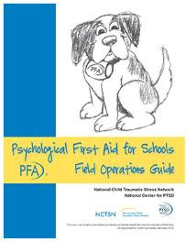](https://www.nctsn.org/resources/psychological-first-aid-schools-pfa-s-field-operations-guide)We use the PFA-S FOG as-needed, to prepare and respond to critical incidents affecting the mental health of our students. [https://www.nctsn.org/resources/psychological-first-aid-schools-pfa-s-field-](https://www.nctsn.org/resources/psychological-first-aid-schools-pfa-s-field-operations-guide) [operations-guide](https://www.nctsn.org/resources/psychological-first-aid-schools-pfa-s-field-operations-guide)

Public Safety and Security

### A picture containing logo Description automatically generatedPurpose

The Public Safety and Security Annex integrates State public safety and security capabilities and resources to support the full range of incident management activities.

### Scope

The Public Safety and Security Annex provides a mechanism for coordinating and providing support to local law enforcement authorities to include non-investigative/non-criminal law enforcement, public safety, and security capabilities and resources during incidents. The Public Safety and Security Annex capabilities support incident management requirements, including force and critical infrastructure protection, security planning and technical assistance, technology support, and public safety, in both pre-incident and post-incident situations. The Public Safety and Security Annex generally is activated in situations requiring extensive assistance to provide public safety and security.

### Key Tasks/Responsibilities

Coordinate public safety and security support (including personnel and equipment) to any affected department/agency during preparation for, response to, and/or recovery from any real or potential incident.

County Sheriff’s Office

Police Department

Other Law Enforcement Agencies Private Security Companies

Coordinate critical information dissemination regarding public safety/security through mass warning/notification.

County Sheriff’s Office Police Department Dispatch

County Emergency Management

Facilitate multi-function public safety activities such as evacuation, traffic, looting, and riot control

County Sheriff’s Office

Police Department

Other Law Enforcement Agencies Fire/EMS

### Concept of Operations

Local law enforcement authorities have the primary responsibility for public safety and security and are the first line of response and support in these functional areas, utilizing the Incident Command System on-scene

In larger-scale incidents, additional resources should first be obtained through the activation of mutual aid agreements with neighboring jurisdictions and/or State authorities, which may require the management of incident operations through a Unified Command structure

Through the Public Safety and Security Annex, outside resources supplement local resources when requested or required, as appropriate, and are integrated into the incident command structure using National Incident Management System principles and protocols

The Public Safety and Security Annex activities should not be confused with the activities described in the Terrorism Incident Annex or other criminal investigative law enforcement activities

As the lead law enforcement official in the United States, the Attorney General, generally acting through the Federal Bureau of Investigation (FBI), maintains the lead for criminal investigations of terrorist acts or terrorist threats by individuals or groups inside the United States

The Public Safety and Security Annex is activated when public safety and security capabilities and resources are needed to support incident operations

This includes threat or pre-incident as well as post-incident situations

When activated, the primary agencies assess public safety and security needs, and respond to requests for resources and planning/technical assistance from county agencies

The Public Safety and Security Annex manages support by coordinating the implementation of authorities related to public safety and security and protection of property, including critical infrastructure, and security resources and technologies and other assistance to support incident management operations and security capabilities and resources are needed to support incident operations

This includes threat or pre-incident as well as post-incident situations

The Public Safety and Security Annex maintains close coordination with Federal, State, and local officials to determine public safety and security support requirements and to jointly determine resource priorities

The primary agencies maintain communications with supporting agencies to determine capabilities, assess the availability of resources, and track resources that have been deployed

Recovery

### Icon Description automatically generatedGeneral

When a disaster occurs, it is all too easy to get consumed by the urgent activities and emotions surrounding the event. That is understandable but don’t allow the intensity of the incident to distract you from some extremely important actions you should be taking. Keep in mind that no financial assistance will occur until there is a declared disaster by the State and the Federal governments.

Tracking time and material (supplies and equipment specifically used for the disaster) should happen always, regardless of disaster declarations. There is no guarantee that we will get our expenses reimbursed. We are at the mercy of the State and Federal governments. In most cases, however, **labor and materials specific to the disaster response** get reimbursed. Losses already covered by our insurance are typically NOT reimbursed. For example, if an employee is injured our Workers’ Compensation would cover the injured employee. If a building was damaged and our insurance does not cover that specific cause of loss there may be a chance it is reimbursable.

### Before – Action Items

Establish relationships and contact information from our county Operational Area and Coordinating Council (OACC)

Create and maintain a current contact list with this information and other contact information essential to the Finance/Administration Section of our ICS structure

Train and practice the Start-up, Operation of, and the Closure of this ICS Section. Modify and update our Emergency Operations Plan as necessary

### During – Action Items

Within the very first moments of an incident, begin tracking every employee’s and volunteer’s

time spent on the incident. (Be alert to any announcements from local or State government

regarding “Public Assistance” requests or meetings.) Use the form designed for that purpose, the Activity Log (ICS 214). If not readily available, make sure each person is tracking the following:

Incident name Date

Worker’s name

Log each major activity and track start and end times

Don’t be concerned with tracking too much – that can be sorted out after the event

This information will need to be transferred onto the Activity Log (ICS 214) before we can apply for Public Assistance funding (this is what they call the State and Federal reimbursement program)

Keep track of ANY disaster-related expenditures for supplies or equipment. It is best to retain copies of priced-out receipts and invoices for possible State and Federal reimbursement. For example, if our facilities may be used as a shelter and we are required to provide custodial services specific to the shelter, toilet paper, paper towels, cleaning material and chemicals would all likely be reimbursable. If our facility were being used as a medical care facility and the HVAC system required filters different than what we would normally use, the cost of the filters (and the labor to change them) are likely reimbursable.

Establish the Recovery Unit in the Finance/Administration Section of our Emergency Operations Center (EOC).

Have all sites or units collect information on their ability to sustain operations. Develop staffing pattern for the Recovery Unit.

Collect information on damages, duration and impact from the following: Utility Providers

Social, medical and health services Transportation routes and services Debris issues

County Government Operations

Private sector retail and wholesale providers Others

Develop initial short term and long-term recovery objectives. Refer to hazard/threat-specific annexes for information.

Develop information for the PIO on the recovery process and progress. Develop a plan to assign personnel to sustain the recovery effort

Coordinate with the OACC, other local jurisdictions and the State on their recovery efforts. While it is best if we already have an established relationship with our county Operational Area

Coordinating Council (OACC) contact, we need to identify that individual and the means of communicating with them. We will want them to know who at our District will serve as the contact for emergency incidents. This will serve a couple of purposes:

It will keep our District “in the loop” and better informed when an incident affecting our

District occurs

It will alert us to any notice of “Public Assistance” informational meetings to learn about

getting Federal and State reimbursement for disaster related District activity

If our county’s OACC is overwhelmed with an incident we should reach out directly to our Emergency Services Coordinator at the Governor’s Office of Emergency Services Region Operational Area.

Ask them to put the District on the list for notification of “Public Assistance” informational

meetings

There are forms that will be exchanged between our District and the OACC or the California

Governor’s Office of Emergency Services (they act as our liaison with FEMA)

If our employees and volunteers remain under our direction and control we are responsible for any costs associated with their activities. Should they perform work that they would not normally do and it is attributable to the disaster we will likely be able to reimburse the labor. Management costs are typically NOT reimbursable.

If our employees and volunteers, or our facilities, are tasked outside of our District we must only do so under the terms of a mutual aid agreement or memorandum of understanding to which the District have agreed, in writing. Make sure we understand when and if risk transfer occurs as it should be clear in these documents. These documents should identify, specifically, what is “covered” and by “whom.” Examples for other agency usage of our facility might include the Fire Department using our facility as a command center for the incident.

Or, local hospitals may be “at-capacity” and need our facility to provide some form of medical or health services. In these cases, (like the case of sheltering) a written request for use of our facilities should be on file or requested prior to allowing the agency to use them. These documents should specify what they will and will not cover in terms of costs related to using the facility. Typically, if an outside agency damages the property or they cause a liability exposure, they are responsible for coverage.

When in doubt, ask for help.

### After – Action Items

Begin closing the Recovery Unit

Assign any open or pending tasks, such as Public Assistance funding or other outstanding receivables or payables, to appropriate staff with specific checkup or due dates

Make sure all Activity Logs and equipment/supply records have been assembled and recorded into the request for Public Assistance from Cal OES and FEMA

Conduct an After-Action debrief within the Finance/Administration Section and include that in the main incident After-Action debrief held by the District

Review our EOP and include any lessons learned or altered actions into the plan for update and redistribution to the emergency management team

Participate in and debriefings provided by our ICS team and close the Recovery Unit

### Resources

[Activity Log (ICS 214)](https://training.fema.gov/emiweb/is/icsresource/assets/ics%20forms/ics%20form%20214%2C%20activity%20log%20(v3.1).pdf)

[Cal OES Regional Operations](https://www.caloes.ca.gov/cal-oes-divisions/regional-operations)

Form [Cal OES 126](https://www.caloes.ca.gov/RecoverySite/Documents/Cal%20OES%20126%20CDAA%20Application%20(Rev%2003-17).pdf) – Project Application, California Disaster Assistance Act Program Form [Cal OES 130](https://www.caloes.ca.gov/RecoverySite/Documents/CalOES%20130%20-%20Fillable.pdf) – Designation Of Applicant's Agent Resolution For Non-State Agencies Form [Cal OES 89](https://www.caloes.ca.gov/RecoverySite/Documents/Project%20Assurances%20For%20Federal%20Assistance%20-%20Cal%20OES%2089.pdf) – Project Assurances For Federal Assistance – Construction Programs Form [FEMA 009-0-49 9/16](https://www.caloes.ca.gov/RecoverySite/Documents/Request%20for%20Public%20Assistance%20(RPA)%20-%20FEMA%20Form%20009-0-49.pdf) – Request For Public Assistance

All links should be verified at least annually and updated. In some cases, expired forms will not be accepted.

Reunification

### A picture containing text Description automatically generatedGeneral

Student release is a crucial part of emergency planning. During an emergency or disaster, the traditional student release procedure is often unsafe and therefore not operable. Accordingly, a comprehensive emergency plan needs to include certain procedures to accomplish the main priority of safety planning which is to ensure the safety of the students to every extent possible.

There are a wide variety of emergency situations that might require student/family reunification. Student/family reunification may be needed if the site is evacuated or closed as a result of a hazardous materials transportation accident, fire, natural gas leak, flooding, earthquake, tsunami, school violence, bomb threat, terrorist attack or other local hazard.

Student/Family reunification is part of the Incident Command System and is assigned to the Operations Area.

### Reunification Procedures

In an emergency, sites must establish a safe area for family members to meet with students. This area must be away from the both the damage and the student’s assembly area. In a typical release the following steps will be followed:

Family member will report to the assigned area and give the name of the student

Picture ID will normally be required by the person in charge to insure the person requesting a minor is a match to the name on the emergency release card

A runner will go to the student assembly area and get the minor requested by the parent or adult and escort the student back to the pick-up area

Parents will be asked to sign a form indicating they picked up the minor (the date and time will also be indicated on the pick-up form)

If the minor is in the first aid area, the parent will be escorted to that area for reunification with their child/children

Counselors, when available, will be located close to the first aid area in the event they are needed

### Traffic Control

Traffic may be controlled by trained and authorized employees who meet the requirements outlined in the Manual on Uniform Traffic Control Devices (MUTCD) Part 7, Traffic Control for School Areas. In the absence of this condition, we must wait until local law enforcement is available and on scene at the site.

To every extent possible, two-way traffic will be maintained to allow for entry and exit of emergency vehicles

As the situation develops there may be time for barricades and other traffic control devices to be delivered and set up

It should be understood this will not occur at the beginning of the incident

When law enforcement arrives on the scene they will take charge and do whatever is necessary, including the towing of vehicles to manage the emergency or disaster

### Maintaining the Procedures

Student rosters should be updated at least twice a year

If enrollment dictates this may be updated more frequently

Updated rosters should be stored in every room in an area easily identified by the both staff and substitutes.

Additional copies of the rosters should be distributed to the site administrator and placed in the back of the emergency plan binder

Emergency cards should be filled out at the beginning of the year

This card should include contact information on family members, as well as other adults who can be contacted if the family member is not available

The card should also indicate who the minor is permitted to leave site with, if necessary DO NOT release students to people not listed on the student emergency card.

A well- intentioned friend may offer to take a minor home; however, District staff must be certain that students are only released to the appropriate people, so their families will know where they are

The card should also include all pertinent medical information such as allergies, medications, and doctor contact information

These cards should be stored in the front office in both hard copy and electronically, if possible

#### Things to Remember

Some family members will refuse to cooperate with the student/family reunification process This situation can be diminished, to some degree, if family members are informed about the

District’s release procedures before the disaster or emergency occurs

They should be reminded that the safety of their student is our utmost priority Family members may be emotional when arriving at the site

Have counselors available to deal with issues if needed

Shortly after the incident, the media will have a presence on our site

The Public Information Officer, part of the command staff operating under the Incident Command System, will deal with the media, however, it is important that family be sheltered from media representatives

Shelter-in-Place

### General

This action is taken to place and/or keep students indoors in order to provide a greater level of protection from airborne contaminants in outside air. Shelter-in- place is implemented when there is a need to isolate students and staff from the outside environment and includes the shutdown of room and/or building air systems. During shelter-in-place, no one should be exposed to the outside air.

### Description of Action

If an emergency occurs that requires students and staff to Shelter-in-Place, the Site Administrator will make an announcement on the PA system. If the PA system is not available, the Site Administrator will use other means of communication (e.g., sending messengers to deliver instructions). The Site Administrator should be calm, convey reassuring comments that the situation is under control, and provide clear and consistent directions. Below is an example of an announcement to be made by the Site Administrator:

“YOUR ATTENTION PLEASE. WE HAVE RECEIVED INFORMATION REGARDING A HAZARD IN THE COMMUNITY. WE ARE INSTITUTING SHELTER-IN-PLACE PROCEDURES. PLEASE REMAIN INSIDE THE BUILDING AWAY FROM OUTSIDE AIR WITH WINDOWS AND DOORS SECURELY CLOSED AND AIR CONDITIONING UNITS TURNED OFF. ALL STUDENTS AND STAFF THAT ARE OUTSIDE ARE TO IMMEDIATELY MOVE TO THE PROTECTION OF AN INSIDE ROOM. PLEASE REMAIN INDOORS UNTIL FURTHER INSTRUCTIONS ARE PROVIDED.”

If inside, staff should keep students in their rooms until further instructions are given If outside, students must proceed to their rooms if it is safe to do so

If it is determined to be unsafe, staff should direct students into nearby rooms or buildings (e.g., auditorium, library, cafeteria, and gymnasium)

Staff and students who were exposed to outside air should congregate in indoor locations away from individuals who were not exposed to outside air

Anyone who is exhibiting symptoms must be treated

Staff is responsible for securing individual rooms and for completing the following procedures as needed:

Shut down the room/building HVAC (Heating Ventilation and Air Conditioning) system Turn off local fans in the area

Close and lock doors and windows

*If necessary, seal gaps under doors and windows with wet towels or duct tape, seal vents with aluminum foil or plastic wrap, and turn off sources of ignition, such as pilot lights*

Situational Awareness

In the U.S., every public agency is expected to address situational awareness and personnel security. Situational Awareness is the ability to identify, process, and comprehend the critical information about an incident. More simply, it is knowing what is going on around us.

### Overview

Situational Awareness requires continuous monitoring of relevant sources of information regarding actual incidents and developing hazards. A common core function of Emergency Operations Centers (EOC) is gaining, maintaining, and sharing Situational Awareness and developing a Situational Picture (SitPic) that is shared between the Incident ICS, EOC, JIS, and field staff participants in the incident.

In the early stages of activation, the EOC will obtain Situational Awareness. This is important because accurate, timely information will enable more informed, effective decision-making. An excellent tool for developing and maintaining this condition of the OODA loop.

#### OODA Loop

The OODA loop is the cycle: observe–orient–decide–act, developed by military strategist and United States Air Force Colonel John Boyd in the 1960s. Boyd applied the concept to the combat operations process, often at the operational level during military campaigns. It is now also often applied to understand commercial operations and learning processes.

The OODA loop has become an important concept in emergency management. According to Boyd, decision-making occurs in a recurring cycle of observe–orient–decide–act. An entity (whether an individual or an organization) that can process this cycle quickly, observing and reacting to unfolding events more rapidly than an “opponent,” can thereby "get inside" the opponent's decision cycle and gain the advantage.

**Observe** – Sensing yourself and the world around you

**Orient** – What you believe: a complex set of filters of genetic heritage, cultural predispositions, personal experience, and knowledge

**Decide** – A review of alternative courses of action and the selection of the preferred course as a hypothesis to be tested.

**Act** – Testing the decision chosen for implementation.

Every employee is a critical link to situational awareness. This annex address the expectations of this District in establishing and maintaining a vital communication and informational internal network.

Whether you are in an office environment, inside a building, in the field, or at home, what you observe and absorb are invaluable to our District.

### Prepare

The following list includes the minimum expectations for every employee:

Develop and maintain a personal family communication plan

Use the [Family Emergency Communication Plan](https://www.ready.gov/sites/default/files/2020-03/family-communication-plan_fillable-card.pdf) *– Wallet Sized* provided by our District

The plan should be completed at hire and updated when any of the information changes but at least annually

Share our plan with your family

Review and familiarize yourself with the District’s Emergency Operations Plan (EOP) Prepare a “Go-Bag” for yourself with a 3-day supply of food and water

See the “Go-Bag” guide for help in assembling and stocking

Keep a copy of the District’s *Critical Incident* Field Operations Guide (FOG) with you at all times during work hours

### Field Protocol

Before, during, and after critical incidents there are some basic steps you should take to improve your situation and help others in need:

If you are operating a vehicle or other equipment, stop your activity as soon as is safely possible (If driving, follow safe driving practices and get maneuver your vehicle without endangering your own or the safety of others)

Assess the situation using the OODA loop and take appropriate action

Follow our District’s Communication protocols as outlined in the EOP

If you are unable to proceed to your primary location ( starting and ending shift worksite) find out if you can return to an alternate site

If returning to any of these sites proves unreasonable, proceed to the nearest public facility (police or fire station, hospital, local government office) and notify our District of your exact location

Provide our District’s Emergency Operations Center (EOC) with as much detailed information as

possible:

Time, Date, and Location of Critical Incident

Your condition (unaffected, injured, etc.) and the condition of your equipment Describe the type of incident such as fire, hazmat, earthquake, etc.

Provide details on estimate impact in your area (how much loss or damage)

### Disaster Service Worker

As a California public employee, you may be called upon to work as a Disaster Service Worker (DSW) in the event of an emergency. The information contained in the Disaster Service Worker website will help you understand your role and obligations as a disaster service worker, and what to do in an emergency (California Government Code Section 3100-3109).

Special Needs Population

### Icon Description automatically generatedPlanning Needs and Assumptions

For individuals with special needs, physical environments become a great deal more hostile and difficult to deal with during and after an emergency. The ability to get to accessible exits and personal items may be reduced. Communication may be impeded at a time when clear and rapid communication is crucial to safety and survival.

To comply with statutes involving students with special needs, individuals responsible for evacuation and emergency operation plans, notification protocols, shelter identification, emergency medical care and other emergency response and recovery programs must:

Have sound working knowledge of the accessibility and nondiscrimination requirements applicable under Federal disability rights laws

Know the special needs demographics of the attending students on site

Involve students with different types of disabilities and staff in identifying the communication and transportation needs, accommodations, support systems, equipment, services, and supplies that they will need during an emergency

Consider emergency accommodations for those with temporary disabilities

Identify existing resources within the site and local community that meet the special needs of these students

Develop new community partners and resources, as needed Inform family members about the efforts to keep students safe Identify medical needs and make an appropriate plan

Determine transportation needs, special vans, and buses for students

Identify any necessary tools such as personal response plans, evacuation equipment or visual aids Include local responders and establish a relationship with individual students with disabilities and

staff

# Hazard/Threat Annex

Hazard-Threat Assessment

A representative number of participants were selected to participate in the Hazard-Threat Assessment Survey (HTAS). This survey follows best practices in emergency management and is a very important part of updating our Emergency Operations Plan.

This survey was designed to help us prioritize possible threats or hazards we may face. It covers many possible scenarios but is not exhaustive in nature. The survey information generated is invaluable in helping our Emergency Operations Plan Collaborative Planning Team identify the hazards and threats most likely to impact us.

The Collaborative Planning team has selected the following Hazards/Threats to be included in this annex:

Active Assailant

Cyber Threat or Attack Earthquake

Fire-Structural

Fire-Forest, Wildfire, or Urban Interface Infectious Disease

Landslides and Debris Flow Power and Utility Failure Severe Weather

Tsunami

### HTAS Report

|  |  |  |  |  |  |  |  |  |  |
| --- | --- | --- | --- | --- | --- | --- | --- | --- | --- |
| ***Hazard*** | [SCORE] | ***Probability*** | [SCORE] | ***Magnitude*** | [SCORE] | ***Warning*** | [SCORE] | ***Duration*** | ***Risk Priority*** |
| Fire-Structural | 4.3 | 4. Highly likely  3. Likely  2. Possible  1. Unlikely | 4.2 | 4. Catastrophic  3. Critical  2. Limited  1. Negligible | 4.4 | 4. Minimal  3. 6-12 hrs.  2. 12-24 hrs.  1. 24+ hrs. | 4.7 | 4. 12+ hrs.  3. 6-12 hrs.  2. 3-6 hrs.  1. <3 hrs. | **14.1** |
| Power-Utility Failure | 4.4 | 4. Highly likely  3. Likely  2. Possible  1. Unlikely | 3.4 | 4. Catastrophic  3. Critical  2. Limited  1. Negligible | 4.5 | 4. Minimal  3. 6-12 hrs.  2. 12-24 hrs.  1. 24+ hrs. | 4.3 | 4. 12+ hrs.  3. 6-12 hrs.  2. 3-6 hrs.  1. <3 hrs. | **13.4** |
| Earthquake | 4.2 | 4. Highly likely  3. Likely  2. Possible  1. Unlikely | 3.5 | 4. Catastrophic  3. Critical  2. Limited  1. Negligible | 4.9 | 4. Minimal  3. 6-12 hrs.  2. 12-24 hrs.  1. 24+ hrs. | 2.9 | 4. 12+ hrs.  3. 6-12 hrs.  2. 3-6 hrs.  1. <3 hrs. | **13.3** |
| Cyber Threat or Attack | 3.9 | 4. Highly likely  3. Likely  2. Possible  1. Unlikely | 3.6 | 4. Catastrophic  3. Critical  2. Limited  1. Negligible | 4.7 | 4. Minimal  3. 6-12 hrs.  2. 12-24 hrs.  1. 24+ hrs. | 4.3 | 4. 12+ hrs.  3. 6-12 hrs.  2. 3-6 hrs.  1. <3 hrs. | **13.3** |
| Fire-Forest, Wildfire, or Uban Interface | 3.4 | 4. Highly likely  3. Likely  2. Possible  1. Unlikely | 3.8 | 4. Catastrophic  3. Critical  2. Limited  1. Negligible | 4.8 | 4. Minimal  3. 6-12 hrs.  2. 12-24 hrs.  1. 24+ hrs. | 3.8 | 4. 12+ hrs.  3. 6-12 hrs.  2. 3-6 hrs.  1. <3 hrs. | **13.0** |
| Active Assailant | 3.0 | 4. Highly likely  3. Likely  2. Possible  1. Unlikely | 3.8 | 4. Catastrophic  3. Critical  2. Limited  1. Negligible | 4.8 | 4. Minimal  3. 6-12 hrs.  2. 12-24 hrs.  1. 24+ hrs. | 2.6 | 4. 12+ hrs.  3. 6-12 hrs.  2. 3-6 hrs.  1. <3 hrs. | **12.3** |
| Extreme Heat and Unhealthy Air Quality | 4.4 | 4. Highly likely  3. Likely  2. Possible  1. Unlikely | 3.5 | 4. Catastrophic  3. Critical  2. Limited  1. Negligible | 3.1 | 4. Minimal  3. 6-12 hrs.  2. 12-24 hrs.  1. 24+ hrs. | 4.6 | 4. 12+ hrs.  3. 6-12 hrs.  2. 3-6 hrs.  1. <3 hrs. | **12.2** |
| Severe Weather | 4.0 | 4. Highly likely  3. Likely  2. Possible  1. Unlikely | 3.4 | 4. Catastrophic  3. Critical  2. Limited  1. Negligible | 3.2 | 4. Minimal  3. 6-12 hrs.  2. 12-24 hrs.  1. 24+ hrs. | 4.5 | 4. 12+ hrs.  3. 6-12 hrs.  2. 3-6 hrs.  1. <3 hrs. | **11.7** |
| Transportation Incident (Air, Sea, Land) | 2.9 | 4. Highly likely  3. Likely  2. Possible  1. Unlikely | 3.1 | 4. Catastrophic  3. Critical  2. Limited  1. Negligible | 4.8 | 4. Minimal  3. 6-12 hrs.  2. 12-24 hrs.  1. 24+ hrs. | 3.2 | 4. 12+ hrs.  3. 6-12 hrs.  2. 3-6 hrs.  1. <3 hrs. | **11.6** |
| Infectious Disease | 3.5 | 4. Highly likely  3. Likely  2. Possible  1. Unlikely | 3.5 | 4. Catastrophic  3. Critical  2. Limited  1. Negligible | 3.4 | 4. Minimal  3. 6-12 hrs.  2. 12-24 hrs.  1. 24+ hrs. | 4.7 | 4. 12+ hrs.  3. 6-12 hrs.  2. 3-6 hrs.  1. <3 hrs. | **11.6** |
| Hazardous Materials Incident | 2.7 | 4. Highly likely  3. Likely  2. Possible  1. Unlikely | 3.1 | 4. Catastrophic  3. Critical  2. Limited  1. Negligible | 4.7 | 4. Minimal  3. 6-12 hrs.  2. 12-24 hrs.  1. 24+ hrs. | 3.5 | 4. 12+ hrs.  3. 6-12 hrs.  2. 3-6 hrs.  1. <3 hrs. | **11.4** |
| Bomb Threat or Explosion | 2.6 | 4. Highly likely  3. Likely  2. Possible  1. Unlikely | 3.4 | 4. Catastrophic  3. Critical  2. Limited  1. Negligible | 4.5 | 4. Minimal  3. 6-12 hrs.  2. 12-24 hrs.  1. 24+ hrs. | 2.8 | 4. 12+ hrs.  3. 6-12 hrs.  2. 3-6 hrs.  1. <3 hrs. | **11.2** |
| Civil Disobedience or Disturbance | 3.2 | 4. Highly likely  3. Likely  2. Possible  1. Unlikely | 3.0 | 4. Catastrophic  3. Critical  2. Limited  1. Negligible | 4.2 | 4. Minimal  3. 6-12 hrs.  2. 12-24 hrs.  1. 24+ hrs. | 2.8 | 4. 12+ hrs.  3. 6-12 hrs.  2. 3-6 hrs.  1. <3 hrs. | **11.1** |
| Landslides and Debris Flow | 2.8 | 4. Highly likely  3. Likely  2. Possible  1. Unlikely | 3.0 | 4. Catastrophic  3. Critical  2. Limited  1. Negligible | 4.2 | 4. Minimal  3. 6-12 hrs.  2. 12-24 hrs.  1. 24+ hrs. | 3.9 | 4. 12+ hrs.  3. 6-12 hrs.  2. 3-6 hrs.  1. <3 hrs. | **11.0** |
| Flood | 3.0 | 4. Highly likely  3. Likely  2. Possible  1. Unlikely | 3.1 | 4. Catastrophic  3. Critical  2. Limited  1. Negligible | 3.4 | 4. Minimal  3. 6-12 hrs.  2. 12-24 hrs.  1. 24+ hrs. | 4.2 | 4. 12+ hrs.  3. 6-12 hrs.  2. 3-6 hrs.  1. <3 hrs. | **10.6** |
| Tsunamis/Tidal Wave | 2.4 | 4. Highly likely  3. Likely  2. Possible  1. Unlikely | 2.9 | 4. Catastrophic  3. Critical  2. Limited  1. Negligible | 4.1 | 4. Minimal  3. 6-12 hrs.  2. 12-24 hrs.  1. 24+ hrs. | 3.4 | 4. 12+ hrs.  3. 6-12 hrs.  2. 3-6 hrs.  1. <3 hrs. | **10.3** |
| Dam and Levee Failures | 2.3 | 4. Highly likely  3. Likely  2. Possible  1. Unlikely | 2.9 | 4. Catastrophic  3. Critical  2. Limited  1. Negligible | 3.8 | 4. Minimal  3. 6-12 hrs.  2. 12-24 hrs.  1. 24+ hrs. | 3.8 | 4. 12+ hrs.  3. 6-12 hrs.  2. 3-6 hrs.  1. <3 hrs. | **10.0** |
| Volcanic Eruption | 2.2 | 4. Highly likely  3. Likely  2. Possible  1. Unlikely | 2.9 | 4. Catastrophic  3. Critical  2. Limited  1. Negligible | 3.9 | 4. Minimal  3. 6-12 hrs.  2. 12-24 hrs.  1. 24+ hrs. | 3.6 | 4. 12+ hrs.  3. 6-12 hrs.  2. 3-6 hrs.  1. <3 hrs. | **9.9** |
| **Top 3 Concerns** |  | **Active Assailant Training** |  | **Fire-Forest, Wildfire, or Urban**  **Interface** |  | **Earthquake** |  |  |  |

Active Assailant

Purpose

Active assailant situations are often over within 10 to 15 minutes, before law enforcement arrives on the scene. Individuals must be prepared both mentally and physically to deal with an active assailant situation.

This Annex will address current best practices for dealing with Active Assailants, Before, During, and After an incident.

### Situation and Assumptions

An Active Assailant is an individual actively engaged in the killing or attempting to kill people in a confined and populated area. In most cases, active assailants use firearms and there is no pattern or method to their selection of victims.

Active Assailant situations are unpredictable and evolve quickly. Typically, the immediate deployment of law enforcement is required to stop the attack and mitigate harm to victims.

### Continuity of Operations (Annex Specific)

Continuity of Operations is defined as the internal effort of an organization to assure that the capability exists to continue essential functions and services in response to a comprehensive array of potential emergencies or disasters.

In the case of an active assailant actions can be taken in advance to mitigate some of the outcome of the attack.

### Organization and Assignment of Responsibilities

Refer to the ***Organization and Assignment of Responsibilities*** section located in the Basic Plan.

### Plan Development

This annex is part of the Hazard and Threat Annex and was developed using current best practices

### Authorities and References

* CISA (Cybersecurity and Infrastructure Security Agency) Active Shooter Preparedness
  + https://[www.cisa.gov/topics/physical-security/active-shooter-preparedness](http://www.cisa.gov/topics/physical-security/active-shooter-preparedness)
* FBI (Federal Bureau of Investigation) Active Shooter Safety Resources
  + [https://www.fbi.gov/how-we-can-help-you/safety-resources/active-shooter-safety-](https://www.fbi.gov/how-we-can-help-you/safety-resources/active-shooter-safety-resources) [resources](https://www.fbi.gov/how-we-can-help-you/safety-resources/active-shooter-safety-resources)
* REMS (Readiness and Emergency Management for Schools) Technical Assistance Center
  + <https://rems.ed.gov/IHEActiveShooterSituations.aspx>

### Incident Command Actions

#### Before

**Threat and Physical Security Assessment of each site**

Conducting periodic threat and physical security assessments will ensure that best practices are in place to control access to your campus.

* Appropriate perimeter fencing installation and maintenance
* Locks and closers on perimeter gates that prevent outsiders from opening the gate (mesh screen around gate area)
* Check for keyed exterior locksets of all classroom doors
* Make sure the lockset on the interior of the classroom door has a thumb lock or other quick-lock style lockset (see Figure 1- Interior Lock)
* Verify visitor access control is in place and works as intended
* Require classroom doors to be closed and locked when

students are present

#### Student Education

*Figure 1- Interior Lock*

* Educate students (age appropriate) through workshops, seminars, lectures, and any other opportunity to teach about the hazards of an active assailant/physical threat and ways each person can potentially react to such a situation
* Supplement in-person instructional elements with additional information to reinforce the training

Such material may be distributed in a variety of ways, including but not limited to web pages, social media, printed literature, radio/TV, etc.



Foster a respectful school community

Be aware of indications of violence and take remedial actions accordingly (i.e. If you see something, say something)

#### Behavioral Red Flags

Recognizing indicators for potential violence by an individual: Increased use of alcohol and/or illegal drugs

Unexplained increase in absenteeism; vague physical complaints Noticeable decrease in attention to appearance and hygiene

Depression/withdrawal

Resistance and overreaction to changes in policy and procedures Repeated violations of District policies

Increased severe mood swings

Noticeably unstable, emotional responses

Explosive outbursts of anger or rage without provocation

Suicidal; comments about “putting things in order”

Behavior, which is suspect of paranoia, (“everybody is against me”)

Increasingly talks of personal problems Talk of severe financial problems

Talk of previous incidents of violence Empathy with individuals committing violence

Increase in unsolicited comments about firearms, other dangerous weapons, and violent crimes

Develop a positive behavioral intervention program that identifies at-risk behaviors early on and ensures administration is aware of these individuals

Decide upon communications and public information releases with your Public Information Officer prior to an incident

Develop model releases that provide well thought out and consistent messaging on behalf of the District

Discuss and decide upon Spontaneous Memorial practices including Ease of public access

Minimize disruption of vehicular and pedestrian traffic Monitored for appropriateness of items placed at the memorial

Prepared to announce the one location to the public and that it will be open from/to specific dates (typically no longer than 2-3 weeks)

Line-of-sight view by administration

#### During

**Responding to an Active Assailant/Physical Threat**

If you are in a situation where your safety is in question and you are at risk of harm from another person, you must quickly determine the most reasonable way to protect your own life.

**Run (evacuate)**

If there is an accessible escape path, attempt to evacuate the building/area. Be sure to: Have an escape route and plan in mind

Evacuate regardless of whether others agree to follow Leave your belongings behind

Help others escape, if possible

Prevent individuals from entering an area where the active assailant may be Keep your hands visible, to prevent confusion to law enforcement

Follow the instructions of law enforcement personnel Do not attempt to move wounded people

Notify Police when you are safe

**Hide (lockdown)**

If evacuation is not possible, find a place to hide where the active assailant is less likely to find you. Your hiding place should:

Be out of the active assailant’s view

Provide protection if shots are fired in your direction (i.e. a room with a closed and locked door) Not trap you or restrict your options for movement

Remember Cover vs. Concealment Spread out to reduce target area

To prevent an active assailant from entering your hiding place: Lock the door, if possible

Blockade the door with whatever is available – heavy furniture, door wedges, file cabinets, etc.

Cover any windows or openings that have a direct line of sight into a hallway If the active assailant is nearby:

Lock the door, if possible

Close windows, shades and curtains.

Silence all cell phone and other electronic devices

Turn off any source of noise (i.e. radios, televisions, etc.) Hide behind large items (i.e. cabinets, desks)

Remain silent

Do not sound the fire alarm

A fire alarm would signal the occupants to evacuate the building and thus place them in potential harm as they attempted to exit

Notify Police when it is safe to do so

**Fight**

If running and hiding are not possible: Remain calm

Notify Police, if possible, to alert hem of the active assailant’s location

If you cannot speak, leave the line open and allow the dispatcher to listen

As a last resort, and only when your life is in imminent danger, attempt to disrupt and/or incapacitate the active assailant by:

Acting as aggressively as possible against him/her Throwing items and improvising weapons

Yelling

Committing to your actions

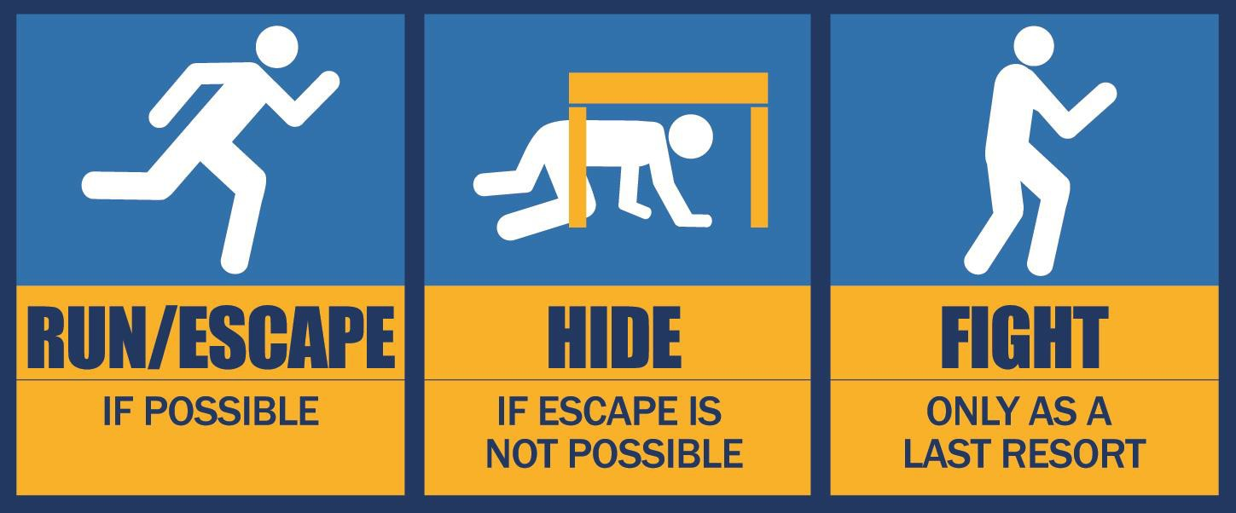

**Law Enforcement**

Law enforcement’s purpose is to stop the active assailant as soon as possible. Officers will proceed

directly to the area in which the last shots were heard.

While officers may prefer to team up, they are likely to deploy individually, upon arrival at the scene Officers may wear regular patrol uniforms or external bulletproof vests, Kevlar helmets, and other

tactical equipment

Officers may be armed with rifles, shotguns, handguns

Officers may use pepper spray or tear gas to control the situation

Officers may shout commands, and may push individuals to the ground for their safety

The first officers to arrive to the scene will not stop to help injured persons. Expect rescue teams comprised of additional officers and emergency medical personnel to follow the initial officers. These rescue teams will treat and remove any injured persons. They may also call upon able-bodied individuals to assist in removing the wounded from the premises.

While law enforcement personnel are still assessing the situation, uniformed security and/or police officers will move through the entire area to ensure the threat is over. For the safety of you and the officers, you may be handcuffed until the incident details are fully known.

How to react when law enforcement arrives:

Remain calm, and follow officers’ instructions

Put down any items in your hands (i.e., cell phones, bags, jackets) Immediately raise hands and spread fingers

Always keep hands visible

Avoid making quick movements toward officers such as holding on to them for safety Avoid pointing, screaming and/or yelling

Do not stop to ask officers for help or direction when evacuating, just proceed in the direction from which officers are entering the premises

Once you have reached a safe location or an assembly point, you will likely be held in that area by law enforcement until the situation is under control, and all witnesses have been identified and questioned. Do not leave until law enforcement authorities have instructed you to do so.

#### Considerations

If a security threat is imminent or occurring, our personnel will take all reasonable and appropriate

actions to minimize the hazard to the District’s students and staff. If the perpetrator(s) is known, Incident Command will immediately deactivate the incident site’s ID card(s) to prevent the individual(s) from entering a building/room equipped with card access.

For locations without electronic access control, incident personnel will make reasonable attempts to secure these doors as quickly as possible. The nature of the threat may make it unsafe for incident personnel to move from door-to-door, thus preventing these locations from being quickly secured.

If you become aware of an active assailant situation, immediately notify Police at 911. Information to provide to law enforcement or 911 operators:

Location of the active assailant Number of assailants

Identity of the assailant(s), if known Physical description of assailant(s)

Number and type of weapons held by the assailant(s) Number of potential victims at the location

#### After

**Good Practice for Coping**

Be aware of your environment and any possible dangers Take note of the two nearest exits in any facility you visit If you are in an office, stay there and secure the door

If you are in a hallway, get into a room and secure the door

As a last resort, attempt to take the active assailant down. When the assailant is at close range and you cannot flee, your chance of survival is much greater if you try to incapacitate him/her.

Call 911 when it is safe to do so

Any time there is a significant security concern, we will make every reasonable attempt to immediately increase security on site. At the same time emergency personnel are responding to the emergency, public safety officials will communicate the hazard to the community via all available and appropriate means.

If you receive an official emergency communication notifying you of a hazardous situation where you must take immediate action to protect yourself, stay as calm as possible and follow these procedures. Only you will be able to determine the safest course of action that should be taken.

Cyber Threat or Attack

### Logo Description automatically generatedPurpose

Understanding the risks and motivations behind cyber threats or attacks is crucial in establishing and implementing this Cyber Threat or Attack annex.

Technology continues to improve and develop at an amazing pace and with

that advancement comes the challenges of protecting what we collect and manage using that technology.

Common criminals as well as hostile foreign actors have a couple of primary motivations when it

comes to attacking your organization’s cyber space. Both money and operational disruption are at the top of that list. For some hackers, they thrive on finding ways to access your information and then sell it, or threaten to disclose it asking for a “ransom,” while freezing up your means of storing, accessing, or distributing information.

This annex will focus on the incident management perspective and address what to do before, during, and after an incident, following current best practices. These practices fall under the general category of cyber security.

### Situation and Assumptions

Think of the cyber world as you would your own facilities. You provide appropriate fencing to ensure the security of those within its boundaries. The more access points you provide the more difficult it becomes to keep that site secure and safe. The cyber world is really the same way. Years ago we may have had only a handful of access points to our local area network. As technology improved, we added access. As we added access we provided more entry points for those who would seek our harm.

We are making some basic assumptions about systems and practices we should have in place:

* Installed and using modern firewall and antivirus software
* Conducting regular antivirus scanning
* Configured firewalls to prevent ransomware
* Keeping operating systems patches up-to-date
* Completing critical patching as expeditiously as possible
* Conducting employee cyber security awareness training including current best practices
* Keeping individual sites segregated
* Keeping user groups segregated (staff and student users segregated)
* Keeping privilege access management limited
* Using multi-factor authentication
* Implemented and using strong password policy
* Using off-site back up
* Providing email filtering to prevent spam reaching employees

### Organization and Assignment of Responsibilities

Our IT department will have leadership over all aspects of our technology equipment and network spaces. They are the core of our Cyber Security Incident Response Team.

It is the responsibility of our Information Technology (IT) professionals to maintain a safe and secure cyber space. However, it is every network user’s responsibility to follow best practices introduced by our IT professionals.

### Glossary of Terms

#### Cyber Security Incident Response Team (CSIRT)

A group of experts that assesses, documents and responds to a cyber incident so that a network can not only recover quickly, but also avoid future incidents.

#### Denial-of-service attack

A denial-of-service attack floods systems, servers, or networks with traffic to exhaust resources and bandwidth. As a result, the system is unable to fulfill legitimate requests. Attackers can also use multiple compromised devices to launch this attack. This is known as a distributed-denial-of-service (DDoS) attack.

#### DNS Tunneling

DNS tunneling utilizes the DNS protocol to communicate non-DNS traffic over port 53. It sends HTTP and other protocol traffic over DNS. There are various, legitimate reasons to utilize DNS tunneling. However, there are also malicious reasons to use DNS Tunneling VPN services. They can be used to disguise outbound traffic as DNS, concealing data that is typically shared through an internet connection. For malicious use, DNS requests are manipulated to exfiltrate data from a compromised system to the attacker’s infrastructure. It can also be used for command and control callbacks from the attacker’s infrastructure to a compromised system.

#### Malware

Malware is a term used to describe malicious software, including spyware, ransomware, viruses, and worms. Malware breaches a network through a vulnerability, typically when a user clicks a dangerous link or email attachment that then installs risky software. Once inside the system, malware can do the following:

* Blocks access to key components of the network (ransomware)
* Installs malware or additional harmful software
* Covertly obtains information by transmitting data from the hard drive (spyware)
* Disrupts certain components and renders the system inoperable

#### Man-in-the-middle attack

Man-in-the-middle (MitM) attacks, also known as eavesdropping attacks, occur when attackers insert themselves into a two-party transaction. Once the attackers interrupt the traffic, they can filter and steal data.

Two common points of entry for MitM attacks:

* On unsecure public Wi-Fi, attackers can insert themselves between a visitor’s device and the

network. Without knowing, the visitor passes all information through the attacker.

* Once malware has breached a device, an attacker can install software to process all of the

victim’s information.

#### Phishing

Phishing is the practice of sending fraudulent communications that appear to come from a reputable source, usually through email. The goal is to steal sensitive data like credit card and login information or to install malware on the victim’s machine. Phishing is an increasingly common cyberthreat.

#### SQL injection

A Structured Query Language (SQL) injection occurs when an attacker inserts malicious code into a server that uses SQL and forces the server to reveal information it normally would not. An attacker could carry out a SQL injection simply by submitting malicious code into a vulnerable website search box. Learn how to defend against SQL injection attacks.

#### Zero-day exploit

A zero-day exploit hits after a network vulnerability is announced but before a patch or solution is implemented. Attackers target the disclosed vulnerability during this window of time. Zero-day vulnerability threat detection requires constant awareness.

### Incident Command Actions

Maintaining a best-practices approach to cyber security requires us to keep up to date on current trends and threats in the cyber world. Most of what we know comes from internet service providers who share this information to help us be better prepared.

Our cybersecurity response process recommendations by the SANS Institute, as defined in its [Incident](https://sansorg.egnyte.com/dl/6Btqoa63at)

[Handler’s Handbook](https://sansorg.egnyte.com/dl/6Btqoa63at).

#### Before

**Preparation**

* Define, develop, and implement an Information Security policy and procedures that addresses current and possible future risks to cyber information handing and protection
* Conduct regular and periodic training for our staff to ensure they have the tools they need to preserve our cyber security. This may include hands-on virtual or email tests and scenarios designed to reinforce safe cyber practices and protect our digital/cyber foot print.
* Perform regular security assessments and intrusion testing
* Provide a trained staff Cybersecurity Incident Response Team (CSIRT)

#### During Identification

* Monitor IT systems and detect deviations from normal operations and see if they represent actual security incidents
* Establish type and severity
* Log actions and responses
* Collect evidence

#### Containment

* Isolate impacted system(s)
* Implement temporary workarounds to maintain operations

#### Eradication

* Identify the root cause
* Remove malicious software from all affected systems
* Take action to prevent root cause from recurring

#### Caution

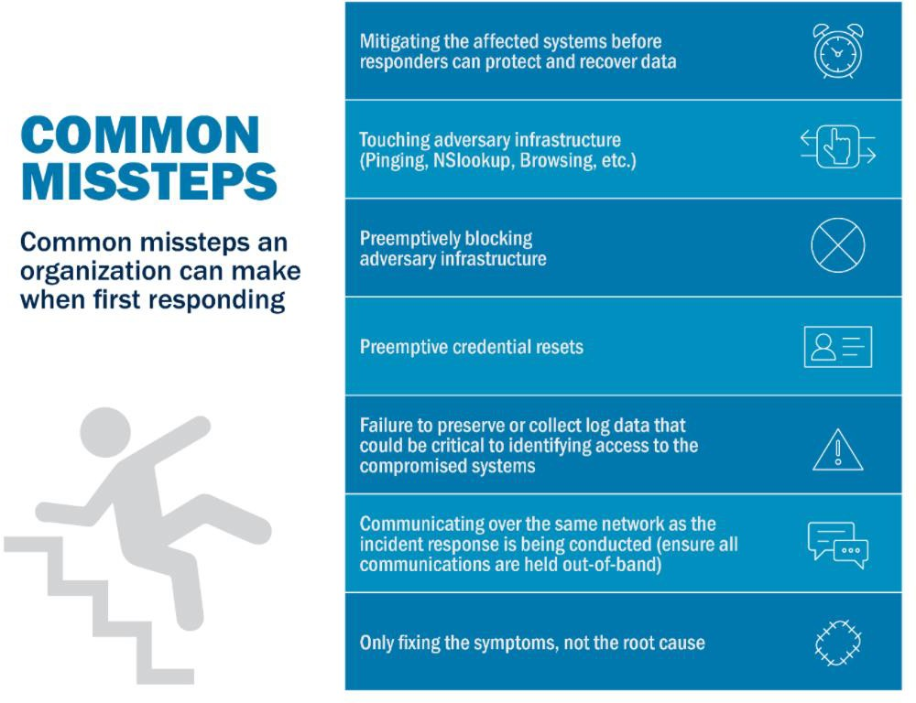

**After Recovery**

* Bring affected systems back online
* Test, verify, and monitor affected systems to ensure they are operating normally

#### After-Action Report

* Finalized incident documentation
* Perform a retrospective of the incident to determine what was effective and what was not to identify lessons learned
* Modify and update this annex and any policy or procedure identified as insufficient or failed in the after-action debrief and report

### Authorities and References

#### State

Cal OES - California Cybersecurity Integration Center

* [https://www.caloes.ca.gov/cal-oes-divisions/law-enforcement/california-cybersecurity-](https://www.caloes.ca.gov/cal-oes-divisions/law-enforcement/california-cybersecurity-integration-center) [integration-center](https://www.caloes.ca.gov/cal-oes-divisions/law-enforcement/california-cybersecurity-integration-center)

#### Federal

Department of Homeland Security - Cybersecurity and Infrastructure Security Agency (CISA)

* <https://www.cisa.gov/>

National Institute of Standards and Technology (NIST) – Cybersecurity

* <https://www.nist.gov/cybersecurity>

Earthquake

### Duck, Cover, and Hold

This action is used to protect students and staff from flying or falling debris. Upon the first indication of an earthquake, staff should direct students to **Duck,**

###### Cover, and Hold.

The Incident Commander will make the following announcement on the PA System:

“ATTENTION PLEASE. DUCK, COVER AND HOLD. DUCK, COVER, AND HOLD. ADDITIONAL INFORMATION TO FOLLOW.”

Note: If the PA system is not available, use other means of communication, i.e. send messengers to deliver instructions, email, etc.

### Description of Action

#### If inside

Drop to knees

Get under desk and remain facing away from windows Clasp both hands behind neck

Bury face in arms

Make body as small as possible

Close eyes and cover ears with forearms.

#### If outside

Drop to knees

Clasp both hands behind neck Bury face in arms

Make body as small as possible

Close eyes and cover ears with forearms. Avoid glass and falling objects

### Procedures

Avoid glass and falling objects. Move away from windows, heavy suspended light fixtures, and other overhead hazards.

When the shaking stops, the Incident Commander will issue the All Clear Response

Use prescribed routes and proceed directly to the Assembly Area. Teachers shall notify the Student Attendance/Release Team of missing students.

The Incident Commander to direct the Security Team to post guards a safe distance away from building entrances to prevent access.

Warn all personnel to avoid touching fallen electrical wires.

First Aid Team will check for injuries and provide appropriate first aid.

The Incident Commander will direct the Facility Team to turn off water, gas, and electrical and to alert appropriate utility company of damages, if appropriate.

If the area appears safe, the Search and Rescue team will be cleared by the Incident Commander to

make an initial inspection of the District’s buildings, if needed.

The Incident Commander will contact the Superintendent to determine if additional actions are deemed necessary.

### During Non-Operating Hours

The Incident Commander and Identified Maintenance/Facilities Personnel will assess damages to determine needed corrective actions. For apparent damages, contact the Superintendent to determine if the District should be closed.

If the District must be closed, notify staff and students as identified in District Closure Response Procedure.

Fire - Structural

The following procedure addresses the necessary actions that should be taken if a fire is discovered in or on the District’s facilities. A timely response to this situation is critical to prevent injuries and further property damage.

### Procedure

**NOTE** – There are cases during Active Assailant incidents where the assailant may

trigger the fire alarm. This is done as a means to induce students and staff to evacuate which may provide the assailant with more “targets.” Modified responses to a fire alarm should be discussed with your local fire and law enforcement jurisdictions to coordinate best practices for your district.

If a fire is discovered on site, the administrative staff will immediately signal the fire alarm and direct students out of the building.

The Incident Commander will call 911 and provide the location and nature of the incident The Incident Commander will immediately initiate the Off-Site Evacuation Procedures

Staff and students will evacuate buildings using pre-designated routes or other safe routes and convene at the Assembly Area

Site staff members must bring their student rosters and take attendance at the Assembly Area to account for all students

Staff will notify the Incident Commander of any missing students

If safe to do so, staff will use fire extinguishers to suppress the fire until the local fire department arrives

All fires, regardless of size, which are extinguished by site personnel, require a call to the

responding Fire Department to indicate “the fire is out”

The Incident Commander will secure the area to prevent unauthorized entry and keep access roads clear for emergency vehicles

The Incident Commander will notify the Senior Executive of the fire. The Senior Executive should work with the Public Information Officer

Outreach and Communication to disseminate information

In the event that students need to be released from the school site, refer to the Reunification Annex for reunification procedures

If necessary, the Incident Commander will notify appropriate Transportation official to request transportation for student and staff evacuation.

Any affected areas will not be reopened until the Fire Department or the appropriate agency provides clearance and the Incident Commander issues authorization to do so. For fires during non-school hours, the Incident Commander and the Senior Executive will determine if the school site will open the following day.

Fire – Forest, Wildfire, or Urban Interface

### General

Fires can happen in almost any place, at any time, in almost any condition or circumstance as long as there is fuel, oxygen, and heat. While District’s are required to have regularly scheduled fire drills by California law it is easy to overlook the risks associated with poor housekeeping, excessive and dried

wildland shrubs and trees close to the District sites and many other factors. The damage caused by fire is real and serious, but the potential hazard of smoke can sometimes be even worse.

### Fire in Surrounding Area

The following procedure addresses actions that should be taken in the event that a fire is discovered in an area nearby District grounds. The initiated response actions should take into consideration the location and size of the fire, its proximity to the District site, and the likelihood that the fire may affect the District.

### Incident Command Actions

#### Before

Review and update the “Recovery” Annex located in your Functional Annex following current State and Federal “Best Practices” guidelines

Locate and participate in CSTI’s course, “Recovery From Disasters: The Local Community Role (G- 205)

Identify and include your “whole community” in strengthening your Pre-Disaster Recovery framework

#### During

Call 911 if you see a fire or flames.

Activate and follow your Emergency Operations Plan.

Use your internal Emergency Management Alert System to communicate with staff, students and parents.

Always follow instructions from your local emergency agencies (Fire and Law Enforcement).

If trapped, call 911 and give your location, but be aware that emergency response could be delayed or impossible. Turn of HVAC and natural gas. Turn on lights to help rescuers find you if you have power. Fill sinks and tubs with water and keep windows and doors unlocked.

Ensure you have a representative designated to be in contact with Cal OES (may be specific to your region) and your local EOC

You might consider predesignating a representative to be an active member of the Recovery task force.

If your site is a designated shelter or evacuation point, follow the instructions of the organization or agency that is managing the site (ie: American Red Cross).

Follow the Cal/OSHA Protection from Wildfire Smoke regulation, Title 8, Section 5141.1 for use of N95 respirators. <https://www.dir.ca.gov/title8/5141_1.html>. and you can find resources on wildfire smoke safety in this Cal/OSHA link. [https://www.dir.ca.gov/dosh/Worker-Health-and-](https://www.dir.ca.gov/dosh/Worker-Health-and-Safety-in-Wildfire-Regions.html) [Safety-in-Wildfire-Regions.html](https://www.dir.ca.gov/dosh/Worker-Health-and-Safety-in-Wildfire-Regions.html)

Monitor the Air Quality Index (AQI) at [www.airnow.gov](http://www.airnow.gov/) and enter the zip code of the location where you will be working. The current AQI is also available from the U.S. Forest Service at <https://tools.airfire.org/> or a local air district, which can be located at [www.arb.ca.gov/capcoa/dismap.htm](http://www.arb.ca.gov/capcoa/dismap.htm)

Listen to EAS, NOAA Weather Radio, or local alerting systems for current emergency information and instructions.

If you are not ordered to evacuate but smoky conditions exist, stay inside in a safe location or go to a location where smoke levels are lower, if possible.

Avoid vigorous activities outdoors and if travelling in a vehicle in the areas affected, close windows

and make sure air is on “re-circulate” mode.

#### After

Continue to follow your EOP Recovery Annex

Listen to authorities to find out when it is safe to return and whether water is safe to drink.

Avoid hot ash, charred trees, smoldering debris, and live embers. The ground may contain heat pockets that can burn you or spark another fire. Consider the danger to pets and livestock.

Avoid downed power lines.

Send text messages or use social media to reach out to family and friends. Phone systems are often busy following a disaster. Make calls only in emergencies.

For those that are part of the damage assessment team, ensure training on personal protective equipment (PPE) use is conducted.

Continue to monitor the Air Quality Index (AQI) at [www.airnow.gov](http://www.airnow.gov/) and enter the zip code of the location where you will be working. The current AQI is also available from the U.S. Forest Service at <https://tools.airfire.org/> or a local air district, which can be located at [www.arb.ca.gov/capcoa/dismap.htm](http://www.arb.ca.gov/capcoa/dismap.htm)

Contact your insurance company/insurance pool/JPA for assistance.

Document everything you do related to the fire. For more details on this process, refer to the IMReady FEMA document.

Wildfires dramatically change landscape and ground conditions, which can lead to increased risk of flooding due to heavy rains, flash flooding and mudflows. Flood risk remains significantly higher until vegetation is restored — up to 5 years after a wildfire.

Be prepared to provide emotional and wellbeing services and resources for students and staff.

Mental and physical fatigue are common in these situations . <https://www.cdc.gov/disasters/wildfires/afterfire.html> and

<https://emergency.cdc.gov/coping/index.asp> and [www.NCTSN.org.](http://www.nctsn.org/)

Any responsible person who observes a fire in the area outside of the District should immediately call 911 and notify the Incident Commander

The Incident Commander will initiate the appropriate Immediate Response Actions, which may include Shelter-in-Place, On-Site Evacuation, or Off-Site Evacuation

The Incident Commander will call 911 (to verify – good redundancy) and provide the location and nature of the incident

The Incident Commander will act to prevent students from approaching the fire and keep routes open for emergency vehicles

The Incident Commander will work with responding emergency personnel to determine if District grounds are threatened by the fire, smoke, or other hazardous conditions

If the Incident Commander issues the On-Site Evacuation procedure, staff and students will evacuate the affected building(s) using pre-designated routes or other safe routes and convene at the Assembly Area

All District staff members must bring their student rosters and take attendance at the Assembly Area to account for all students. Staff will notify the Incident Commander of any missing students

The Incident Commander should monitor local radio stations for emergency information. The Incident Commander will notify the Senior Executive of the emergency situation

The office of the Senior Executive should work with the Office of Public Information and Communication to disseminate information

If necessary, the Incident Commander will notify the appropriate Transportation official to request transportation for staff and student evacuation

The Incident Commander will initiate Off-Site Evacuation procedures, as described in the Evacuation Annex, if warranted by changes in conditions

* In the event that students need to be released from the District site, refer to the Reunification Annex for reunification procedures

Infectious Disease

### Logo Description automatically generatedPurpose

The purpose of the Infectious Disease annex is to help equip our organization to be ready for the unexpected – before, during, and after an infectious disease outbreak. **This annex does note replace the required Injury and Illness Prevention Program (IIPP) or other health and safety orders relevant to California Occupational Safety and Health Administration (Cal OSHA) or California Department of Public Health (CDPH)requirements**.

Following are two current and specific requirements:

* COVID-19 Safety Plan (CSP) – The CSP is outlined in the CDPH Guidance and Framework for K-12 schools dated January 14, 2021
* The COVID-19 Prevention Plan (CPP) – The CPP is a requirement of the Cal/OSHA COVID -19 Prevention emergency temporary standard.

Infectious diseases occur, often with little or no warning. Essentials that need to be considered include the following:

EOPs may have to be activated with community partners if there is an infectious disease outbreak;

Rapid evolution and dissemination of information about an infectious disease incident will likely require activation of the Communication Annex;

Extensive absences may cause normal operations to close for days or weeks, calling for the activation of the Continuity of Operations (COOP) Annex;

Depending on the disease, there may potentially be some deaths in the community; and, If handled poorly, community trust in our organization is likely to be shaken.

### Disease Sources

Infectious diseases are illnesses that are transmitted from one person to another through various routes. These infectious diseases can be viral, bacterial, or fungal. Some of the more common infectious diseases that may affect us are:

Gastroenteritis; norovirus; influenza; chicken pox; and hand, foot, and mouth, which are all caused by a *viral infection*,

*Bacterial infections* that can cause E. Coli, MRSA, and strep throat, and

*Fungal infections*, like ringworm.

Influenza, one of the most common infectious diseases, is a highly contagious viral disease. Pandemic influenza differs from both seasonal influenza (flu) and avian influenza in the following aspects:

It is a rare global outbreak which can affect populations around the world. It is caused by a new influenza virus to which people do not have immunity

Depending upon the specific virus, it can cause more severe illness than regular flu

Influenza can affect young healthy people more so than older, sick people. The Department of Health and Human Services will take the lead in mobilizing a local response to pandemic influenza. Public health alerts will be reported to our organization and the community. Individual rooms, hallways or, if necessary, entire sites may be closed temporarily to contain spread of the virus.

While influenza is the most common infectious disease there are others that can greatly affect our operations, including reduction in work force size to levels that make it difficult to fulfill organizational or operational mission objectives. The “**Historical Information**” section of this annex identifies some of the major infectious diseases that have affected us in the near past.

### Rate of Spread

Infectious diseases may be categorized according to the rate at which they infect the population. The

U.S. Centers for Disease Control and Prevention (CDC) categorizes the rate at which diseases are spread as a continuum from smallest to largest: case, outbreak, epidemic, and pandemic.

#### Case

A case is defined as *an individual* with the disease.

#### Outbreak

An outbreak is defined as a *localized*, as opposed to a generalized, epidemic. This term is also used synonymously with epidemic, and is sometimes the preferred word, as it may prevent sensationalism associated with the word epidemic.

#### Epidemic

An epidemic is defined as the *occurrence of more cases of disease than expected* in a given area or among a specific group of people over a period.

#### Pandemic

A pandemic is defined as an *epidemic occurring over a very wide area* (several countries or continents) and usually affecting a large proportion of the population.

### Situation and Assumptions

The World Health Organization (WHO) provides an influenza pandemic alert system, with a scale ranging from Phase 1 (a low risk of a flu pandemic) to Phase 6 (a full-blown pandemic). See Figure 1, below.

**Phase 1:** A virus in animals has caused no known infections in humans.

**Phase 2:** An animal flu virus has caused infection in humans.

**Phase 3:** Sporadic cases or small clusters of disease occur in humans. Human-to-human transmission, if any, is insufficient to cause community-level outbreaks.

**Phase 4:** The risk for a pandemic is greatly increased but not certain.

**Phase 5:** Spread of disease between humans is occurring in more than one country of one WHO region.

**Phase 6:** Community-level outbreaks are in at least one additional country in a different WHO region from phase 5. A global pandemic is under way.

**Figure 1: Infectious Disease Phases (WHO)**

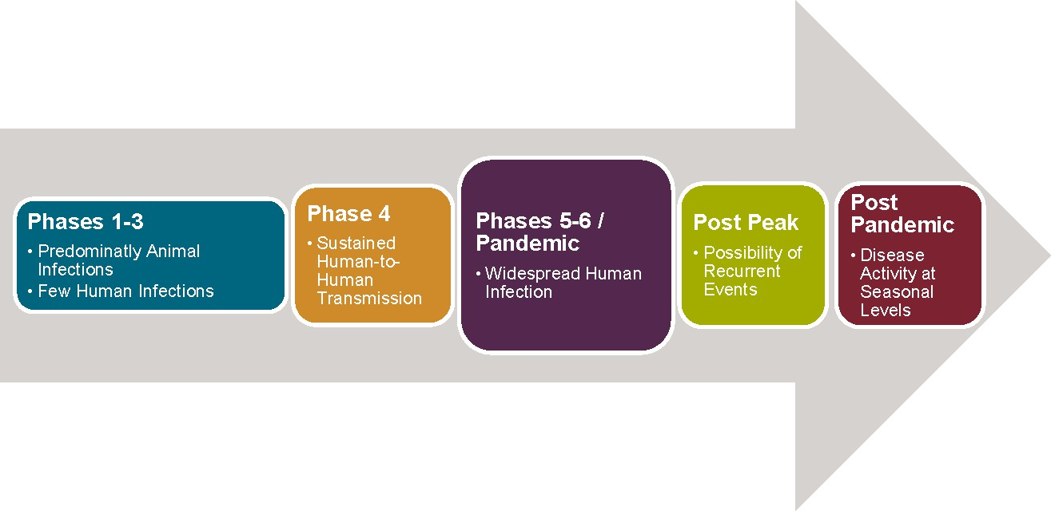

### Concept of Operations

We monitor the following levels of activation for our EOP and Emergency Operations Center:

#### Level 3 (lowest level):

This level implies that, with modest augmentation, the lead agency or program can address the primary needs of the response. In the United States, many small natural disasters or environmental responses fall into this activation level.

#### Level 2 (intermediate level):

This level implies substantial augmentation is required for the lead agency or program to meet response requirements.

#### Level 1 (highest level):

This level requires an agency wide response and often includes domestic and international partners. As an example, there have been five Level 1 activations since 2005: Hurricane Katrina (2005), influenza A (H1N1) pandemic (2009–10), Ebola virus disease outbreak (2014–2016), Zika virus outbreak (2016– 2017), and Coronavirus Disease 2019 (2019-202?).

### Continuity of Operations (Annex Specific) Important Notice

Occupational Health and Safety standards impose additional requirements on employers to protect employees from airborne infectious diseases like COVID-19 and pathogens transmitted by aerosols. Under section 3203 of California’s general industry safety regulations, employers must establish, implement, and maintain an effective Injury and Illness Prevention Program (IIPP) to protect employees from workplace hazards. Employers are required to determine if the infectious disease is a hazard in their workplace. If it is a workplace hazard, then employers must implement infection control measures, including applicable and relevant recommendations from federal, state and local guidelines. It is the employer’s responsibility to maintain a current and relevant IIPP.

All staff are to be informed regarding protective actions and/or modifications related to this plan. Messaging and risk communications during an emerging infectious disease or pandemic will be conducted by our Emergency Operations Center. Guidance and instructions on established infection control measures such as social distancing, personnel protective equipment and telework polices are provided by our Emergency Operations Center to assist in limiting the spread of influenza at the primary and alternate worksites.

Within the workplace, social distancing measures could take the form of:

Modifying the frequency and type of face-to-face employee encounters (e.g., placing moratoriums on hand-shaking, substituting teleconferences for face-to-face meetings, staggering breaks, posting infection control guidelines);

Establishing flexible work hours or worksite, (e.g., telecommuting);

Promoting social distancing between employees and those with whom they interact to maintain six-feet spatial separation between individuals; and

Implementing strategies that request and enable employees with influenza to stay home at the first sign of symptoms.

Frequent, daily contact is important to keep our employees informed about developments in our response, impacts on the workforce, and to reassure employees that we are continuing to function as usual.

When necessary, our planners and pandemic response teams will include deliberate methods to measure, monitor, and adjust actions to changing conditions and improved protection strategies.

Implement a formal worker and workplace protection strategy with metrics for assessing worker conformance and workplace cleanliness.

Monitor and periodically test protection methods.

Track and implement changes in approved or recommended protection measures. Pre-position material and equipment onsite.

Ensure essential personnel are at the primary worksite.

Reaffirm that essential suppliers have their material and personnel on-hand and can respond, and support as planned.

Coordinate with local public health and emergency response points of contact to ensure open, adequate communications.

### Organization and Assignment of Responsibilities

We utilize the Standardized Emergency Management System (SEMS) which incorporates the Incident Command System (ICS) as the method of managing a crisis or event until operations return to

“normal.” This includes activation, when necessary, of incident command posts and the activation of our EOC.

### Plan Development

During the health crisis it is vital that we capture lessons learned and alternative practices to our operations as they occur

Maintain a central depository for this information to use it following the crisis to update this annex and our EOP in general

It is our intent to review our EOP and annexes at least annually and update as necessary to maintain a best-practices EOP

We will share this annex periodically with our Health partners to ensure it has captured the most current trends and practices

### Authorities and References

In the United States, the responsibility for public health rests primarily with city or county and state public health agencies. All states and many large counties and cities have their own public health departments. Although many public health investigations are conducted with local resources, a city, county, or state health department can request field epidemiologic or laboratory assistance from the next higher-level public health agency in response to a large or complex outbreak or problem that requires additional staff, expertise, or other resources.

In the United States, the Centers for Disease Control and Prevention (CDC) is the highest-level public health agency. Federal prisons, military bases, and tribal reservations have their own independent health systems but also can request assistance from CDC. Globally, countries can request assistance for field investigations from the World Health Organization, which coordinates with its members for needed resources. The Centers for Disease Control and Prevention (cdc.gov) contains the most current and relevant information on specific exposures and the appropriate practices and protocols.

### Incident Command Actions

#### Before

One of the best things to do prior to an infectious disease incident is to identify, collect, and maintain current and relevant contact information of organizations and agencies that will be important to our ongoing operations. These should include local, state, and federal public health jurisdictions such as:

Your local health department contact

(Searchable database <https://www.naccho.org/membership/lhd-directory>)

California Department of Public Health – <https://www.cdph.ca.gov/> Centers for Disease Control and Prevention (CDC) - <https://www.cdc.gov/>

Building and maintaining relationships with local health officials cannot be over emphasized. This effort before an infectious disease outbreak will prove invaluable as we seek support and guidance in maintaining, shutting down, and resuming operations.

In addition to this practice it is important to identify and document operational norms and standards that you maintain on an ongoing basis. These records will greatly help you resume operations following a major infectious disease event.

#### During

We activate our Emergency Operations Plan at a level sufficient to stay ahead of issues as much as possible including the activation of:

Communication annex

Continuity of Operations Plan (COOP) annex Additional actions include:

Maintain contact with our local Health Department and coordinate our actions based upon their recommendations

Collect preventive informational flyers and documents and disseminate to staff and/or students, as relevant

Activate heightened surveillance of illness within our sites. Gather data on symptoms of all students and/or staff who are sick at home.

Insure those who are ill stay home Send the sick home immediately

Provide fact sheets and guidelines for families to make them aware of symptoms and remind them of respiratory hygiene etiquette

Monitor bulletins and alerts from the Department of Health and Human Services Keep staff and students informed of developing issues

Assist the Department of Health and Human Services in monitoring outbreaks Respond to media inquiries regarding organization attendance status Implement telework procedures, if necessary, so that staff can stay home

Maintain surveillance after the initial epidemic in the event a second wave passes through the community

#### After

As with any major crisis or incident the major goal of our institution is to get things back to “normal.” This means restoration of our primary operations back to pre-incident or event levels. This is most effectively accomplished when there are accurate and well-maintained records and practices in place that help us on this recovery journey. Following are key concepts and actions that should be

considered in getting back to “normal.”

### COVID-19 Specific Guidance

The source of information contained in this portion of the Infectious Disease annex is located on the Center for Disease Control and Prevention (CDC) website, in the Covid-19 section at:

<https://www.cdc.gov/coronavirus/2019-nCoV/index.html>

#### Primary Symptoms

fever

dry cough shortness of breath fatigue

Newly acquired loss of taste or smell

#### Preventative Measures

* Vaccines are available. Consider getting vaccinated.
* Wear face Coverings
* Avoid close contact and maintain Social Distancing (approximately 6 feet apart)

The CDC has posters available for our use. See **“Stop the Spread of Germs”** poster in Figure 2 as an example.

Know How It Spreads Wash Your Hands Often

Avoid Close Contact (Social distancing) Wear Face Coverings

Clean And Disinfect Monitor Your Health Daily

#### Know How It Spreads

There are now vaccines available to help prevent coronavirus disease 2019 (COVID-19) and its variants. The virus is thought to spread mainly from person-to-person:

Between people who are in close contact with one another (within about 6 feet). Through respiratory droplets produced when an infected person coughs, sneezes or talks.

These droplets can land in the mouths or noses of people who are nearby or possibly be inhaled into the lungs.

Some recent studies have suggested that COVID-19 may be spread by people who are not showing symptoms.

#### Wash Your Hands Often

Wash your hands often with soap and water for at least 20 seconds especially after you have been in a public place, or after blowing your nose, coughing, or sneezing. It’s especially important to wash:

Before eating or preparing food Before touching your face

After using the restroom After leaving a public place

After blowing your nose, coughing, or sneezing After handling your cloth face covering

After changing a diaper

After caring for someone sick After touching animals or pets

If soap and water are not readily available, use a hand sanitizer that contains at least 60% alcohol. Cover all surfaces of your hands and rub them together until they feel dry.

#### Avoid touching your eyes, nose, and mouth with unwashed hands. Avoid Close Contact

**Inside your home**:

Avoid close contact with people who are sick.

If possible, maintain 6 feet between the person who is sick and other household members.

#### Outside your home:

Put 6 feet of distance between yourself and people who don’t live in your household.

Remember that some people without symptoms may be able to spread virus.

Stay at least 6 feet (about 2 arms’ length) from other people.

Keeping distance from others is especially important for people who are at higher risk of getting very sick.

#### Wear Face Coverings

Cover your mouth and nose with a cloth face cover when around others You could spread COVID-19 to others even if you do not feel sick.

The cloth face cover is meant to protect other people in case you are infected.

Everyone should wear a cloth face cover in public settings and when around people who don’t live

in your household, especially when other social distancing measures are difficult to maintain.

Cloth face coverings should not be placed on young children under age 2, anyone who has trouble breathing, or is unconscious, incapacitated or otherwise unable to remove the mask without assistance.

Do NOT use a facemask meant for a healthcare worker. Currently, surgical masks and N95 respirators are critical supplies that should be reserved for healthcare workers and other first responders.

Continue to keep about 6 feet between yourself and others. The cloth face cover is not a substitute for social distancing.

#### Clean And Disinfect

Clean and disinfect frequently touched surfaces daily. This includes tables, doorknobs, light switches, countertops, handles, desks, phones, keyboards, toilets, faucets, and sinks.

If surfaces are dirty, clean them. Use detergent or soap and water prior to disinfection.

Then, use a household disinfectant. Most common EPA-registered household disinfectants will work.

#### Monitor Your Health Daily

Be alert for symptoms. Watch for fever, cough, shortness of breath, or other symptoms of COVID-19. This is especially important if you are running essential errands, going into the office or workplace, and in settings where it may be difficult to keep a physical distance of 6 feet.

**Take your temperature** if symptoms develop.

Don’t take your temperature within 30 minutes of exercising or after taking medications that could

lower your temperature, like acetaminophen.

Follow CDC guidance if symptoms develop.

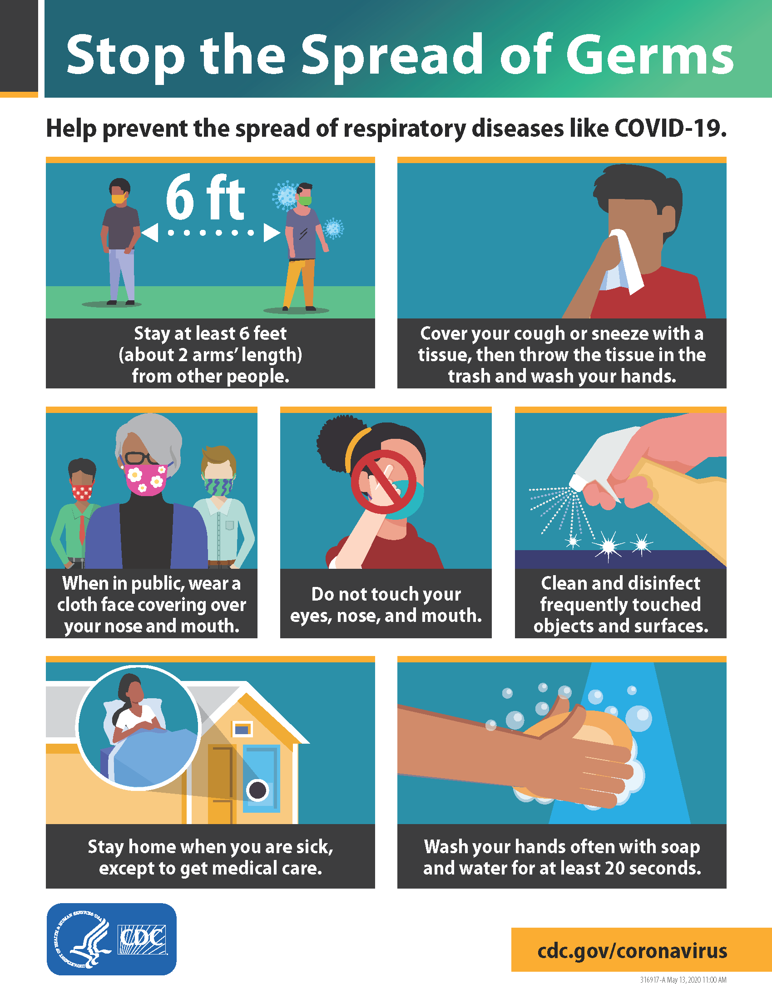**Figure 2: Stop the Spread of Germs**

### Historical Information

This timeline captures the last century, to date. See Figure 3, following.

#### 1918: H1N1 flu

H1N1 is a strain of flu that still circulates the globe annually.

#### 1921-1925: Diphtheria epidemic

Diphtheria peaked in 1921, with 206,000 cases. It causes swelling of the mucous membranes, including in your throat, that can obstruct breathing and swallowing.

#### 1916-1955: The peak of polio

Polio is a viral disease that affects the nervous system, causing paralysis. It spreads through direct contact with people who have the infection.

#### 1957: H2N2 flu

A major flu outbreak occurred again in 1957. The H2N2 virus, which originated in birds, was first reported in Singapore in February 1957, then in Hong Kong in April 1957.

#### 1981-1991: Second measles outbreak

Measles is a virus that causes fever, runny nose, cough, red eyes, and sore throat, and later a rash that spreads over the whole body.

#### 1993: Contaminated water in Milwaukee

One of Milwaukee’s two water treatment plants became contaminated with cryptosporidium, a parasite that causes the cryptosporidiosis infection. Symptoms include dehydration, fever, stomach cramps, and diarrhea.

#### 2009: H1N1 flu

In the spring of 2009, the H1N1 virus was detected in the United States and spread quickly across the country and the world. This outbreak made headlines as the swine flu.

#### 2010, 2014: Whooping cough

Pertussis, known as whooping cough, is highly contagious and one of the most commonly occurring diseases in the United States. These coughing attacks can last for months.

#### 1980s to present: HIV and AIDS

First documented in 1981, the epidemic known today as HIV appeared to be a rare lung infection. Now

we know that HIV damages the body’s immune system and compromises its ability to fight off

infections. AIDS is the final stage of HIV and, according to the CDC, in 2018 it was the 9th leading cause of death in the United States among people 25 to 34 years old. Just because a person gets HIV doesn’t mean they’ll develop AIDS.

#### 2020: COVID-19

The SARS-CoV-2 virus, a type of coronavirus that causes the disease COVID-19, was first detected in Wuhan City, Hubei Province, China in late 2019. It seems to spread easily and sustainably in the community. Cases have been reported all over the world, and as of late May 2020, there were over 1.5 million cases and over 100,000 deaths in the United States.

#### Figure 3: Infectious Disease Timeline - 21st Century

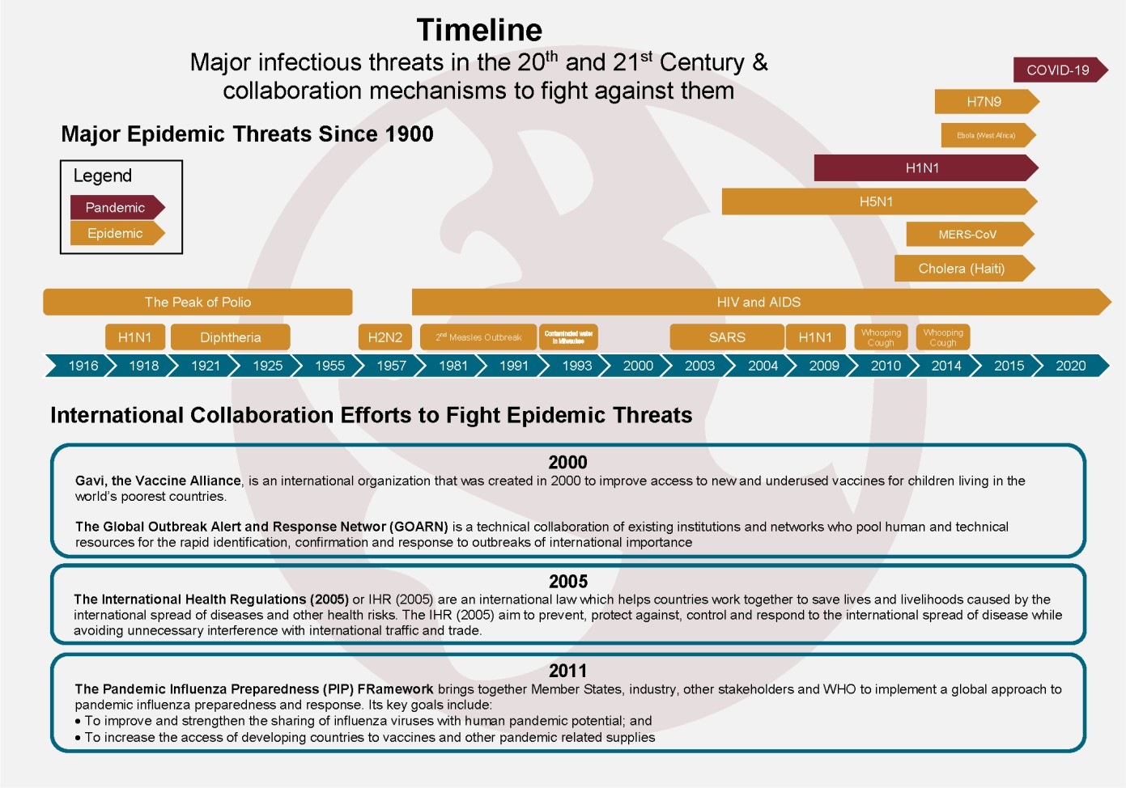

Landslides & Debris Flow

Landslides occur in all U.S. states and territories and can be caused by many factors including earthquakes, storms, volcanic eruptions, fire and human modification of land. The deadliest landslides are the ones that occur quickly, like debris flows, often with little notice. Whether you are at work or at home, the best way to prepare is to stay informed, and understand when a dangerous landslide is likely to occur.

In a landslide, masses of rock, earth or debris move down a slope. Debris and mud flows are rivers of rock, earth, and other debris saturated with water. They develop during intense rainfall, runoff, or rapid snowmelt, changing the earth into a flowing river of mud or “slurry.” They can flow rapidly, striking with little or no warning at avalanche speeds (faster than a person can run). They also can travel many miles from their source, growing in size as they pick up trees, boulders, cars and other materials. Debris flows don’t always stay in stream channels and they can flow sideways as well as downhill.

When a wildfire burns a slope, it increases the chance of debris flows for several years. Although some landslides require lengthy rain and saturated slopes, a debris flow can start on a dry slope after only a few minutes of intense rain. “Intense” rain means a burst of rain at a fast rate, about half an inch in an hour. With debris flows, the rate matters more than total rainfall.

How to protect staff, students and property depends on the type of landslide. Land-use zoning, professional inspections, and proper design can reduce many landslide problems but evacuation is often the only way to protect lives from a debris flow or other fast-moving landslide. Never ignore an evacuation order.

### Before a Landslide

The following are things we can do to protect staff, students, visitors and property from the effects of a landslide or debris flow:

* To begin preparing, build an emergency kit and make sure our Communications Annex is up to date.
* Connect with our local emergency services, heed evacuation warnings.
* Leave if we have been told to evacuate or we feel it is unsafe to remain at our site.

Text **SHELTER** + your ZIP code to **43362** (4FEMA) to find the nearest shelter in your area (example: ***shelter 12345***).

* Prepare for landslides by following proper land-use procedures - avoid building near steep slopes, close to mountain edges, near drainage ways or along natural erosion valleys.
* Become familiar with the land around us. Learn whether landslides have occurred in our area

by contacting local officials. However, don’t assume that what happened last time will happen

next time. Debris flows can start in places they’ve never been and return to slopes where they’ve already been.

* Get an assessment of our District’s property by a qualified geotechnical professional.
* Consult a professional for advice on appropriate preventative measures for our District’s sites.
* Protect District property based on the recommendations from the ‘qualified geotechnical professional’ and/or local city/county guidance on protection from debris flow and flooding. We can't stop or change the path of a debris flow. However, we may be able to protect District property from floodwaters or mud by use of sandbags, retaining walls or k-rails (Jersey barriers).
* In mud and debris flow areas, consider building channels or deflection walls to try to direct the flow around buildings. Be aware, however, that when a flow is big enough, it goes where it pleases. Also, if we divert the flow and it flows onto property owned by others, we may be liable for damages.

### Recognize Warning Signs

Watch for debris flows and other fast-moving landslides that pose threats to life:

* If you are near a wildfire burn area, sign up for emergency alerts and pay attention to weather forecasts for the burn area. The weather in the burn area could be very different from where you are.
* Listen and watch for rushing water, mud, unusual sounds.
* Unusual sounds, such as trees cracking or boulders knocking together, might indicate moving debris.
* A faint rumbling sound that increases in volume is noticeable as the landslide nears.
* Fences, retaining walls, utility poles, k-rails, boulders, or trees move.
* Huge boulders in the landscape can be signs of past debris flows. Watch for slow-moving landslides that pose threats to District property:
* Changes occur in landscape such as patterns of storm-water drainage on slopes (especially the places where runoff water converges) land movement, small slides, flows, or progressively leaning trees.
* Doors or windows stick or jam for the first time.
* New cracks appear in plaster, tile, brick, or foundations.
* Outside walls, walks, or stairs begin pulling away from the building.
* Slowly developing, widening cracks appear on the ground or on paved areas such as streets or parking lots.
* Underground utility lines break.
* Bulging ground appears at the base of a slope.
* Water breaks through the ground surface in new locations.
* Fences, retaining walls, utility poles, or trees tilt or move.
* The ground slopes downward in one direction and may begin shifting in that direction under your feet.

### During a Landslide

* Activate our Emergency Operations Plan and follow the plan concerning all notifications and communications.
* Listen to local news stations on a battery-powered radio for warnings.
* Heed all warnings and evacuation notices.
* Be aware that by the time you are sure a debris flow is coming, that will be too late to get away safely. Never cross a road with water or mud flowing. Never cross a bridge if you see a flow approaching. It can grow faster and larger too quickly for you to escape.
* If you do get stuck in the path of a landslide move uphill as quickly as possible.
* Avoid river valleys and low-lying areas during times of danger.
* If you are near a stream or channel, be alert for any sudden increase or decrease in water flow or water that changes from clear to muddy. These can be signs that a landslide is coming.

### After a Landslide

* Stay away from the slide area. There may be danger of additional slides.
* Listen to local radio or television stations for the latest emergency information.
* Watch for flooding. Floods sometimes follow landslides and debris flows because they may both be started by the same conditions.
* Check for injured and trapped persons near the slide, without entering the direct slide area. Direct rescuers to their locations.
* Report broken utility lines and damaged roadways and railways to appropriate authorities. Reporting potential hazards will get the utilities turned off as quickly as possible, preventing further hazard and injury.
* Allow trained professionals to check the building foundations, and surrounding land for damage.
* Replant damaged ground as soon as possible since erosion caused by loss of ground cover can lead to flash flooding and additional landslides in the near future.
* Seek advice from a geotechnical expert for evaluating landslide hazards or designing corrective techniques to reduce landslide risk. A professional will be able to advise you of the best ways to prevent or reduce landslide risk, without creating further hazard.

Power and Utility Failure

Extended power outages may impact the whole community and the economy. A power outage is when the electrical power goes out unexpectedly. A power outage may:

* Disrupt communications, water, and transportation
* Close retail businesses, grocery stores, gas stations, ATMs, banks, and other services
* Cause food spoilage and water contamination
* Prevent use of medical devices

### Protect Students And Staff During A Power Outage

* Keep freezers and refrigerators closed
* Only use generators outdoors and away from windows or air intakes
* Do not use gas appliances for heating
* Disconnect appliances and electronics to avoid damage from electrical surges
* Have alternate plans for refrigerating medicines or using power-dependent medical devices
* If safe, go to an alternate location for heat or cooling

### Electrical Systems

The M&O Department should identify the location of all electrical main and subpanels throughout the site

* Use a clean and clear site map of each site and label the map “Electrical Systems Field Operations Guide” (known as the Electrical Systems FOG)
* Indicate the locations of the main electrical shut-off and each sub-panel main shut-off in the Electrical Systems FOG
* Include a photo of each panel and label the photos corresponding to the panel numbers
* If panels do not have a numeric identifier, consider adding that at all panel locations
* Label the site main and subpanel main shut-off for each panel so as to minimize confusion
* Laminate or plastic-protect the Electrical Systems FOG and provide to designated and trained employee(s) who will be responsible for emergency shutdown and restoration following an electrical failure

### Backup Supplies and Other Resources

* Identify all of the items needed that rely on electricity
* Identify and have emergency plans for students or staff relying upon medical devices powered by electricity and refrigerated medicines
* Find out how long medication can be stored at higher temperatures and get specific guidance for any medications that are critical for life
* Plan for batteries and other alternatives to meet our needs when the power goes out
* Sign up for local alerts and warning systems. Monitor weather reports
* Ensure that any carbon monoxide detectors are in working order and that battery backups are available
* Determine whether the phone system will work in a power outage and how long battery backup will last
* Review the supplies that are available in case of a power outage
* Have flashlights with extra batteries available for individual rooms or offices without exterior light sources
* Maintain an inventory of nonperishable food and water
* Regularly check the thermometer in the refrigerator and freezer so that we can know the temperature when the power is restored. Throw out food if the temperature is 40 degrees or higher
* Keep mobile phones and other electric equipment charged and gas tanks full

### Survive During

* When power goes out, a trained and responsible employee should:
* Keep freezers and refrigerators closed. The refrigerator will keep food cold for about four hours. A full freezer will keep the temperature for about 48 hours. Use coolers with ice if necessary. Monitor temperatures with a thermometer.
* Maintain food supplies that do not require refrigeration
* Avoid carbon monoxide poisoning. Generators and any fuel or gas-powered devices should always be used outdoors and at least 20 feet away from windows
* Turn off or disconnect all appliances, equipment, or electronics. Power may return with

momentary “surges” or “spikes” that can cause damage

### Power Restoration

* When in doubt, throw it out! Throw away any food that has been exposed to temperatures 40 degrees or higher for two hours or more, or that has an unusual odor, color, or texture
* If the power is out for more than a day, discard any medication that should be refrigerated, unless the drug’s label says otherwise. If a life depends on the refrigerated drugs, consult a doctor or pharmacist and use medicine only until a new supply is available

Severe Weather

### Logo Description automatically generatedPurpose

The State of California is vulnerable to a variety of severe weather hazards. This incident annex addresses the hazards associated with severe weather. When severe weather occurs, the impacts can be devastating and may affect isolated locations or multiple jurisdictions simultaneously.

When the impacts exceed the capabilities of local jurisdictions, the State must respond in a prompt, organized, and efficient manner to save lives, mitigate property damage, and restore a sense of normalcy to the community. This response is coordinated through the Governor’s Office of Emergency Services (OES) in concert with local, state, Federal, volunteer, and private sector partners.

### Situation and Assumptions

##### El Niño

During El Niño, trade winds weaken. Warm water is pushed back east, toward the west coast of the Americas. El Niño means Little Boy in Spanish. South American fishermen first noticed periods of unusually warm water in the Pacific Ocean in the 1600s. The full name they used was El Niño de Navidad because El Niño typically peaks around December.

El Niño can affect our weather significantly. The warmer waters cause the Pacific jet stream to move south of its neutral position. With this shift, areas in the northern U.S. and Canada are dryer and warmer than usual. But in the U.S. Gulf Coast and Southeast, these periods are wetter than usual and have increased flooding.

##### Hail

Hail is considered severe when it reaches 1 inch in diameter. Hail can reach sizes much larger than the severe threshold size. Hail causes close to $1 billion in damage to property and crops each year in the

U.S. While property is typically at greatest risk for hail damage, the National Oceanic and Atmospheric Administration (NOAA) estimate that 24 people are injured from hail each year.

##### Thunderstorms

The National Weather Service (NWS) defines a severe thunderstorm as any storm that produces one or more of the following: a tornado, damaging wind speeds of 58 mph (50 knots) or greater, and/or hail 1 inch in diameter or larger.

### Continuity of Operations (Annex Specific)

The goal of emergency management is to restore operations of any organization back to its primary

purpose, or “normal.” In some cases, restoration of operations may have to be a new normal.

### Organization and Assignment of Responsibilities

This organization follows SEMS/NIMS requirements, specifically incorporating the Incident Command System into emergency and incident operations.

### Plan Development

This annex was selected for inclusion in this Emergency Operations Plan (EOP) following best practices Hazard/Threat Analysis and is reviewed annually for currency and applicability.

Severe weather-related hazards can occur at any time throughout the year

Local jurisdictions adversely affected by severe weather may declare local State of Emergency upon being affected

Local jurisdictions adversely affected by severe weather may use mutual aid agreements as part of their response to the disaster

Local jurisdictions affected by severe weather may request resources from the State as the situation evolves

### Authorities and References

[Center for Disease Control - Natural Disasters and Severe Weather](https://www.cdc.gov/disasters/index.html) [National Weather Service – Severe Weather Awareness](https://www.weather.gov/mob/Severe_Tstorms#%3A~%3Atext%3DSevere%20thunderstorms%20are%20defined%20as%2Cthunderstorms%20generate%20potentially%20deadly%20lightning) [Ready.Gov – Severe Weather](https://www.ready.gov/severe-weather)

### Incident Command Actions

For predictable severe weather, such as excessive rain, wind, and/or snow, the following should be included in your procedures:

##### Before

* Review your current Emergency Operations Plan (EOP) and make sure it is up to date with current best practices
* Monitor weather via reliable weather sources, such as NWS
* Have stored rain gear or have material that could be used for rain protection, such as plastic bags with head and arm cutouts
* Have enough food and water available for your site (typically a gallon of water, per day, for everyone)
* Access to sand and sandbags at a convenient location
* Make sure there are no outstanding work orders from any earlier storm damage
* Make sure all gutters, roof drains, downspouts, and catch basins are free and clear of any debris that might block normal water flow
* Be prepared for use of substitute employees and for working custodians extra hours, as needed
* If sites have generators, make sure they are currently operational and appropriately ready to run
* Revise and/or prepare for parent communications about probable event
* Consider cancelling all field trips
* Trim trees and remove dead limbs or trees
* Name and verify possible evacuation sites
* Obtain a large map of the geographical area of your district that shows streets and utilities

##### During

* Start an activity log of the event (use the ICS 214 log for this purpose)
* Follow your student dismissal protocol
* Make sure you have copies of first taken attendance of the day and have proper staff double check to make sure all persons are accounted for
* Follow staff dismissal protocol
* Follow your emergency operations plan
* Provide damage control to minimize or mitigate property damage or loss
* Be prepared for possible power outage
* Monitor issues happening in your community

##### After

* Conduct debris and mud clean up (use your property insurance provider for aid)
* Figure out classroom availability and possible alternate classroom locations for damaged and unavailable classrooms
* Conduct inspection of sites and seal off damaged areas from access by site seers
* Be prepared for mold inspections and remediation of possible mold damaged areas
* Collect and complete all documentation, including logs, pictures taken, damage assessments, etc.
* Accounting for all overtime performed
* Have returning staff check in time and make sure they are individually managing personal impacts caused by the event
* Prepare staff to collaborate with returning students and their families (may need crisis counseling referrals)
* Report any injuries to workers’ compensation (risk management)
* Keep staff well informed of all progress and any concerns

## Tsunami

### Purpose

The purpose of this annex is two-fold. The first priority is to save lives through Tsunami awareness training and preparedness which equips us to know what to do, whether we have plenty of advance warning or little to no warning. The second priority is to equip us to provide shelter and support for those communities who may be directly affected by a Tsunami. This annex will provide an overview and will include resources you can use to be better prepared.

### Situation and Assumptions

A tsunami is one of nature’s most powerful and destructive forces. It’s a series (more than one) of extremely long waves caused by a large and sudden displacement of the ocean (after an earthquake, for example). A tsunami radiates outward in all directions from its source and can move across entire oceans in less than a day.

The speed of a tsunami depends on the depth of the water it’s traveling through. The deeper the water, the faster the tsunami. In the deep ocean, tsunamis are barely noticeable, but they can move as fast as a jet plane, over 500 mph. As they enter shallow water near land, they slow to approximately 20 or 30 mph, which is still faster than a person can run.

As they slow down, tsunamis grow in height. In extreme cases, they can exceed 100 feet when they strike near their source. Large tsunamis can flood low-lying coastal areas more than a mile inland.

Text and image credit: NHMP Tsunami Information Guide, 2019

Large image: Modified from The orphan tsunami of 1700—Japanese clues to a parent earthquake in North America, 1st edition, USGS Professional Paper 1707, by B. F. Atwater and others.

We provide appropriate training to our staff, students, and volunteers, as necessary, to keep them informed of actions and roles that may be needed in a Tsunami incident. Coastal inundation and evacuation maps are provided for our area, and may include adjacent areas and counties. They are sorted, alphabetically, first by County, then by area.

### Continuity of Operations (Annex Specific)

#### Tsunami Categories

A tsunami can be categorized as local, regional, or Pacific-wide. Those terms describe the potential destruction relative to the tsunami source area.

**Local (near-source)** tsunamis occur soon after the generating event and allow little time for warning and evacuations. Their impact may be large, but in a limited area. For example, in 1958, waves from a local tsunami in Lituya, Alaska ran up 485 meters, but destruction was focused on a small area.

**Regional (intermediate)** tsunamis are by far the most common. Destruction may be limited because the energy released was not sufficient to generate a destructive Pacific-wide tsunami, or because the source area limited the destructive potential of the tsunami. These events can occur within 15 minutes to 2 hours after the generating event. Areas affected by the tsunamis may not have felt the generating event.

**Pacific-wide (distant source)** tsunamis are much less frequent, but have a far greater destructive potential. The waves are not only larger initially, but they subject distant coastal areas to their destructive impact as they cross the Pacific basin. For example, the Chilean tsunami of May 22, 1960, spread death and destruction across the Pacific from Chile to Hawaii, Japan, and the Philippines. These events may have long lead times (up to 6 hours), but the breadth of the destruction is wide.

### Organization and Assignment of Responsibilities

We utilize the Incident Command System following SEMS/NIMS guidelines for all hazards and threats. For further detail refer to the “Purpose,” “Objectives,” and “Scope” of this EOP found in the Basic Plan section.

### Plan Development

Each site lying within areas identified in the Inundation and Evacuation Maps section of this annex should pre-identify evacuation routes and locations to reassemble following a Tsunami event.

### Authorities and References

#### IF YOU ARE UNDER A TSUNAMI WARNING:

* First, protect yourself from an Earthquake. Drop, Cover, then Hold On.
* Get to high ground as far inland as possible.
* Be alert to signs of a tsunami, such as a sudden rise or draining of ocean waters.
* Listen to emergency information and alerts.
* Evacuate: DO NOT wait! Leave as soon as you see any natural signs of a tsunami or receive an official tsunami warning.

### Incident Command Actions

#### Before

* If your site is near a coastal area, learn about the risk of tsunami in the area
* Consult your County EOC to integrate your planning with theirs
* If you are new to the area, ask about community plans
* Learn the signs of a potential tsunami, such as an earthquake, a loud roar from the ocean, or unusual ocean behavior, such as a sudden rise or wall of water or sudden draining of water showing the ocean floor
* Know and practice our community evacuation plans and map out your routes from school, home, and play
* Pick shelters 100 feet or more above sea level, or at least one mile inland. Other schools and/or school districts may be willing to enter into a memorandum of understanding with your district
* Create a family emergency communication plan that has an out-of-state contact. Plan where to meet if you get separated
* Sign up for your community’s warning system. The Emergency Alert System (EAS) and National Oceanic and Atmospheric Administration (NOAA) Weather Radio also provide emergency alerts

#### During

* If you are in a tsunami area and there is an earthquake, first protect yourself from the earthquake. Drop, Cover, and Hold On. Drop to your hands and knees. Cover your head and neck with your arms. Hold on to any sturdy furniture until the shaking stops
* A picture containing text, sign, clipart

  Description automatically generatedWhen the shaking stops, if there are natural signs or official warnings of a tsunami, then move immediately to a safe place as high and as far inland as possible. Listen to the authorities, but do not wait for tsunami warnings and evacuation orders.
* If you are outside of the tsunami hazard zone and receive a warning, then stay where you are unless told otherwise by your organization management or other authorities.
* Leave immediately if you are told to do so. Evacuation routes are often marked by a wave with an arrow in the direction of higher ground.
* If you are in the water, then grab onto something that floats, such as a raft, tree trunk, or door.
* If you are in a boat, then face the direction of the waves and head out to sea. If you are in a harbor, then go inland.

#### After

* Listen to local alerts and authorities for information on areas to avoid and shelter locations.
* Avoid wading in floodwater, which can contain dangerous debris. Water may be deeper than it appears.
* Be aware of the risk of electrocution. Underground or downed power lines can electrically charge water. Do not touch electrical equipment if it is wet or if you are standing in water.
* Stay away from damaged buildings, roads, and bridges.
* Save phone calls for emergencies. Phone systems are often down or busy after a disaster. Use text messages or social media to communicate with family and friends.

### Tsunami Warnings

#### Del Norte County Office of Emergency Services

##### Del Norte Community Alert System - Register

<https://member.everbridge.net/index/892807736723128#/signup>

##### Del Norte Community Alert System – Update Your Information

<https://member.everbridge.net/892807736723128/login>

#### Humboldt County Office of Emergency Services (OES)

##### Humboldt Alert – Register

<https://member.everbridge.net/index/453003085616405#/signup>

##### Humboldt Alert – Update Your Information

<https://member.everbridge.net/453003085616405/login>

#### Federal and International Warning Systems

##### NOAA / National Weather Service – U.S. Tsunami Warning System

<https://ntwc.ncep.noaa.gov/>

# Section 3 – Data Analysis

School Performance Overview Dashboard

School Performance Overview - 2023

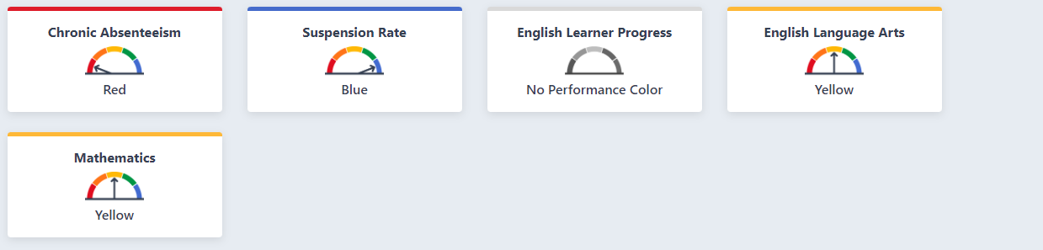

School Performance Overview - 2022

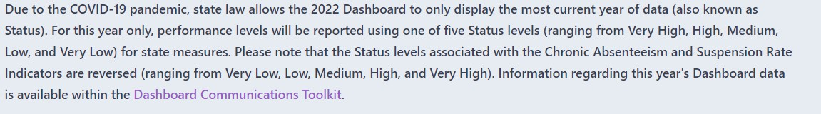

School Performance Overview - 2021

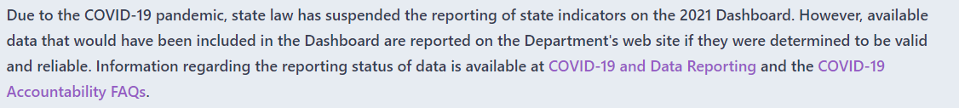

Student Population – 2023

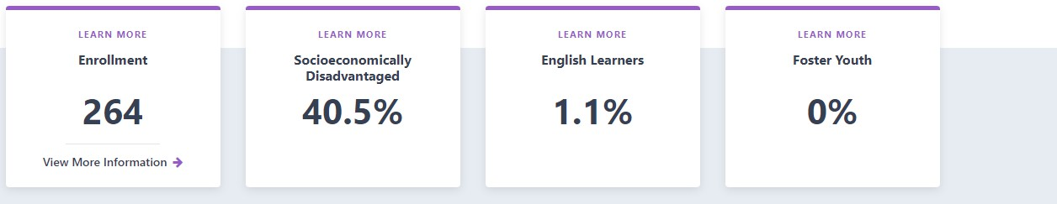

Student Population – 2022

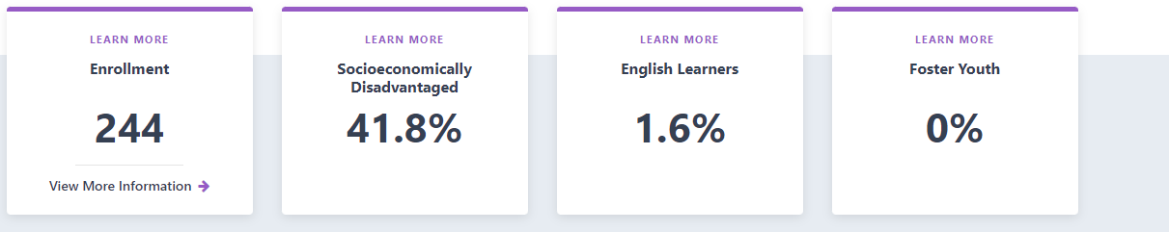

Student Population – 2021

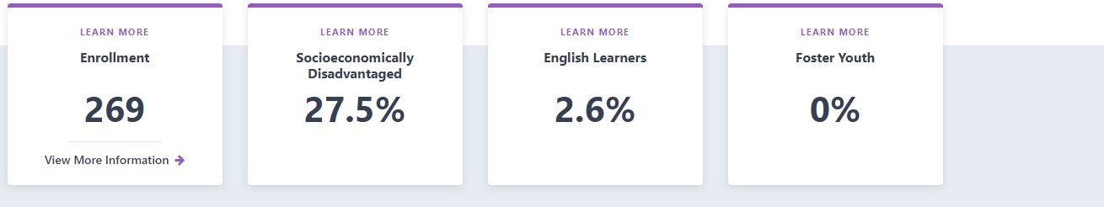

Academic Performance – 2023

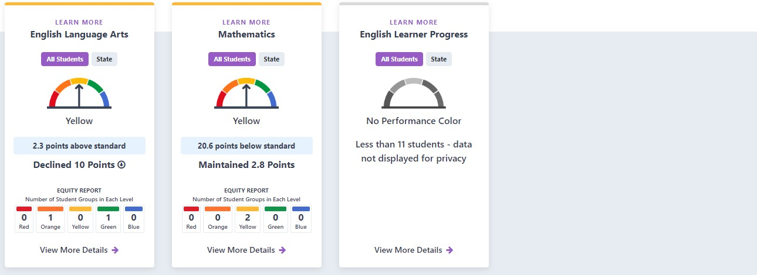

Academic Performance – 2022

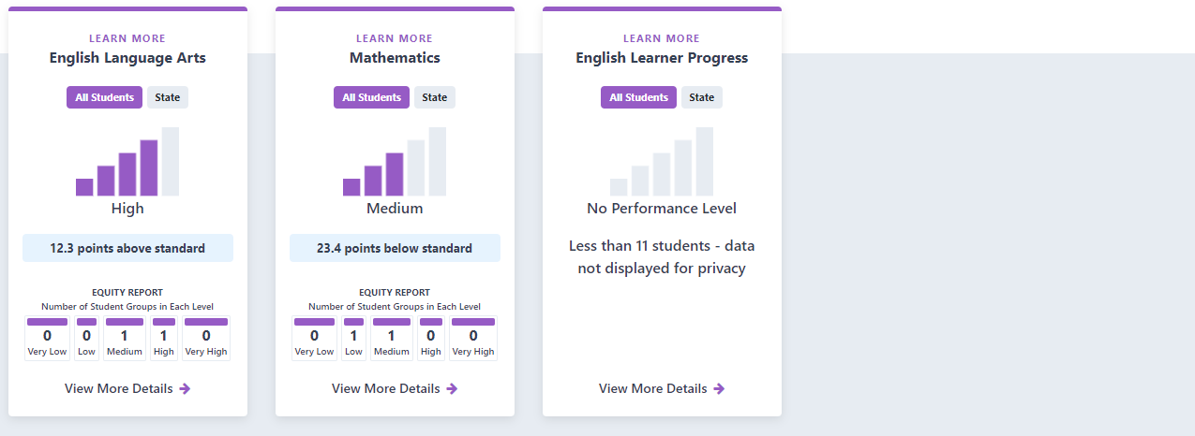

Academic Performance – 2021

No data available

Academic Engagement – 2023

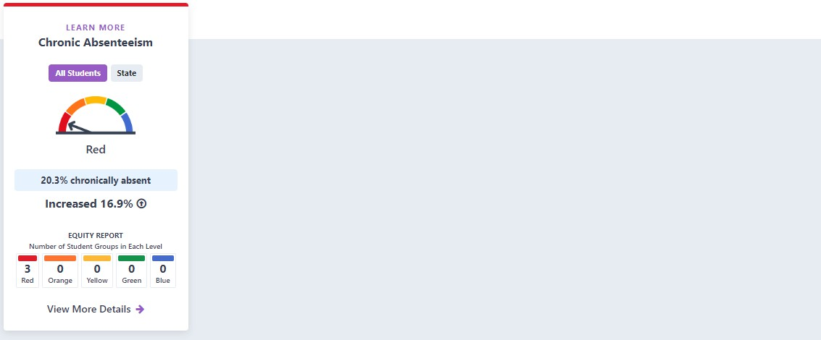

Academic Engagement – 2022

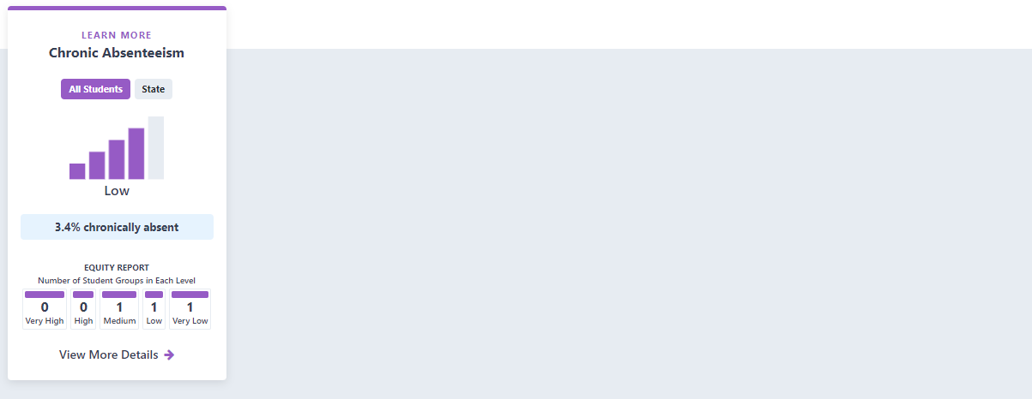

Academic Engagement – 2021

No data available

Conditons and Climate – 2023

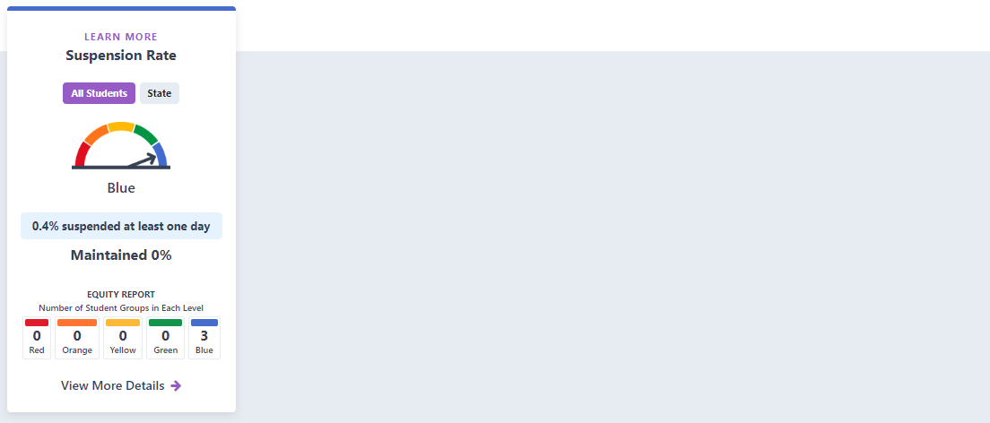

Conditons and Climate – 2022

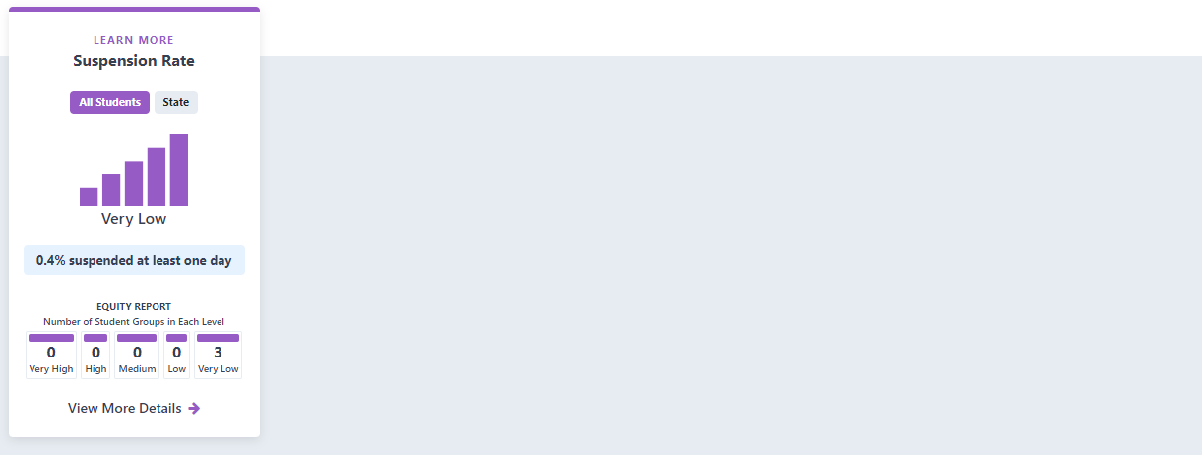

Conditons and Climate – 2021

No data available

Suspension/Expulsion Data

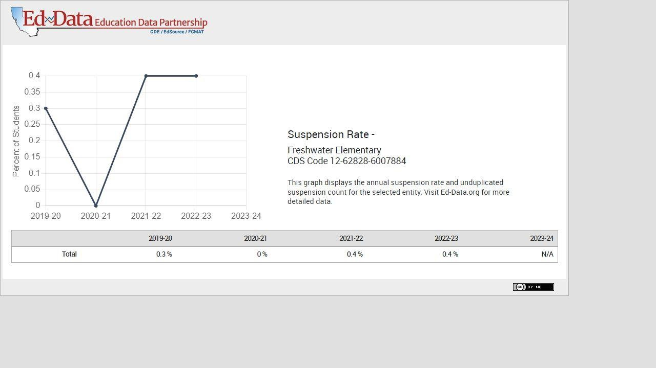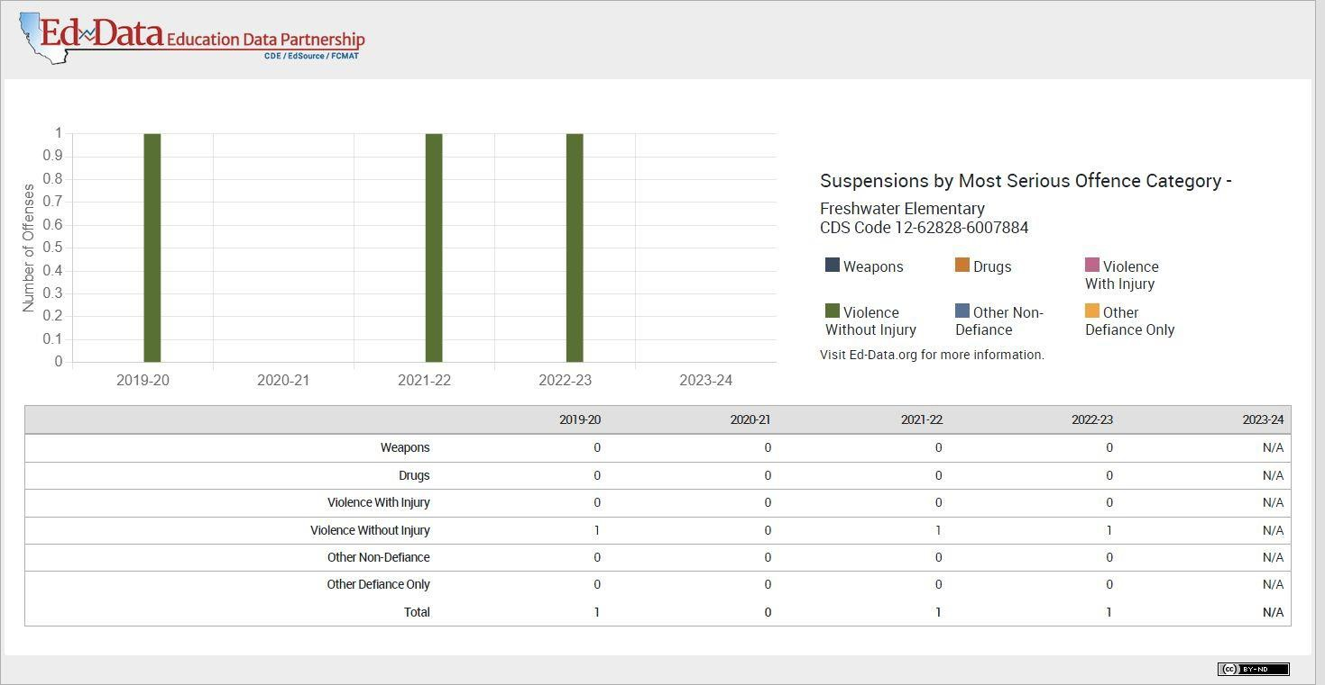Suspension Rate

Expulsion Rate

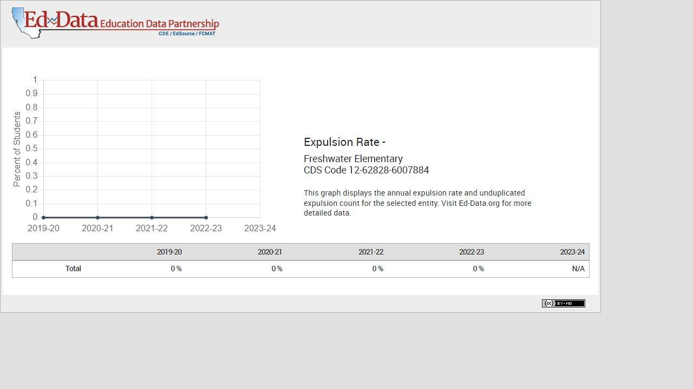

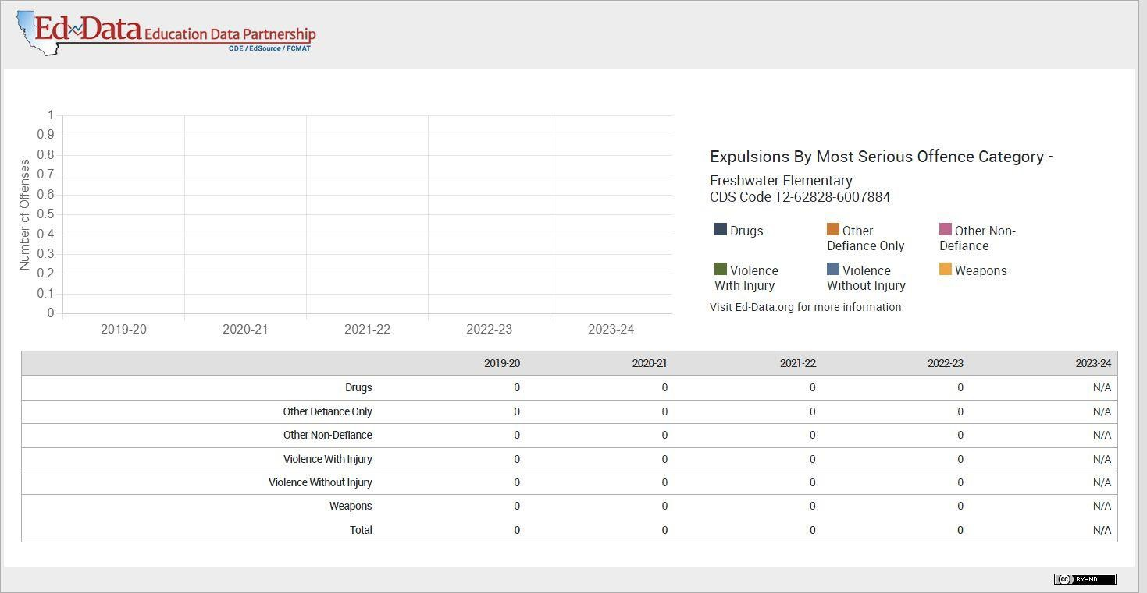

Drills, Training, and Exercises – Conducted

Fire Drills

9/6/23

12/6/23

1/10/24

4/3/24

5/1/24

6/5/24

### Earthquake Drills (Duck, Cover, Hold)

10/4/23

2/7/24

### Lockdown Drills

11/2/23

3/6/24

### Evacuation

# Section 4 – Action Plan

Action Plan

### Areas of Pride/Accomplishments

* School Climate
* Student Safety
* Character Education, Restorative Practices & Healthy Play
* Parent Involvement
* Comprehensive Curriculum
* Rural Environment
* Multi-Tiered System of Support (MTSS) & Positive Behavioral Interventions and Supports (PBIS) Implementation
* Proactive counseling services
* Quality After School Program
* Sports Program
* Music Program
* School sponsored extracurricular events and programs
* Universal Meals Program: Breakfast & Lunch for All students made from scratch using as many locally sourced, seasonal, and organic foods as possible
* CA Distinguished School Award
* Summer Enrichment Camp
* PBIS GOLD Medal Recognition

### Findings & Desired Improvements

* Analyze California Healthy Kids Survey (CHKS) student, staff, and parent data.
* Gather and review input and feedback from educational partners through additional surveys and other outreach efforts to plan further improvements for Freshwater School.

### Priorities/Goals

* Generate more student input about their educational experience at Freshwater School
* Provide more opportunities for family and student involvement at school in extracurricular events such as Lego & Game Nights, Family Movie Nights, Sports and Music events, afterschool Enrichment Classes, family garden work parties, and holiday events
* Implement Multi-Tiered Systems of Support (MTSS) and Positive Behavioral Interventions and Supports (PBIS) School-wide
* Track student behavior referrals using SWIS and have Leadership Team analyze data to make recommendations for further interventions for student support.
* Decrease chronic absenteeism to 5% by providing a positive school climate and providing family outreach and support plans. Parent education regarding importance of attendance will be included regularly in the weekly school wide bulletin. Leadership teams will implement classwide attendance recognition at monthly assemblies.
* Provide Narcan training for staff and establish a District emergency opioid overdose protocol.

### Overall Strategies for the 2024 – 2025 School Year

* Generate more student input about their educational experience at Freshwater School
* Decrease chronic absenteeism by 5% by providing a positive school climate and providing family outreach and support plans. Parent education regarding importance of attendance will be included regularly in the weekly school wide bulletin. Leadership teams will implement classwide attendance recognition at monthly assemblies.

#### Component 1 People and Programs (School Climate):

* Continue implementing Multi-Tiered Systems of Support (MTSS) and Positive Behavioral Interventions and Supports (PBIS) School-wide, including posting signage, holding Expectation Station assemblies, tracking behavior referrals and analyzing data to support student outcomes, and incentivizing students that make good choices.
* Continue implementing Restorative Practices and Healthy Play school wide.
* Continue to track student discipline using SWIS in an effort to implement more Multi-Tiered Systems of Support (MTSS).
* Utilize updated Second Step Social-Emotional curriculum in all grades with fidelity. Student Support Specialist will oversee implementation and provide classroom support as needed.
* Provide virtual counseling for students in need through Tiny Eye Therapy Services
* Establish PBIS Tier 1 and 2 Leadership teams with representation of diverse roles on campus. Streamline team processes to maximize efficiency of services provided.
* Utilize Character Strength curriculum developed by the SEL Leadership Team to guide school wide SEL efforts.
* Equity Committee will hold ad hoc meetings as needed and report out at PAC meetings.
* Continue to restore Freshwater Garden will the support of the Freshwater Education Foundation and fundraising efforts.
* Parent Advisory Council (PAC) will meet three times each school year to oversee LCAP and provide input on district initiatives.
* Publicize and encourage parents to use our new Parent Lending Library with parent books and resources.
* Provide PBIS and Character Strength School to Home connections so families can learn and support these concepts at home.
* Provide and encourage ample professional development opportunities for all staff (Restorative & Trauma-Informed Practices, PBIS, Crisis Prevention, School Safety, Science of Reading/UFLI, Culturally Responsive Teaching, UDL, Compassionate Systems.
* Implement a process for collecting student input regarding their experience at Freshwater School through Student Leadership.

#### Component 2 Places (Physical Environment):

* Upgrade gymnasium water fountains with a hydration station.
* Install an air quality PM sensor to accurately gather air quality data at Freshwater School.
* Extend perimeter fencing in the north woods of campus.
* Remove old floor covering and polished concrete in cafeteria.
* Upgrade kitchen with new high-temp dishwasher, a double door refrigerator, three compartment dish sink and a handwashing sink.
* Upgrade the lighting for gym parking lot.
* Replace vinyl floors in gym bathrooms.
* Purchase 2 new electric buses and install charging infrastructure.
* Upgrade our Safety boxes to include Narcan and Epipens.
* Upgrade DVR for enhanced video security